# Colorado's Decision Support Systems

# 7.0 Standard Modeling Procedures

This chapter provides technical notes on selected operations, guidance for frequently asked questions regarding the operation of StateMod, and standard and accepted StateMod modeling procedures for implementing the various operations. It is recommended the user follow these approaches, however if the approaches are adapted for more specific operations, it is the user’s responsibility to test and verify the results. The following sections are available within this chapter:

* 7.1 Running the Model
* 7.2 Creating Natural Flows at Gages and Ungaged Locations
* 7.3 How to Simulate Soil Moisture Accounting and Variable Efficiency
* 7.4 How to Add or Change Modeled Input Data
* 7.5 How to Model Reservoir Operations
* 7.6 How to Model Off-Channel Reservoir Systems
* 7.7 How to Model Well Operations
* 7.8 How to Model Plan Structures and Operations
* 7.9 How to Model a Release Limit Plan
* 7.10 How to Model Augmentation Plans
* 7.11 How to Model Changed Water Rights and Return Flow Obligations
* 7.12 How to Model Augmentation Plans
* 7.13 How to Model Imported Water
* 7.14 How to Model Reusable Supplies
* 7.15 How to Implement a Futile Call
* 7.16 Basin-Specific Operations and Compacts
* 7.17 How to Add Daily Capability

## **7.1 Running the Model**

StateMod can be executed through either the StateMod GUI or through command line arguments. See the StateMod GUI User’s Manual for more information on how to execute the model through the GUI. In a command line, it is recommended that the user first call for the StateMod executable along with the specific response file (*.rsp), then select the option using the prompted menu. Figure 5 shows the command line argument calling for StateMod Version 15.00.01 (statemod15_0001) and the Lower South Platte Model scenario (SP2013L). The resulting options can then be selected to create natural flows (baseflows), simulate the model, report results, or perform a data check on the model input files. Table 1 summarizes the functionality of each option; a more detailed summary of each option is provided in Section 3.3. Although it is recommended to execute options using the menu, options shown in Table 1 can be included after the response file in the command line argument and executed using a single command.

|  |
| --- |
| **Modeling Tips:**   * Section 2.0 describes the general sequence for developing and operating StateMod, providing guidance on which option should be run. * It is recommended the user perform a data check on modeling scenarios prior to simulation, in order to check for missing data or incorrect file formats. See the *.log file for a summary of warnings/issues for each file. |

Figure 5: Model Execution Command Line Example

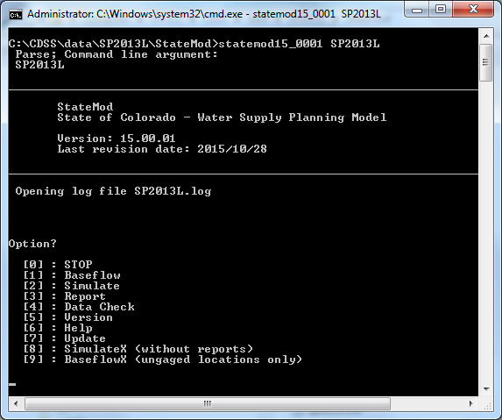

Table 1: StateMod Menu Options

|  |  |  |
| --- | --- | --- |
| Menu Option | Command Line Designation | Description |
| 0. STOP | N/A | Exit out of current scenario |
| 1. Baseflow | -base or -baseflow | Perform baseflow option and generates baseflows at all locations if data is available. |
| 2. Simulate | -sim or -simulate | Perform simulate option with standard reports |
| 3. Report | -rep or -report | Perform report option |
| 4. Data Check | -chk or -check | Perform data check option |
| 5. Version | -v or -version | Print the program version |
| 6. Help | N/A | Option not currently functional |
| 7. Update | -u or -update | Print recent StateMod updates |
| 8. SimulateX | -simx or -simulatex | Perform simulate option without standard reports |
| 9. BaseflowX | -basex or  -baseflowx | Perform baseflow option for ungaged areas only (option typically used after baseflows at gaged locations have been generated and need to be distributed to ungaged areas) |

If the Report option (3) is selected, the user will be prompted with a menu of available reports to select from, as shown in Figure 6. Descriptions of the information in each output report can be found in Section 5.0. If the *-rep* option is used, additional parameters are required in order to request the desired report and desired station as appropriate, by including a report output command. For example, the user can included *-xdc* following *–rep* in the command line argument to create the Diversion Comparison output file. A complete list of available report output commands can be found in Section 5.0.

Figure 6: StateMod Report Options

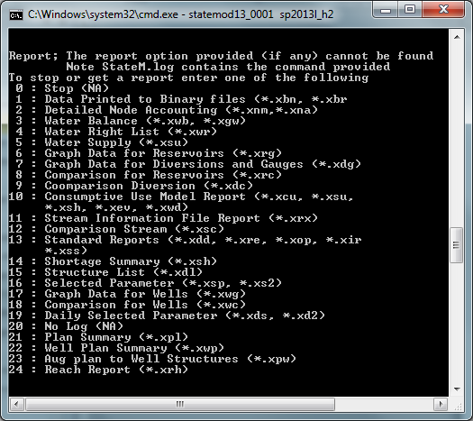

### 7.1.1 Abnormal Model Termination

It is the user’s responsibility to correctly represent the modeled basin and operations in the overall scenario, and understand information supplied in each input file. StateMod will perform minimal error checking of user-supplied data, focusing primarily on consistency between model structures between files, select missing or errant data, and file formats. Incorrect or inconsistent input data will result in an error when executing StateMod and cause the model to terminate prior to completing the execution. The errors are documented in a log file; it is the responsibility of the user to read error messages and react accordingly.

If the model terminates prior to completing the simulation, open the log file (*.log) in a text editor and review the information. The log file will contain various notes on which files were expected to be read and which files were actually read from the response file (*.rsp). The error is the last piece of information in the log file, and the error is generally associated with the last file that was read. Use Section 4.0 to review the format and required data in the specific input file and correct.

## 7.2 Creating Natural Flows at Gages and Ungaged Locations

As discussed in Section 2.0, natural flows (or baseflows) represent basin streamflows absent man’s influence including diversions, return flows, reservoir operations and pumping. If 100% of man’s influence is removed, baseflows are often called virgin flows or natural flows. It is recommended that users first develop natural flows at gaged locations, and then distribute those natural flows to ungaged areas. Natural flows at gaged and ungaged locations are then used as the natural flow input to simulation scenarios, such as Historical Calibration or Baseline scenarios.

StateMod estimates natural flows using the Baseflow option and the following equation:

Natural Flow at Gaged Locations =

Div. = 100

+ Gaged Flow

+ Upstream Diversions

RF. = 40

– Upstream Return Flows

CU = 60

+/- Upstream Change in Storage

+ Upstream Evaporation

Gage = 200

– Imports

Natural Flow = 200 + 100 – 40 = 260

The following steps are recommended to develop a scenario to estimate Baseflow:

1. Create a model scenario that includes a minimum of the following files , as designated in the response file (*.rsp):

* Control (*.ctl)
* River_Network (*.rin)
* StreamGage_Station (*.ris)
* StreamGage_Historic_Monthly (*.rih)
* Diversion_Station (*.dds)
* Diversion_Right (*.ddr)
* Diversion_Historic_Monthly (*.ddh)
* DelayTable_Monthly (*.dly)
* Reservoir_Station (*.res)
* Reservoir_Right (*.rer)
* Evaporation_Annual (*.eva)
* Reservoir_Target_Monthly (* tar)
* Reservoir_Historic_Monthly (*.eom)

If crop consumptive use is known and variable efficiency will be considered, also include the following files:

* IrrigationPractice_Yearly (*.ipy)
* ConsumptiveWaterRequirement_Monthly (*.iwr)
* StateCU_Structure (*.str)

If well structures and pumping will be considered, also include the following files:

* Well_Station (*.wes)
* Well_Right (*.wer)
* Well_Historic_Monthly (*.weh)

|  |
| --- |
| **Modeling Tip:**   * There are several complete StateMod datasets available on the CDSS website. It is recommended the user download an existing dataset to use as a template and to assist with trouble shooting. |

1. Run the Baseflow option with the scenario to create natural flows at the gaged locations. Note that diversion records, gage data, or reservoir contents can contain missing records (designated as -999 in the files). StateMod will not calculate a natural flow estimate for a month that contains any missing data, leaving the month as missing in the output file. The output from this Baseflow scenario is summarized in the Baseflow Information report (*.xbi) and in the Baseflow at Stream Gages file (*.xbg).
   1. The river connectivity in the network diagram impacts the development of natural flows. It is recommended that confluence nodes should be used to represent tributaries; it is not recommended that a diversion structure or other structure type be used to reflect multiple tributaries.
2. If incomplete records were used to create the baseflow at gaged locations (i.e. -999 in the *.xbg), an external filling technique is required. CDSS models have historically used the Mixed Station Model to automate the filling of missing data through monthly and annual regression relationships; however other tools and techniques can be used. Select a tool/technique and fill the missing data to develop a complete baseflow at gaged locations file (*.xbf).
3. If complete records are used, the Baseflow option will generate natural flows at both gaged and ungaged locations; see discussion below for the additional file (streamflow coefficient/baseflow file (*.rib) required for distribution of natural flows to ungaged locations.

Once complete natural flows are developed at gaged locations, it is necessary to distribute those gains to ungaged locations. Baseflows at ungaged tributaries are zero unless specified by the user and gains are estimated to occur at a gaged locations. Therefore, in order to have a water supply in tributary headwaters or to simulate the river’s gain or loss between gaged points, ungaged baseflows must be estimated. StateMod generates baseflows at ungaged locations based on the following formula:

FlowX = (FlowB(1)*coefB(1) + FlowB(2)*coefB(2)+ ....) +

pf * (FlowG(1)*coefG(1) + FlowG(2)*coefG(2)+ ....)

Where;

FlowX = Flow at intermediate node to be estimated

FlowB = Base flow station(s)

FlowG = Gain flow station(s)

pf = Proration factor for gain term

coefB = Base flow coefficient

coefG = Gain flow coefficient

The first term (FlowB(1)*coefB(1)...) represents upstream gaged flow while the second term (pf * (FlowG(1)*coefG(1) ...) represents a distribution of the gain which occurs between gaged flow. The terms FlowB and FlowG are commonly at gaged streamflow stations. The proration factor (pf) is used to distribute the gain between reaches and is commonly estimated to be a ratio of the drainage area multiplied by average annual precipitation compared to that in the gaining reach. The coefficients coefB and coefG are provided throughout the formula for special cases, but are typically 1.0 or -1.0.

The general baseflow formula described above is typically implemented with discretion by a modeler to represent the “gain approach” or the “neighboring gage approach”. In the “gain approach”, StateMod pro-rates baseflow gain above or between gages to ungaged locations using the product of drainage area and average annual precipitation. Figure 7 illustrates a hypothetical basin and the areas associated with each of three gages and an ungaged location.

Figure 7: Hypothetical Basin Illustration

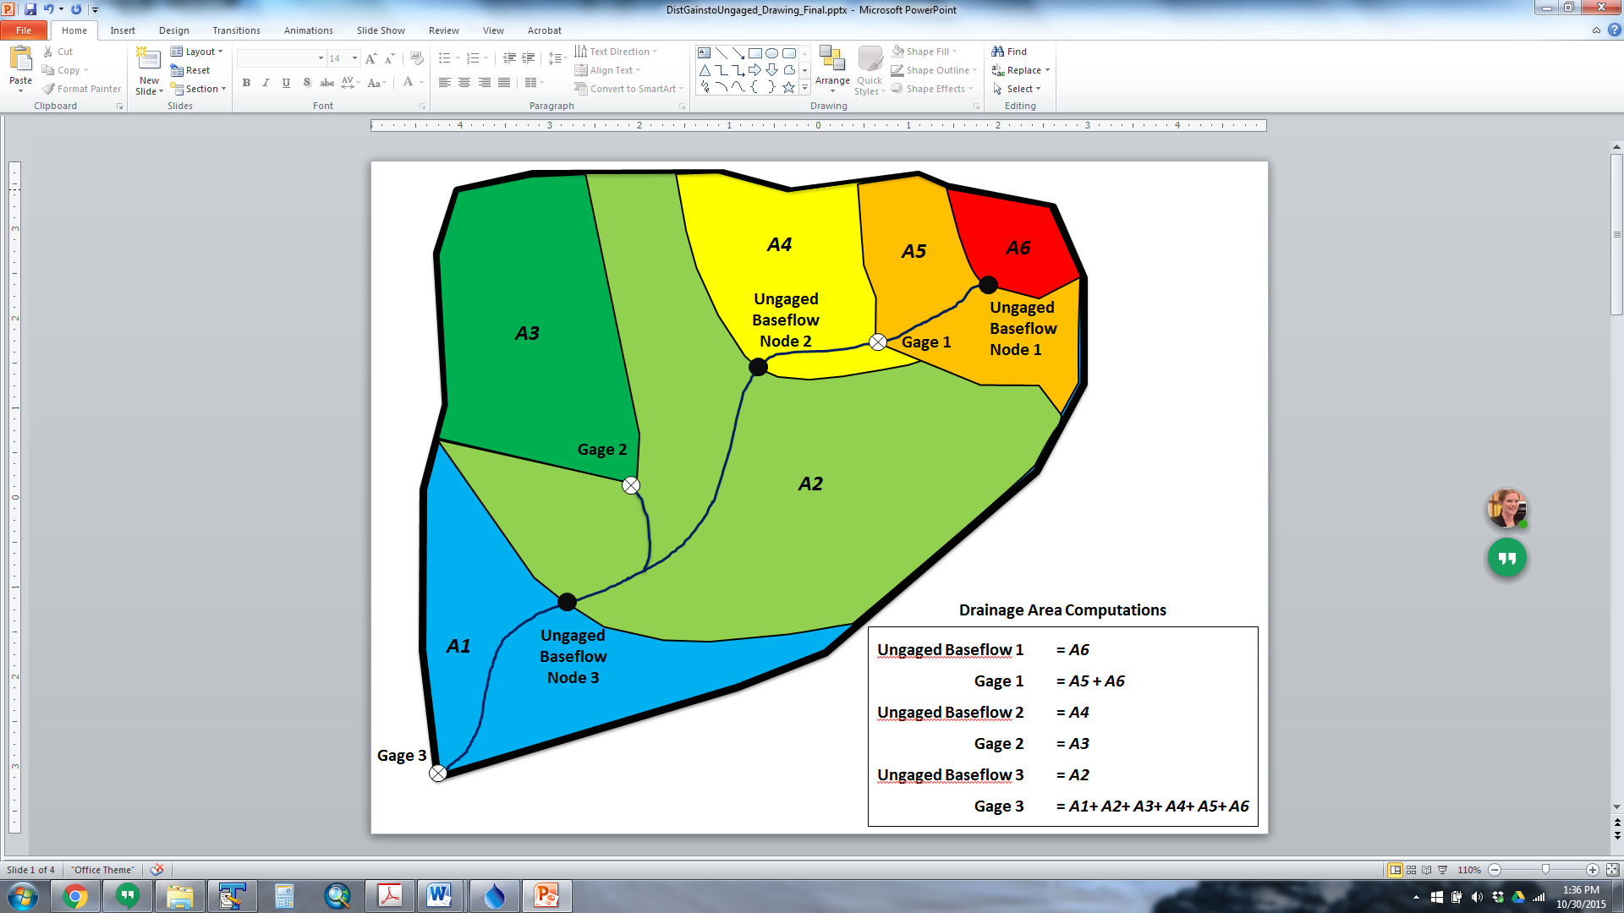

The area associated with gages is the total upstream area. The area associated with ungaged nodes only includes the incremental area from the ungaged location to the next upstream gage or gages. For example, Gage 3 area includes the entire basin. Ungaged Baseflow Node 3 area only includes the upstream area up to Gage 2 and Gage 1. Precipitation for gaged and ungaged areas should represent the average annual precipitation (inches) for the entire upstream drainage area.

In Figure 7, there are three ungaged baseflow nodes; the StateMod “gain approach” computes the total baseflow at each ungaged node based on the following:

The baseflow gain distributed to Ungaged Baseflow Node 1 is the baseflow gain above Gage 1 pro-rated on the A*P terms.

$${Gain}_{ungaged,1}=\left(\frac{{(A*P)}_{ungaged,1}}{{(A*P)}_{gage,1}}\right)\left({BF}_{gage,1}\right)$$

Total baseflow at Ungaged Node 1 is equal to the Gainungaged,1 term.

The baseflow gain distributed to Ungaged Baseflow Node 2 is the baseflow gain between Gage 1, 2, and 3 pro-rated on the A*P terms.

$${Gain}_{ungaged,2}=\left(\frac{{(A*P)}_{ungaged,2}}{{(A*P)}_{gage,3}-{\left(A*P\right)}_{gage,2}-{(A*P)}_{gage,1}}\right)\left({BF}_{gage,3}-{BF}_{gage,2}-{BF}_{gage,1}\right)$$

Total baseflow at Ungaged Node 2 is equal to the Gainungaged,2 term plus the baseflow at Gage 1.

$${BF}_{ungaged,2}={Gain}_{ungaged,2}+{BF}_{gage,1}$$

Ungaged Baseflow Node 3 calculations are very similar. The baseflow gain distributed to Ungaged Baseflow Node 3 is the baseflow gain between Gage 1, 2, and 3 pro-rated on the A*P term.

$${Gain}_{ungaged,3}=\left(\frac{{(A*P)}_{ungaged,3}}{{(A*P)}_{gage,3}-{\left(A*P\right)}_{gage,2}-{(A*P)}_{gage,1}}\right)\left({BF}_{gage,3}-{BF}_{gage,2}-{BF}_{gage,1}\right)$$

Total baseflow at Ungaged Node 3 is equal to the Gainungaged,3 term plus baseflow at Gage 1 and Gage 2.

$${BF}_{ungaged,3}={Gain}_{ungaged,3}+{BF}_{gage,1}+ {BF}_{gage,2}$$

A second option for estimating headwater baseflows can be used if the default “gain approach” method created results that do not seem credible. This method, referred to as the “neighboring gage approach”, creates a baseflow time series by multiplying the baseflows at a specified gage by the ratio (A*P)headwater/(A*P)gage. This approach is effective when the runoff at an ungaged location does not follow the same pattern as the gains along the main stem. For example, a small ungaged tributary that peaks much earlier or later than the main stem should use the neighboring gage approach with a streamgage in a similar watershed. The user is responsible for ensuring that the overall reach water balance is maintained when using the neighboring gage approach.

|  |
| --- |
| **Modeling Tips:**   * Use the “gain approach” at an ungaged location that is dominated by upstream gaged flows or when the ungaged location has a relatively large drainage area when compared to the downstream gaged data’s drainage area. * Use the “neighboring gage approach” when the ungaged location’s drainage area is relatively small when compared to the downstream gaged location’s drainage area. Note, when the neighboring gage approach is taken, the modeler is, in effect, adding a “new” gage. Therefore, when this approach is implemented, care must be exercised to ensure the gain coefficients (coefG) and proration factor (pf) accurately account for this 'new' gage and its associated drainage area. |

The following steps are recommended to develop a scenario to distribute baseflow to ungaged locations:

1. Copy and rename the baseflow model scenario response (*.rsp) file to reflect a new model scenario. It is recommended a suffix of “x” be added to the model name to designate the use of the BaseflowX option.
2. Input the area/precipitation factors in the Network (*.net) file in order to create the streamflow coefficient/baseflow file (*.rib) using the standard CDSS approach using StateDMI. Additionally, reflect any neighboring gage assignments in the streamflow coefficient/baseflow file.
3. Add the following files to the new response file (*x.rsp):
   * StreamEstimate_Coefficients (*.rib)
   * Stream_Base_Monthly (*.xbf – reflects the filled baseflows at gaged locations)
4. Set the StreamGage_Historic_Monthly file to the (*.xbf) for output comparison purposes.
5. Run the BaseflowX option with the scenario to distribute natural flows at ungaged locations. The output from this BaseflowX scenario is provided in the Baseflow at Gaged and Ungaged Locations file (*.xbm). This baseflow file (*.xbm) serves as the natural flows (Stream_Base_Monthly ) for subsequent simulation scenarios.

### 7.2.1 Natural Flows with Recharge

When recharge water is part of historical river operations and is to be included in the natural flow calculations, the same natural flow formula is used with the following data:

* Historical diversions (*.ddh) include water from all sources (priority, exchange, etc.) and for all uses (irrigation, municipal, storage, recharge, etc.). This data is commonly called Total Diversion from Headgate.
* StateMod’s Natural Flow module knows the amount of total diversion taken to reservoir storage using a reservoir end-of-month file (*.eom) file. This file that contains reservoir storage data for every reservoir in the system.
* The portion of the total diversions that is taken to recharge is input into the model in the Diversion_To_Recharge (*.dre) file. This file contains total diversions to recharge for every diversion structure that carries water to recharge.
* StateMod’s Natural Flow module adjusts total diversions to account for the portion that is carried to recharge. In order to calculate return flows associated with recharge, a Reservoir_To_Recharge (*.rre) file is provided containing recharge data for every recharge reservoir. This data, along with the reservoir seepage characteristics specified in the reservoir station (*.res) file and return flow properties specified in the reservoir return file (*.rre), are used to calculate accretions from a recharge site.
* The above calculations can be confirmed by reviewing the Natural Flow Base Flow output(*.xbi). The following are noted:
  + The column titled Divert is the sum of all upstream diversions included in the historical diversion file (*.ddh). Therefore it includes water from all sources (priority, exchange, etc.) and for all uses (irrigation, municipal, recharge, etc.).
  + The column titled Return includes return flows from consumptive uses as well as recharge.
  + The column titled Divert to Rech echoes the data provided in the Diversion_To_Recharge (*.dre) file.
  + The column titled Reservoir to Rech echoes the data provided in the Reservoir_To_Recharge (*.rre) file.
  + When the historical diversion data are adjusted by the amount diverted to recharge, the calculation is not allowed to go negative.
  + Diversion_To_Recharge data are only required for a ditch that carries water to recharge. If data are not provided, the diversion to recharge is estimated to be zero. The WDID specified in this file should be the same as the Diversion ID to be adjusted.
  + Reservoir_To_Recharge data are only required for a reservoir with recharge. If data are not provided, any accretions or recharge associated with the diversions to recharge are assumed to be zero. The WDID specified in this file should be the same as the Reservoir ID with recharge.

### 7.2.2 How to Check for Natural Flow Issues

Following are recommended checks to identify problems with natural flow estimates.

**Situation:** Negative baseflows occurring at stream gages or base flow nodes in model network. Negative baseflows occur when the gage flows is less than the other parameters used in the natural flow calculation. StateMod automatically sets any natural flow estimated to be negative at a gaged location to zero prior to distributing gains to ungaged locations, essentially “creating” water in the system. As natural flows represent the flow in the absence of man, negative natural flows are not physically based and likely caused by data inconsistencies.

**Checks**:

* Review *.log file from –Base Flow module for the *Negative Flows* summary. Identify extent of negative baseflows by the number of months (“Count” column) and magnitude of negative baseflows (“Est” column). Review monthly distribution of negative baseflows for the stream gage ID or base flow node ID in the Baseflow output (*.xbi) summary file or time series (*.xgn) file.
* For gaged locations, review the data used to calculate baseflows (diversions, return flows, reservoir contents). Filled data in diversion records, streamflow gage records, or reservoir contents can result in negative flow issues.
* Review the Baseflow output (*.xbi) file for months with negative baseflows to determine which of the data used to calculate baseflows is causing the calculation to go negative. This is typically due to simulated return flows greater than historical gaged flows + upstream diversions or data filling techniques; particularly with regard to reservoir contents.
* Review return flows above gage based on topography and acreage location because return flow are subtracted from gage data. Specifically investigate return flows to neighboring tributaries or other locations that bypass a gage. Mis-location of Return Flow ID’s (crtnid), Return Flow Percentages (pcttot), and Return Flow Locations (irtndl) in the diversion station (*.dds) file can have a significant impact on calculated baseflows.

**Situation:** The natural flow at an upstream gage is greater the natural flow at the downstream gage, essentially creating a “losing reach”. As natural flows represent the flow in the absence of man, it is expected that as the drainage area increases from upstream to downstream, the natural flow increases from upstream to downstream as well. Often times, the “losing reach” will be limited to sporadic months, however in rare cases, the upstream gage is greater than the downstream gage for the entire period. It is recommended that any “losing reaches” be addressed prior to distributing the gains (or losses) to ungaged locations.

**Checks**:

* Check that natural flows increase from upstream to downstream. Use a graphical tool, such as TSTool or MS Excel, to quickly add the time series of natural flows from the *.xbm file above each gage to assure they are equal or greater to the natural flow estimated at the downstream gage.
* If losing reaches occur, use the files and techniques outlined in the “negative flow” discussion above to identify issues or data inconsistencies that may be the cause.
* If the “losing reach” is consistent throughout the entire period, it is recommended that the diversions, reservoir storage, imports, and return flows in the upstream reach be analyzed. In some situations, the losing reaches are caused by incorrectly routed return flows, incorrect locations of diversions (above/below the gage), problems with physical representation of the basin, or imports that are included in the natural flow estimates.

|  |
| --- |
| **Modeling Tip:**   * It is recommended that the user address any negative natural flow or losing reach issues prior to distributing the natural flow gains (or losses) to ungaged locations. |

**Situation:** More than 100 percent of the natural flow gains between gages are distributed to an ungaged location, resulting in “created” water and a “losing reach” at the downstream gage. Gains are distributed to ungaged locations using either the “gain approach” or “neighboring gage approach”, both of which use a coefficient to distribute the gain or loss.

**Checks**:

* In the gain approach, the coefficient is based on the *incremental* area below an upstream gage multiplied by the total average annual precipitation for the upstream drainage area. Review the area and precipitation values in the network (*net) to represent the appropriate values.
* In the neighboring gage approach, review the assigned coefficients in the streamflow coefficient/baseflow file (*.rib) to make sure that the distributed gains are not greater than 100 percent, especially if a gage was used for multiple ungaged locations.
* The gain approach assigns the distribution of gains for main stem gages to tributary gages. This may not be an adequate representation, in which case the neighboring gage should be used.

|  |
| --- |
| **Modeling Tip:**   * Once the natural flow at gaged and ungaged locations have been checked for the situations discussed above, they are used as the natural flow input to subsequent simulation models. Additional adjustment to the natural flows may be necessary pending the results of a Historical Calibration scenario. |

## 7.3 How to Simulate Soil Moisture Accounting and Variable Efficiency

StateMod has the ability to store in the soil reservoir and subsequently use soil moisture as a water supply. Additionally, StateMod has the ability to simulate under variable efficiency, whereby the model allows irrigation efficiency to vary from zero to a user-specified maximum value. These two functions are generally used together, and the soil moisture function requires the variable efficiency option be used.

The soil moisture option allows diverted water to be stored in the soil zone up to its defined capacity considering the diverting structures (direct diversion or well) efficiency. It uses an operating rule to specify an administration date that controls when water is available to be taken out of the soil zone to satisfy a consumptive demand. StateMod initializes the soil moisture reservoir contents to be 50% of the soil moisture capacity.

The variable efficiency option allows the model to vary the efficiency in which it meets a demand. For example, variable efficiency will operate at the maximum efficiency when a demand is water-short, but a lower efficiency would be used when a system is water-long. The following notes should be considered with variable efficiency:

* Variable efficiency uses the Modified Direct Solution Algorithm and can be used with or without soil moisture storage.
* When variable efficiency is used, the efficiency data provided in the diversion station (*.dds) file and well station (*.wes) file are ignored for structures with irrigation demands provided in the irrigation water requirement file (*.iwr).
* Variable efficiency capability calculates the maximum system efficiency for a diversion to be the conveyance efficiency times the maximum flood efficiency provided in the annual time series file (*.ipy).
* Variable efficiency capability calculates the maximum system efficiency for a well to be the maximum flood efficiency or maximum sprinkler efficiency provided in the annual time series file (*.ipy). The control file variable *isprnk* controls whether flood or sprinkler efficiency data are used. Sprinkler efficiency is used preferentially up to the acres served by sprinklers. Thereafter, any remaining acres served by wells are served by using the maximum flood efficiency.
* Variable efficiency capability applies to all direct diversion, well pumping and carrier to diversion structure operations if irrigation demands provided in the irrigation water requirement file (*.iwr).

The following steps are recommended to implement soil moisture accounting and variable efficiency, respectively.

### 7.3.1 Soil Moisture Implementation

1. In the control file (*.ctl), set the soil moisture switch (*soild*) to a number greater than 0 that represents a typical soil zone depth in feet (e.g. 3.0 feet).
2. In the control file (*.ctl), set the annual time series file switch (*itsfile*) to 10. As described in the control file documentation, an entry of 10 allows variable efficiency and other more complex water use data to be used.
3. If not already created in support of a StateCU model scenario, create a structure file which includes a representative available water capacity (AWC) parameter for each structure in the scenario. The structure file is a primary input to the StateCU model; see the StateCU User’s Manual for information on the format and content of this file.
4. Include the StateCU Structure file (*.str) in the response file (*rsp).
5. In the operating rule file (*.opr), add a Type 22 operating rule that provides the administration number to control when water is available to be taken out of the soil zone to satisfy a consumptive demand.

### 7.3.2 Variable Efficiency

1. In the control file (*.ctl), set the variable efficiency switch (*ieffmax*) to 1.
2. In the control file (*.ctl), set the annual time series file switch (*itsfile*) to 1 or 10. As described in the control file documentation, when the control variable *itsfile* is set to 10 conveyance, maximum flood, and sprinkler efficiency data provided by structure and year are used. Set the control variable *ieffmax* to 1 so irrigation water requirement (*.iwr) data provided for every diversion and well only structure by year is used.
3. If not already created in support of a StateCU scenario, create an annual time series (*.ipy) file for every irrigation structure served by a diversion or wells only. The annual time series file is a primary input to the StateCU model; see the StateCU User’s Manual for information on the format and content of this file.
4. If not already created in support of a StateCU scenario, create a monthly irrigation water requirement (*.iwr) file for every irrigation structure in the scenario. The StateMod formatted irrigation water requirement file (*.ddc) is an output from StateCU; see the StateCU User’s Manual for information on the format and content of this file.
5. Include the annual time series file (*.ipy) and irrigation water requirement file (*.iwr) in the response file(*.rsp) .

## 7.4 How to Add or Change Modeled Input Data

This section provides a recommended approach on how to add or change typical model data that follows the standard CDSS data-centered approach. The CDSS data-centered approach focuses on the flow of information from HydroBase or other data sources through data management interfaces (DMI) that correctly format the input files for the CDSS models (StateCU and StateMod). The data-centered approach means the process of developing the model, organizing the files, and documenting the model is consistent for every CDSS StateMod dataset; and that many of the major modeling decisions are documented in the command files of the DMI. There is a file dependency element to the data-centered approach whereby the creation of a StateMod file may be dependent on another file. Therefore it is important for the user to understand these dependencies as well as the recommended method for creating StateMod input files.

To support the data-centered approach, a common directly structure was estimated by CDSS. As shown, the main directory contains subdirectories representing each aspect of the model. For example, the Diversion folder contains command files and supporting files used to create the StateMod input files associated with diversions (e.g. diversion station (*.dds) and diversion rights (*.ddr) file). The actual input files are stored in StateMod folder. The DocSW folder includes the StateMod model documentation.

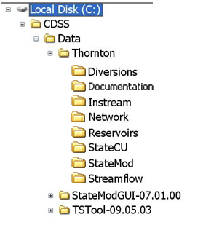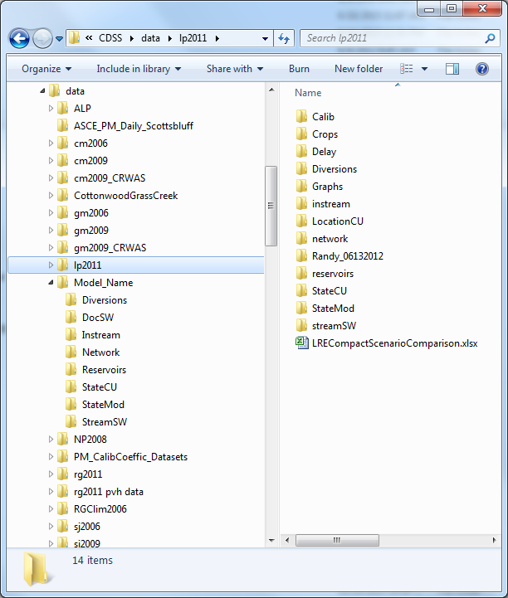

Table 2 is a quick guide to assist the user as to which files and tools should be revised, or at a minimum reviewed, if a specific structure type is added or modified. The directory where the command files can be found is also shown. Note that the network files are associated input files with most structure types; the network diagram and the river network command file can be found in the ..\Network\ folder.

Table 2: Quick Guide for Modifying StateMod Data Set Input Files

|  |  |  |
| --- | --- | --- |
| **Structure Type** | **Associated Input Files** | **Tool Generally Used to Create Input Files** |
| Stream Gage  ..\StreamSW\ | Network (*.net) | Edit network in StateDMI |
| River Network File (*.rin) | Commands in StateDMI |
| River Station File (*.ris) | Commands in StateDMI |
| Natural Flow (*.xbm) | Output from Natural Flow scenario |
| Diversion Node  ..\Diversions\ | Network (*.net) | Edit network in StateDMI |
| River Network File (*.rin) | Commands in StateDMI |
| Direct Diversion Station File (*.dds) | Commands in StateDMI, generally dependent on a set of DDS and DDH commands |
| Direct Diversion Right File (*.ddr) | Commands in StateDMI |
| Direct Flow Demand File - Monthly (*.ddm) | Commands in StateDMI |
| Delay Table (*.dly or *.urm) | Edit in text editor |
| Reservoir Node  ..\Reservoirs\ | Network (*.net) | Edit network in StateDMI |
| River Network File (*.rin) | Commands in StateDMI |
| Reservoir Station File (*.res) | Commands in StateDMI |
| Reservoir Right File (*.rer) | Commands in StateDMI |
| Reservoir Target Content File – Monthly (*.tam) | Commands in TSTool |
| Evaporation Data File – Annual (*.eva) | Edit in text editor |
| Instream Flow Node  ..\Instream\ | Network (*.net) | Edit network in StateDMI |
| River Network File (*.rin) | Commands in StateDMI |
| Instream Flow Station File (*.ifs) | Commands in StateDMI |
| Instream Flow Right File (*.ifr) | Commands in StateDMI |
| Instream Flow Demand File – Monthly (*.ifm) | Commands in TSTool |
| Plan Node  ..\StateMod\ | Network (*.net) | Edit network in StateDMI |
| River Network File (*.rin) | Commands in StateDMI |
| Plan Data (*.pln) | Edit in text editor |
| Operating Rules  ..\StateMod\ | Operating Rule File (*.opr) | Edit in text editor |
| Model Scenario Files  ..\StateMod\ | Response File (*.rsp) | Edit in text editor |
| Control File (*.ctl) | Edit in text editor |

|  |
| --- |
| **Modeling Tips:**   * This section is not all-inclusive and does not provide instructions for more complex changes or additions. If the user needs to implement a change or addition not discussed herein, it is recommended the user refer to the completed CDSS StateMod models available on the CDSS website for examples of how to implement more complex changes. * StateMod output files reflect the same file name as the response file (*.rsp); use descriptive response file names to manage different scenarios and for easier comparisons. |

### 7.4.1 Change the Period of Record

1. Open the control file (*.ctl) in a text editor.
2. Revise the beginning (iystr) and/or ending years (iyend); note that input data must be complete for the period of record selected.
3. Save the revised control file (*.ctl); consider saving with a new file name to preserve the original file.
4. Confirm the revised control file (*.ctl) is reflected in the response file (*.rsp).
5. Simulate the model.

### 7.4.2 Add a Diversion Structure

The following approach assumes that the added diversion structure is a “future” structure and not an actual diversion with a valid model identifier (WDID) in HydroBase. If the added structure is in HydroBase, create the input files without set commands first and identify missing information prior to setting input data.

1. Open the network (*.net) in StateDMI, navigate to the appropriate location, and right-click to *Add an Upstream Location*. Enter the appropriate information and designate the structure type as either diversion (D) or diversion/well (DW).
   1. Note that if the structure type is designated as DW, appropriate well files must be included in the scenario.
   2. Note if a diversion structure is added as a headwater node, it must be made a baseflow node and have a natural flow distribution.
2. Recreate the river network file (*.rin) to reflect the additional structure.
3. Add the structure to the diversion station file (*.dds) using the StateDMI commands:
   1. Set the structure capacity in CFS.
   2. Set the structure system efficiency (annual or monthly efficiency values).
   3. Set the demand and use types (see Section 4 for more discussion).
   4. Set the return flow locations and patterns; must reference the delay patterns provided in the delay file (*.dly or *.urm).
4. Add water rights to the diversion right file (*.ddr) using the StateDMI commands:
   1. Set the water right ID as the structure ID with a numeric suffix for each right.
   2. Set the water right priority (administration number) and amount in CFS.
5. Add the structure’s demand to the direct flow demand file (*.ddm) using the StateDMI commands.
   1. Set the monthly demand or read in an external StateMod formatted file (*.stm) with the demand.
6. Confirm the revised diversion files (*.dds, *.ddr, *.ddm) are reflected in the response file (*.rsp).
7. Simulate the model.
8. Review the direct diversion summary output file (*.xdd) and the structure summary output file (*.xss) for output information on the new diversion structure.

### 7.4.3 Add a Reservoir

The following approach assumes that the added reservoir is a “future” structure and not an actual reservoir with a valid model identifier (WDID) in HydroBase. If the added structure is in HydroBase, create the input files without set commands first and identify missing information prior to setting input data.

1. Open the network (*.net) in StateDMI, navigate to the appropriate location, and right-click to *Add an Upstream Location*. Enter the appropriate information and designate the structure type as a reservoir.
   1. Note if a reservoir is added as a headwater node, it must be made a baseflow node and have a natural flow distribution.
2. Recreate the river network file (*.rin) to reflect the additional structure.
3. Add the structure to the reservoir station file (*.res) using the StateDMI commands:
   1. Set the total capacity of the reservoir in AF.
   2. Set individual accounts (e.g. users in the reservoirs or an inactive pool), their respective capacities, and their starting volumes.
   3. Set the reservoir outlet capacity for off-channel reservoirs or downstream river channel capacity for on-channel reservoirs in CFS.
   4. Set the net evaporation station; must reference the evaporation station provided in the evaporation file (*.eva).
   5. Set the area/capacity/seepage table.
4. Add water rights to the reservoir right file (*.rer) using the StateDMI commands:
   1. Set the water right ID as the structure ID with a numeric suffix for each right.
   2. Set the water right priority (administration number) and amount in AF.
   3. Set the accounts that can be filled with the water rights and whether it is a first-fill or refill right.
5. Add the structure’s demand to the reservoir target file (*.tam) using the TSTool commands.
   1. Set the monthly reservoir minimum and maximum targets (generally zero and the reservoir capacity) or read in an external StateMod formatted file (*.stm) with the capacity target in AF.
6. Confirm the revised diversion files (*.res, *.rer, *.tam) are reflected in the response file (*.rsp).
7. Simulate the model.
8. Review the reservoir summary output file (*.xre) for output information on the new reservoir.

### 7.4.4 Add an Instream Flow Reach

The following approach assumes that the added instream flow is a “future” structure and not an actual instream flow with a valid model identifier (WDID) in HydroBase. If the added structure is in HydroBase, create the input files without set commands first and identify missing information prior to setting input data.

1. Open the network (*.net) in StateDMI, navigate to the appropriate location, and right-click to *Add an Upstream Location*. Enter the appropriate information and designate the structure type as an instream flow node. If the instream flow is a reach, also add a downstream node and designate the structure type as an *Other* node.
   1. Downstream nodes are typically named with the instream flow ID and *_Dwn* suffix.
   2. Note if an instream flow is added as a headwater node, it must be made a baseflow node and have a natural flow distribution.
2. Recreate the river network file (*.rin) to reflect the additional structure(s).
3. Add the structure to the instream flow station file (*.ifs) using the StateDMI commands:
   1. Set the ID of the upstream and downstream nodes that define the reach; or set the same ID as the upstream and downstream nodes to reflect a point.
   2. Indicate whether a variable (*.ifm) or constant (*.ifa) demand will be provided.
4. Add water rights to the instream right file (*.ifr) using the StateDMI commands:
   1. Set the water right ID as the structure ID with a numeric suffix for each right.
   2. Set the water right priority (administration number) and amount in CFS.
5. Add the structure’s demand to the instream flow demand file (*.ifa or *.ifm) using the TSTool commands.
   1. Set the monthly instream flow demands or read in an external StateMod formatted file (*.stm) with the demand in CFS .
6. Confirm the revised diversion files (*.ifs, *.ifr, *.ifa/m) are reflected in the response file (*.rsp).
7. Simulate the model.
8. Review the instream reach output file (*.xir) for data on the minimum instream diversion and the diversion at every point within the instream flow reach.
   1. When modeled as a reach, the information in the diversion summary output file (*.xdd) represents the minimum amount diverted by the instream flow within the reach. Therefore one may notice the water available in the river exceeds the amount diverted.

### 7.4.5 Add/Change a Water Right Priority or Amount

1. For direct flow rights: Edit the diversion right file (*.ddr) using the StateDMI commands; use set commands to add a water right or overwrite the water right amount or priority for an existing right.
2. For reservoir rights: Edit the reservoir right file (*.rer) using the StateDMI commands; use set commands to add a water right, overwrite the water right amount or priority for an existing right, or change the accounts that can be filled by that water right.
3. For instream flow rights: Edit the instream flow right file (*.ifr) using the StateDMI commands; use set commands to add a water right or overwrite the water right amount or priority for an existing right.
4. Confirm the revised water rights files (*.ddr, *.rer, *.ifr) are reflected in the response file (*.rsp) and simulate the model.

### 7.4.6 Add/Change a Demand

1. For direct flow demand: Edit the diversion demand file (*.ddm) using the StateDMI commands and either set the monthly demand or read in an external StateMod formatted file (*.stm) with the demand.
2. For reservoir demand: Edit the reservoir demand file (*.tar) using the TSTool commands and either set the minimum/maximum monthly demands or read in an external StateMod formatted file (*.stm) with the demands.
   1. See Section 4 for information on flood control operations (e.g. use of “-1” in the target file)
3. For instream flow demand: Edit the instream flow demand file (*.ifa/*.ifm) using the TSTool commands and either set the monthly demand or read in an external StateMod formatted file (*.stm) with the demand.
   1. Use a monthly instream flow demand file (*.ifm) to input a demand for each month in the simulation period.
   2. Use an annual instream flow demand file (*.ifa) to input twelve monthly demands to be used for each year.
   3. Set the demand type in the instream flow station file (*.ifs).
4. Confirm the revised demand files (*.ddm, *.tar, *.ifa/m) are reflected in the response file (*.rsp) and simulate the model.

### 7.4.7 Demand Considerations

StateMod allows demands to be set at the headgate or well structure as an irrigation water requirement at the irrigated land by month or by year (12 values repeated each year). The following are noted.

* When a total demand is provided for a direct diversion structure the variable *idvcom* of the direct diversion station file (*.dds) should be set to 1 for monthly data and 2 for annual data. Similarly for a well structure the variable *idvcomw* of the well station file (*.wes) should be set to 1 for monthly data and 2 for annual data (annual data option for wells is reserved but not yet active). By providing total demand data, StateMod recognizes that a structures demand includes inefficiencies associated with conveyance and on-farm irrigation practices. The fate of inefficient water is controlled by the return flow data provided. This standard approach is recommended when wells are not part of an analysis.
* When an irrigation water requirement is provided for a direct diversion structure the variable *idvcom* of the direct diversion station file (*.dds) should be set to 3 for monthly data and 4 for annual data. Similarly for a well structure the variable *idvcomw* of the well station file (*.wes) should be set to 3 for monthly data and 4 for annual data (annual data option for wells is reserved but not yet active). By providing an irrigation water requirement as demand data, StateMod recognizes that a structure's demand does not includes losses associated with conveyance and on farm irrigation practices. Therefore these adjustments are done within StateMod using the efficiency data provided in the direct diversion station file (*.dds) and the well station file (*.wes). The fate of inefficient water is controlled by the return flow data provided. This approach is recommended when wells are part of an analysis since the system efficiency associated with surface water and ground water are often significantly different.
* When co-mingled supplies (surface and ground water sources) are used to meet a common demand, the control variable *icondem* of the control file (*.ctl) controls how demand data are provided to and treated by StateMod.
  + **Historical Demand Approach**. Set *icondem* = 1 to indicate surface water demands are provided in the diversion demand file (*.ddm), well demands are provided in the well demand file (*.wem) and no addition to determine a total structure demand occurs. This means that any surface water shortages cannot be supplied by ground water and vice versa. Also, the diversion and well station demand type variables (*idvcom* and *idvcomw*) are typically set to 1 or 3 which means monthly total demands (1) or monthly Irrigation Water Requirement demands (3) will be provided. Note this option is typically used during a historical model calibration when historical diversions and pumping are known or estimated from a StateCU scenario.
  + **Historical Sum Demand Approach**. Set *icondem* = 2 to indicate surface water demands are provided in the diversion demand file (*.ddm), well demands are provided in the well demand file (*.wem) and they are added together to determine a total structure demand. This means that any surface water shortages for a structure can be supplied by ground water and vice versa. The priority of the surface and ground water rights (limited by water right, capacity, etc.) dictates which source (surface water or ground water) will try to supply water. Also, the diversion and well station demand type variables (*idvcom and idvcomw*) are typically set to 1 or 3 which means monthly total demands (1) or monthly irrigation water requirement demands (3) will be provided in the monthly well demand file (*.wem). This option is typically used during calibration to quantify the impact of what occurs when priorities dictate the water supply source.
  + **Structure Demand Approach**. Set *icondem* =3 to indicate one demand is provided for structures served by both surface and ground water in the direct diversion demand file (*.ddm). For well only lands demand is provided in the well demand file (*.wem). Similar to when *icondem* = 2, this means that any surface water shortages for a structure can be supplied by ground water and vice versa. The priority of the surface and ground water rights (limited by water right, capacity, etc.) dictates which source (surface water or ground water) will try to supply water. Also, the well station demand type variable (*idvcomw*) is typically set to 6 indicating demands will be provided in the direct diversion demand file (.ddm) and no demand data are expected in the monthly well demand file for co-mingled structures. The diversion station demand type variable (*idivcom*) dictates if the data provided in the monthly demand file (*.ddm) is total demand or irrigation water requirement. This option is typically used during calibration and a baseline run when a structure's total demand is known but the mixture of surface water and ground water supplies is not.
  + **Supply Demand Approach**. Set *icondem* = 4 to indicate data are provided in the same way as when icondem=3 (e.g. for co-mingled structures one demand is provided in the direct diversion demand file(s) (*.ddm) and for well only lands demand is provided in the well demand file (*.wem)). This method requires the variable efficiency method be operational (control variable *ieffmax=1*). It allows surface water and ground water demands to operate somewhat independently. Like all demand options surface and ground water use under the Supply Demand Approach are dictated by the priority of each source and when diversion or pumping occurs the structures CIR is reduced as a function of the efficiency of the supply source. The Supply Demand Approach allows surface water to be diverted up to the user-supplied demand even if there is no CIR. Ground water is only allowed to pump when a CIR exists. This option is typically used during a calculated model calibration and a baseline run to better match historic operations. Its net effect is to 1. Divert surface water up to the user specified demand when available and in priority regardless of how efficient or inefficient that surface water will be used, and 2. Pump ground water only when there is a CIR. Note it operates most effectively in conjunction with the sprinkler option which allows a structure to pump preferentially on lands with sprinklers but still divert surface water to meet both CIR and recharge demands.
  + **Decreed Demand Approach**. Set *icondem* = 5 to indicate data are provided in the same way as when icondem=3 or 4 (e.g. for structures with both a surface and ground water supply one demand is provided in the direct diversion demand file(s) (*.ddm) and for well only lands demand is provided in the well demand file (*.wem). This method requires the variable efficiency method be operational (control variable *ieffmax=1*) and operates surface and ground water supplies exactly the same as when icondem=4. In addition, the Decreed Demand Approach overrides demand data provided for structures with both surface and ground water supplies to equal the total of their surface water decrees if there is a CIR in that time step. Like the Supply Demand Approach, the Decreed Demand Approach 1. Allows surface water to be diverted up to the user-supplied demand (water rights) even if there is no CIR and 2. Allows ground water to be pumped only when a CIR exists. This option is typically used during a calculated model calibration and a baseline run to better match historic operations. Note it operates most effectively in conjunction with the sprinkler option which allows a structure to pump preferentially on lands with sprinklers but still divert surface water to meet both CIR and recharge demands.

Note that the Supply Demand Approach (*icondem=4*) and Decreed Demand Approach (*icondem=5*) could be extended to assist in determining when to use reservoir supplies (i.e. only make a reservoir release if a CIR exists).

|  |
| --- |
| **Modeling Tip:**   * Co-mingled demand options are complex and all functionality has not been thoroughly tested or vetted; it is up to the user to verify these operations are simulating as desired. |

## 7.5 How to Model Reservoir Operations

This section provides a recommended approach on how to model typical reservoir operations using the standard modeling approaches taken during developing CDSS models. As illustrated in Figure 8, reservoir operations involve the reservoir station file (*.res), reservoir right file (*.rer), reservoir target file (*.tar), evaporation file (*.eva), and the operating rule file (*.opr). StateMod simulates operations of reservoirs in the model based on the input from these files and in accordance with the current DWR administration of reservoirs per Colorado Water Law (DWR General Administrative Guidelines for Reservoirs, Oct. 2011). This includes, but is not limited to, “paper fill” whereby “*storable inflow is charged against a storage water right either because the reservoir owner elected not to physically divert or store water under that right or a junior upstream reservoir diverted the storable inflow out of priority”* and the “one fill rule” whereby “a *reservoir user may only use a storage right to “call” for water during the seasonal year if the decree for the storage right has not yet been filled during that year”* unless specified otherwise in the input files.

Figure 8: Reservoir Operations Illustration

Evaporation

Area/Capacity Table

Rights Used to Fill/Refill the Reservoir

User “Accounts” in the Reservoir

Operating rules to divert to storage

Operating rules to release from user’s accounts

|  |
| --- |
| **Modeling Tip:**   * This section is not all-inclusive and does not provide instructions for more complex reservoir operations. If the user needs to implement a change or addition not discussed herein, it is recommended the user refer to the completed CDSS StateMod models available on the CDSS website for examples of how to implement more complex reservoir operations. * Review the Colorado DWR General Administrative Guidelines for Reservoirs (Oct. 2011) for more information on the terminology used and impact of specific parameters in the reservoir files. |

### 7.5.1 Distribution of Reservoir Water Rights to Accounts

StateMod has the ability to assign a reservoir (storage) right to one or more accounts. It is particularly important to assign storage rights to specific accounts for on-channel reservoirs as they can store in-priority without an operating rule. For off-channel reservoirs, reservoirs store under water rights that have been carried via operating rules and the user has additional control over which accounts can be filled using specific water rights. See the below for additional information on off-channel reservoirs.

* To assign a reservoir water right to a specific account, set the variable *iresco* of the reservoir right file (*.rer) to the account number specified in the reservoir station file (*.res).
* To assign a reservoir water right to serve several or all accounts, set the variable *iresco* of the reservoir right file (*.rer) to *-n* where *n* is the first *n* accounts specified in the reservoir station file (*.res). When water is stored in-priority under the storage right, it is distributed according to the ratio of space available in each account. For example if 30,000 AF is diverted to two accounts that have 20,000 AF and 40,000 AF of capacity available (account capacity - current capacity); the first account will receive 10,000 AF and the second will receive 20,000 AF.
  + If each account is fully utilized in most years, this approach to distribute reservoir water rights typically works well. However, this approach can result in one reservoir account receiving what may be determined to be an inappropriate share of a reservoir’s water right because they typically have less of their available space in use. For such a case it is recommended the storage right be broken into a number of sub-rights which are assigned to each account directly. This approach has the additional benefit of being able to properly implement the one-fill rule between accounts.

### 7.5.2 Reservoir Release Operations

StateMod has several operating rules that allow water to be released from a reservoir to a direct flow diversion, including operating rule Types 2, 3, 4, 10, 11 and 14. See the Operating Rules Decision Tree in Section 4 for all operating rules associated with reservoirs.

* Releases are limited to available water in the source reservoir and account, the capacity of the diversion structure, the downstream channel capacity, and the structure demand. For operating rules that release via exchange (e.g. Type 4), reservoir releases are also limited to the exchange potential in the intervening reach.
* Operating rules require the user to specify which account the releases will be made from, and releases can be made via the river or via a carrier/conduit depending on the operating rule type selected.

### 7.5.3 General Replacement Reservoir Operations

The general replacement reservoir operating rule (Type 10) provides a method to supply reservoir water to a large number of structures without supplying individual operating rules for each structure. This operating rule has generic applications but was originally developed to handle the Historic User Pool replacement reservoir obligations of Green Mountain Reservoir in the Colorado River Basin. It serves all water rights which are senior to its Administration number which have the variable *ireptyp* in the direct diversion station file (*.dds) set to offset a diversion (1) or a depletion (-1).

* The replacement reservoir operating rule checks whether reservoir replacement water will be supplied to a diversion by a direct reservoir release or exchange.
* When more than one replacement reservoir is specified, they are sorted by Administration number and operate by priority, most senior first.
* The replacement reservoir-operating rule applies to direct flow structures only. For off-channel structures, a specific operating rule must be included to release from the replacement reservoir to the off-channel structure via a carrier.
* The need to call a replacement reservoir is checked after every direct flow water right is operated. Replacement operations are called only if the right is senior to the most senior replacement reservoir's administration number and it is water short. The replacement routine then checks if a replacement can be provided and ensures that the replacement amount does not exceed the structure's water right, capacity, and demand.
* The replacement reservoir operating rule logic is controlled by subroutine *Replace*. This routine organizes and calls standard StateMod subroutines that control a direct reservoir release (*DivresP2*) and a reservoir exchange (*DivrplP*). Therefore reservoir operations are exactly the same when a reservoir operates as a replacement reservoir as they are when the reservoir operates as a standard reservoir.
* Total releases from a replacement reservoir can be limited to monthly or annual volumetric limits using a Release Limit Plan. See below for additional plan operations or Section 4 for Release Limit Plans (Plan Type 12).

### 7.5.4 Re-distribute Reservoir Contents

Certain reservoirs do not allow carry-over of storage water in users’ accounts from one year to the next; they have provisions that require they re-distribute the total reservoir content pro-rata to each account prior to beginning the next “release season”. For these reservoirs, bookover operating rules are used to simulate these operations by re-distributing the reservoir contents in a specific month.

* In the reservoir station file (*.res), create an additional “bookover” account in the reservoir that is equal to the sum of the accounts’ capacities that will be re-distributed; often this is the full capacity of the reservoir. Set evaporation for the bookover account to zero.
* In the reservoir right file (*.rer), set the storage rights to only fill the active accounts in the reservoir, not the bookover account.
* Include bookover operating rules (Type 6) in the operating rule file (*.opr) that individually book the active accounts into the bookover account. Use monthly switches and appropriate priorities to control when the bookover occurs.
* At a priority just junior to the step above, include a “re-distribution” bookover operating rule (Type 6) that distributes the contents of the bookover account back to the individual user accounts based on the ratio of the account capacity compared to the full capacity.
  + To prevent StateMod from re-operating the bookover in a single time step, which causes inflated bookover amounts in model output, include the “re-distribution” Type 6 operating rule ID in the initial bookover operating rules to stop the re-operation once the “re-distribution” operating rule triggers. See additional discussion on this functionality using the ciopso(2) and OprLimit flags in the Type 6 operating rule in Section 4.
* Re-distribution can also be used to reflect a specific order in which the accounts should be filled. To do so, first fill a larger bookover account with the reservoir rights and use Type 6 operating rules to bookover the stored water into smaller accounts using appropriate priorities to control the order accounts are filled.
* The amount that is booked over in these operations is reported in the operating rule summary (*.xop) file and in the reservoir summary output (*.xre) file. Note that the reservoir summary for each account reflects the bookover amount coming into or going out of the account. The bookover amount is double-counted in the reservoir summary for the total reservoir (Account 0), because it is reflecting the sum of the bookover amounts for all the accounts, which includes the smaller accounts and the larger “bookover” account. It is recommended the user refer to the individual account summaries in the reservoir summary file (*.xre) or the operating rule summary file (*.xop) for the amount booked over from one account to another.

### 7.5.5 Reservoir Evaporation

StateMod calculates reservoir evaporation every time step as a function of the reservoir’s surface area, and the combination of precipitation and evaporation stations assigned to each reservoir. The calculation is done at the end of a time step after all water rights have operated as follows:

* Net evaporation (evaporation less precipitation) is calculated in units of feet (Evap0).
* The average surface area is calculated to be the average of the surface area at the beginning of the time step and the area at the end of the time step in units of acres (Area0).
* Total net evaporation is calculated to be the product of net evaporation (Evap0) and average surface area (Area0).
* Total net evaporation is distributed to the reservoir accounts that share in net evaporation.
  + If the distribution to accounts equals the total net evaporation, total evaporation is applied.
  + If the distribution to accounts does not equal total net evaporation, distribute any remaining net evaporation beginning with the last reservoir account first.
  + The calculations performed in the last step are sometimes required because the average area is an approximation that can, under certain circumstances, result in more net evaporation than is available in the reservoir at the end of a time step (e.g. net evaporation is calculated to be 10 acre-feet but the ending storage is 2 acre-feet).

### 7.5.6 Reservoir Spills

StateMod has two methods to spill water from a reservoir; Type 9 and Type 29. The Type 9 rule spills water from a reservoir to meet a reservoir target. The Type 29 spills water from a reservoir for an administrative reason and is typically used as part of a plan operation. When a spill occurs, two key variables associated with StateMod’s ability to report streamflow at a river node and allocate water to a demand are affected; River Outflow and Available Flow. River Outflow is reported in the Stream Balance (*.xdd) and represents water leaving a river node.

Available Flow is adjusted each time a diversion occurs during a time step. It is used to determine if water is available for diversion by a node located at or upstream of the reservoir. The Available Flow reported in the Stream Balance (*.xdd) represents the minimum value available at and downstream of the reservoir at the end of the time step after every water right has had an opportunity to divert water. The following are noted with regard to the two methods available to simulate reservoir spills by StateMod:

* Type 9 Operation: When a reservoir spills using a type 9 operating rule (spill to target) the River Outflow at the node containing the reservoir is adjusted to reflect the spill. However the Available flow (term used to determine if water is available to be diverted) does not get adjusted. The net result is that the River Outflow reflects wet water at the reservoir node while the Available Flow limits future diversions at and upstream of the reservoir.
* Type 29 Operation: When a reservoir spills using a type 29 operating rule (spill from a plan or reservoir) the user has the ability to spill from a plan, from a reservoir or from a reservoir and a plan.
  + If a plan is specified, with or without a reservoir, the user has the ability to control if the available flow at the node where the reservoir is located does or does not get adjusted. This capability is often required for a Changed Water Right Plan where the water may be diverted, temporarily stored in a plan that subsequently gets spilt for temporary storage in other plans associated with multiple users and ultimately released.
  + If a plan is not specified, e.g. water is being spilled from a reservoir for an administrative purpose, the spill will occur at the reservoir node and the River Outflow and Available Flow are adjusted using the same approach as a type 9 operating rule.

### 7.5.7 Reservoir Operations Troubleshooting

**Situation:** On-channel reservoir will not fill to capacity.

1. Check if there are sufficient storage rights (*.rer) to meet the reservoir capacity, as defined in the reservoir station (*.res) file.
2. Review the reservoir target file (*.tar) to see if the monthly target equals the reservoir capacity set in reservoir structure (*.res) file.
3. Check if the storage right is assigned to the correct accounts in the reservoir rights file (*rer).
4. Check if there is sufficient physically and legally available flow available to the reservoir.
   1. Review the River Balance information in the direct diversion summary output file (*.xdd), specifically reviewing River Inflow, Reach Gain, Available Flow, and Control Location at the reservoir.
   2. If the reservoir is located at the top of a tributary, make sure that natural flow has been distributed up to the reservoir.
   3. If there is physical flow but no available flow, there is a downstream calling right that is causing the reservoir to bypass the physical flow in the river to meet the downstream demand.

**Situation:** Diversion demand is not being fully satisfied from supplemental storage supplies.

1. Check if reservoir account(s) specified as source(s) in the operating rule file (*.opr) has water in storage available for release; review reservoir contents for each account in the reservoir summary file (*.xre).
2. If the release is via exchange, check if exchange potential is limiting the released amount. Review the River Balance information in the direct diversion summary output file (*.xdd) for each of the intervening structures.
3. Check if the diversion demand capacity in the direct diversion station file (*.dds) is limiting additional releases from being diverted, particularly if the releases are being made via an operating rule with a carrier.
4. Make sure the River Inflow to reservoir (River Inflow (+) column in *.xre file) is not equal to or greater than the reservoir maximum release rate (*FloMax*) assigned in the reservoir station (*.res) file, thus limiting releases due to downstream channel capacity.

## 7.6 How to Model Off-Channel Reservoir Systems

Off-channel reservoirs require special consideration in StateMod, both during natural flow development and during simulation scenarios. Although off-channel reservoir systems generally reflect off-channel reservoirs that serve irrigation demands, this approach can be adapted for any structure that carries to more than one off-channel demand. For example, a structure that carries to irrigation, municipal, and augmentation demands. As diversions to both off-channel reservoirs and irrigation demands are more common in the South Platte River Basin as compared to other basins, the following standard CDSS modeling approach to representing these systems was developed during the South Platte Decision Support System modeling effort. The key aspects of this approach allow:

* Baseflows to be calculated correctly without special considerations of baseflow gage locations
* Total historical diversion from the river to remain at the river location,
* End-Of-Month (EOM) contents in the reservoir to be represented by historical values,
* Return flows to be accounted for at the correct locations and operated either by variable efficiency (for irrigation structures) or by a constant efficiency (for carrier structures).

Figure 9: Off-Channel Reservoir System Schematic

3

4

1

2

5

1. River Diversion
2. Carrier Return Flow
3. Off-Channel Reservoir
4. Off-Channel Demand
5. Demand Return Flow

**River Network Setup**

The off-channel system is represented as a “mock” tributary in the network diagram and connected to the network at the furthest downstream location of return flows from the off-channel demand(s). It is recommended that the off-channel demands use their primary source WDID as an identifier if appropriate, or an appropriate suffix attached to the river diversion WDID (e.g. 0100503_I for irrigation demands served by 0100503).

#### Natural Flow Calculations

The natural flow calculations on the mainstem of the river network will be calculated correctly because of the following considerations:

* The river sees the entire historical diversion at Location 1
* Return flows from carrier losses are accounted for in their correct location
* Returns from the river diversion to the off-channel tributary are balanced by increases in storage and diversion at off-channel demand structure(s)
* Reservoir releases are balanced by diversions at off-channel demand structure(s),
* Return flows from off channel demands are accounted for in their correct location.

The following approach is recommended to implement an off-channel reservoir system in natural flow calculations.

*River Diversion (Location 1)*

* Historical diversions are equal to total river diversions, including all water diverted to storage and to other demands from this location. Note that in some cases total diversions may need to be calculated, especially winter diversions, due to lack of diversion records and changes in diversion coding over time. Winter diversions to storage can be estimated based on the change in reservoir end-of-month content from one month to the next and accounting for evaporation.
* The structure is 0% efficient, as set in the direct diversion station (*.dds) file, which results in 100% of the water diverted at this structure to be returned as follows:
  + Use the return flow location(s), percentage(s), and delay pattern(s) in the direct diversion station (*.dds) file to route the conveyance loss back to the correct location. *This is represented by Location 2 in the figure above*.
  + Use the return flow location(s), percentage(s), and delay pattern(s) in the direct diversion station (*.dds) file to return the total diversions less ditch loss to the upstream most node in the off-channel system in the same time step. *This is represented by Location 3 in the figure above.*
  + For example, if Location 1 is 75 percent efficient, the direct diversion station (*.dds) file for the river diversion will reflect 25 percent lagging back to the river to Location 2, and 75 percent returns in the same time step to Location 3.
* Additional information needs to be set in the direct diversion station (*.dds) file so that the basin wide summary tables do not double account diversions for these systems:
  + irturn(1) set to 3 – carrier
  + demsrc(1) set to 7 – carrier structure.

*Off-Channel Reservoir (Location 3)*

* Values in the end-of-month (*.eom) file are based on historical end-of-month reservoir content.

*Off-Channel Demand (Location 4)*

* Historical diversions are equal to water delivered from the river diversion (Location 1) minus conveyance losses plus releases from the off-channel reservoir (Location 3), if applicable. Note that reservoir releases are calculated based on change in reservoir end-of-month content from one month to the next and accounting for evaporation.
* Return flow location(s), percentage(s), and delay pattern(s) in the direct diversion station (*.dds) file for this structure are based on locations of returns from the use. *This is represented by Location 5.*

|  |
| --- |
| **Modeling Tips:**   * If the off-channel system is modeled correctly and all the diversion and reservoir data is consistent, the natural flow for the off-channel tributary would be zero. * If there are data inconsistencies between diversion and reservoir data or the system is not represented correctly in the model, StateMod will estimate natural flow from this tributary. * Use a “calibration” streamflow gage (a streamflow gage with zero streamflow) at the bottom of the “mock” tributary to determine if there is natural flow being estimated for the off-channel system. * Once data inconsistencies are corrected and the estimate of natural flow at the calibration gage is minimal/zero, the gage needs to be removed from the network (or set to an Other structure type) before simulation scenarios are run. |

#### Simulation Scenarios

Simulation scenarios will operate the system correctly because all demands (reservoir, irrigation, etc.) in the off-channel system will be satisfied by carried water from the river diversion via operating rules. This ensures that water is delivered only in amounts up to what is needed for the off-channel system. If setup correctly, there will not be excess water returning from the off-channel system via the physical network connection (via the river). The following approach is recommended to implement an off-channel reservoir system in simulation scenarios.

*River Diversion (Location 1)*

* Historical and baseline demands are set to zero in the diversion demand (*ddm) files.
* The structure is 0% efficient, as set in the direct diversion station (*.dds) file, which results in 100% of the water diverted at this structure to be returned as follows:
  + Use the return flow location(s), percentage(s), and delay pattern(s) in the direct diversion station (*.dds) file to route the conveyance loss back to the correct location. *This is represented by Location 2 in the figure above*.
  + As operating rules will be simulating the diversions from this structure, the return flows at this structure need to reflect only the conveyance loss routing.
* Use operating rules in the operating rule (*.opr) file to divert water to storage *(Location 3)* and/or to the off-channel demand (*Location 4)* via the river diversion structure.
  + Reservoir water rights are located at the reservoir and operating rules will carry water to the reservoir via the river diversion structure using the reservoir right as the source water right.
  + Diversion rights are located at the river headgate and operating rules will carry water to the off channel demand via the river diversion structure using the diversion right as the source water right.

*Off-Channel Reservoir (Location 3)*

* Set the demand in the historical reservoir target (*.tar) file to the historical end-of-month reservoir content.
* Set the demand in the baseline reservoir target (*.tar) file to the full reservoir capacity.
* Use operating rules in the operating rule (*.opr) file to release water from storage to the off-channel demand (*Location 4)*.

*Off-Channel Demand (Location 4)*

* Historical demands in the historical diversion demand (*ddm) file are set to the historical diversions calculated for natural flow calculations; i.e. water delivered from the river diversion (*Location 1*) minus conveyance losses plus releases from the off-channel reservoir (*Location 3*), if applicable.
* Baseline demands in the baseline diversion demand (*ddm) file are based on the irrigation water requirement or other appropriate off-channel demand.

## 7.7 How to Model Well Operations

This section provides a recommended approach on how to model typical well operations using the standard modeling approaches used to develop CDSS models. In general, these approaches focus on representing a group of wells that provide either the full or supplemental irrigation supply. Although single wells can be represented, it is recommended they be aggregated to collectively supply a co-mingled irrigation demand or ground water only demand. When aggregated, they are represented in the model either tied to an existing direct diversion structure ID or tied to a ground water only aggregate. Single wells modeled explicitly are only recommended if they represent augmentation or recharge wells (see the *How to Model Augmentation Plans* section below).

Sections in this StateMod documentation discuss modeling more complex well operations than discussed in this section; however they have not be thoroughly tested or vetted. This is particularly applicable to the different ways a ground water demand can be included in the model, as indicated by the *icondem* parameter in the control (*.ctl) file. It is recommended the user implement the historical demand approach (*icondem = 1)*, in which demands for structures using surface water and ground water demands are provided in separate demand files (e.g. *.ddm and *.wem) and are not added together (i.e. surface water shortages cannot be supplied by ground water and vice versa). In any scenario, it is up to the user to make sure wells are operating as expected.

### 7.7.1 Add Supplemental Wells

Wells that provide a supplemental supply do not need to be represented by a specific structure on the river network, rather they can be tied to a co-mingled direct diversion structure using appropriate flags in the input files.

1. Open the response (*rsp) file in a text editor and include the files specific for well operations.
   1. Well_Station (*.wes)
   2. Well_Right (*.wer)
   3. Well_Demand_Monthly (*.wem)
2. Open the control (*.ctl) file in a text editor and set the *iwell* parameter to 1 to indicate that wells will be included in the scenario and set the *icondem* parameter to 1 to designate the historical demand approach.
3. Open the network (*.net) in StateDMI, right click on the structure(s) to receive supplemental ground water supplies, and revise the structure type from *D* for diversion only structure to *DW* diversion. This indicates to the model which co-mingled structures will be provided well information.
4. Create a well station (*.wes) file using the StateDMI commands:
   1. Read in *DW* structures from the network diagram.
   2. Set the total well capacity in CFS.
   3. Set the well system efficiency (annual or monthly efficiency values).
   4. Set the demand and use types (see Section 4 for more discussion).
   5. Set the *idvcow2* parameter to be the co-mingled structure ID; StateMod considers it to be a ground water only structure if this parameter is left as *N/A.*
   6. Set the depletion and return flow locations and patterns; must reference the delay patterns provided in the delay file (*.dly or *.urm).
      1. Depletion and accretion locations and patterns are typically the same, unless a portion of non-consumed water returns more quickly via overland flow.
5. Create a well right (*.wer) file using the StateDMI commands:
   1. Use HydroBase to pull well rights for each well or set each well water right; in both situations, tie each water right to the co-mingled structure ID.
   2. Set the water right priority (administration number) and amount in CFS.
   3. Review options to determine if a “turn-on” date is appropriate; note that a “turn-off” date has not been implemented and once a well is turned on, it is available to pump for the remainder of the model period.
6. Create the well demand file (*.wem) using the TSTool commands.
   1. The well demand (*.wem) file reflects the co-mingled supplemental supply, and is indicated in this file under the co-mingled structure ID.
   2. Set the monthly demand or read in an external StateMod formatted file (*.stm) with the demand.
   3. The well demand file only reflects the demand on ground water supplies, and when using the historical pumping approach, cannot be met from surface water.
   4. For irrigation structures, the well demand (*.wem) file generally reflects estimated pumping output from StateCU for each co-mingled structure. These pumping estimates are generally used for the historical well pumping (*.weh) file for baseflow calculations as well as simulation scenarios.
7. Simulate the model.
8. Review the direct diversion summary output file (*.xdd) , structure summary output file (*.xss), and the well summary (*.xwe) file for output information on the well structures.

### 7.7.2 Add Ground Water Only Aggregate Structures

Irrigated parcels that receive only ground water supply are generally grouped together regionally and are modeled as a ground water aggregate. Additionally, the ground water rights are grouped to provide a total supply to the ground water only structure. Unlike supplemental wells, ground water only aggregates need to be reflected explicitly in the model as a unique ground water aggregate structure.

1. Open the response (*rsp) file in a text editor and include the files specific for well operations.
   1. Well_Station (*.wes)
   2. Well_Right (*.wer)
   3. Well_Demand_Monthly (*.wem)
2. Open the control (*.ctl) file in a text editor and set the *iwell* parameter to 1 to indicate that wells will be included in the scenario and set the *icondem* parameter to 1 to designate the historical demand approach.
3. Open the network (*.net) in StateDMI, navigate to the appropriate location, and right-click to *Add an Upstream Location*. Enter the appropriate information and designate the structure type as a well only structure (*W)*.
4. Recreate the river network file (*.rin) to reflect the additional structure(s).
5. Create a well station (*.wes) file using the StateDMI commands:
   1. Read in *W* structures from the network diagram.
   2. Set the total well capacity in CFS.
   3. Set the well system efficiency (annual or monthly efficiency values).
   4. Set the demand and use types (see Section 4 for more discussion).
   5. Set the *idvcow2* parameter to *N/A.*
   6. Set the depletion and return flow locations and patterns; must reference the delay patterns provided in the delay file (*.dly or *.urm).
      1. Depletion and accretion locations and patterns are typically the same, unless a portion of non-consumed water returns more quickly via overland flow.
6. Create a well right (*.wer) file using the StateDMI commands:
   1. Use HydroBase to pull well rights for each well or set each well water right; in both situations, tie each water right to the ground water only structure ID.
   2. Set the water right priority (administration number) and amount in CFS.
   3. Review options to determine if a “turn-on” date is appropriate; note that a “turn-off” date has not been implemented and once a well is turned on, it is available to pump for the remainder of the model period.
7. Create the well demand file (*.wem) using the TSTool commands.
   1. The well demand (*.wem) file reflects the ground water only supply, and is indicated in this file under the ground water structure ID.
   2. Set the monthly demand or read in an external StateMod formatted file (*.stm) with the demand.
   3. For irrigation demand, the well demand (*.wem) file generally reflects estimated pumping output from StateCU for each ground water only structure. These pumping estimates are generally used for the historical well pumping (*.weh) file for baseflow calculations as well as simulation scenarios.
8. Simulate the model.
9. Review the direct diversion summary output file (*.xdd), structure summary output file (*.xss), and the well summary (*.xwe) file for output information on the well structures.

### 7.7.3 Well Operational Considerations

* Wells may increase the water supply available at the river at a given time step if well return flows exceed the stream depletion. StateMod checks for such a condition and re-operates to allow senior ditches to benefit from the additional water supply.
* Wells may require two or more delay patterns to represent the delay associated with return flows and depletions. The data for both types of delays are specified in the unit response file (*.dly or *.urm). When the sum of return flows to the river is less than 100%, the balance is treated as a loss (e.g evaporation or phreatophytes). Similarly when the sum of depletions to the river is less than 100%, the balance is assumed to come from ground water storage.
* Wells may cause river flows to go negative when the well’s estimated depletion to the river exceeds the streamflow. StateMod treats such an occurrence as an indication that pumping impacts have depleted ground water storage rather than the stream flow. Under such a case, StateMod allows the pumping to occur and accounts for the source of water as originating from ground water storage. This water is presented in the column *From/To GW Stor* for each river node in the diversion summary output (*.xdd) and for the whole basin in the water budget report (*.xwb). Note the quantity of water supplied by ground water storage in a simulation time period is taken out of the stream the next time period before any water allocation occurs. The control file (*.ctl) variable *iwell* = 2 or 3 allows the repayment of this water to be limited to a maximum amount to represent a stream ground water system that are disconnected. Also, since data for this term is generally not observed, baseflow calculations may be influenced by this lack of data.
* Well information is presented in four columns of the diversion summary report (*.xdd). The column titled *From Well* describes the total amount of water pumped and made available to a diversion. The column titled *Well Depletion* represents the impact of a previous months pumping on the river. The column titled *To/From GW Stor* was described above. The column titled *River by Well* represents the impact of the current months pumping on the river. The *Well Depletion* and *River by Well* data are separated because the impact of a previous months pumping on the river influences the water supply available to all users before any diversions occur while the impact of the current months pumping impacts water rights that are junior to the well only. Note by definition, a well structure that is not tied to a diversion has no data under the column *From Well*. However, the columns titled *Well Depletion* and *River by Well* include the impact of all well pumping on the river.

### 7.7.4 How to Implement the Maximum or Mutual Supply Approaches

StateMod allows the user to simulate wells using a Maximum or Mutual water supply approach. Both require an irrigation parameter (*.ipy) file be provided that contains total ground water acreage, sprinkler acreage, efficiency data, and water use approach parameter (*gwmode =* 1 or 2*)* which controls whether Maximum or Mutual Supply will be used. Additionally, both options require variable efficiency to be turned on in the control (*ctl) file (*ieffmax* = 1). Both approaches operate from senior to junior using water right data provided.

For the Maximum Supply approach, an operating rule allows the water right priority of wells associated with lands served by sprinklers to be made senior in order to apply water to lands served by sprinklers before any other source. To enable this functionality:

1. Open the control (*.ctl) file in a text editor and set the *isprink* parameter to 1. Additionally, confirm variable efficiency is being considering by verifying the *itsfile* parameter is set to 10 and the *ieffmax* parameter is set to 1.
2. Set the water use approach variable (*gwmode*) in the irrigation parameter (*.ipy) file to 1 to indicate the maximum supply option.
3. If appropriate, verify that acreage served by sprinkler and/or ground water supplies is not zero. If the acreage served by sprinklers is zero or no ground water acreage is included, then sprinklers cannot be operated at a senior priority.
4. Include a Type 21 operating right where the administration date reflects a senior value that will cause wells with sprinklers to operate first.

For the Mutual supply approach there is no operating rule required and wells operate according to the priority provided in the well water right file.

1. Open the control (*.ctl) file in a text editor and set the *isprink* parameter to 1. Additionally, confirm variable efficiency is being considering by verifying the *itsfile* parameter is set to 10 and the *ieffmax* parameter is set to 1.
2. Set the water use approach variable (*gwmode*) in the irrigation parameter (*.ipy) file to 2 to indicate the mutual supply option.
3. No operating rule is necessary.

During a natural flow simulation, operating rule data is not read. Therefore natural flows are calculated using a Maximum Supply approach if the irrigation parameter (*.ipy) file variable *gwmode* is set to 1 and the control file (*.ctl) variables are set as follows: *itsfile* = 10, *ieffmax* = 1, *isprnk* = 1. If any of the above are not set appropriately the Mutual Supply approach is used.

|  |
| --- |
| **Modeling Tips:**   * See StateCU Consumptive Use Model User’s Manual for additional discussion on Mutual and Maximum Supply options. * This functionality has not been thoroughly tested or vetted; it is up to the user to verify these operations are simulating as desired. |

## 7.8 How to Model Plan Structures and Operations

StateMod uses plan structures to model complex operations, such a reusable supplies, recharge supply and augmentation demands, terms and conditions, changed water rights, out of priority plans, and imports. The specific operation desired by the user is defined by the type of plan structure used, the associated plan input files, and the array of operating rules required to operate the plan structure.

As with any other structure type, plan structures must be included in the network diagram and river network (*.rin) file at the location where the plan is to be implemented. For example if the terms and conditions of a transfer require historical return flows be maintained at the transfer location, then a Term and Condition (T&C) Plan should be located just downstream of the transfer location. Similarly if a reuse plan allows releases from a water treatment plant to be reused then a Non-Reservoir ReUse Plan should be located just below the treatment plant discharge.

StateMod currently supports the operation of the following 11 plan types; refer to the Modeling Tip at the end of this section to find more information on these operations. The user specifies the plan type and other specific parameters in the plan structure (*.pln) file; see Section 4 for more discussion on the information in and format of this file. Note that Plan Types 5 and 6 are intentionally omitted; they are no longer used in StateMod.

**Type 1 - T&C Plan** is used to store a future obligation associated with the transfer of water from one structure to another. For example, a water right transfer might require historical return flows be maintained as part of the transfer. When a T&C plan is specified, StateMod calculates the obligation for the time step it occurs and all associated future time steps. Future returns and/or depletions are estimated using the same delay information specified for the source structure or in the operating rule that includes the T&C plan.

**Type 2 - Well Augmentation Plan** is used to store a future obligation to return water to the river (augment) when a well depletes the river out of priority. When a Well Augmentation Plan is specified, StateMod calculates the current and future obligation for the time step it occurs and all associated future time steps. Future returns and/or depletions are estimated using the same delay information specified for the source well structure.

**Type 3 - Reservoir Reuse Plan** is used to store a reusable water supply associated with a reservoir. As the reuse plan represents water stored in the reservoir, any unused water can be carried over in the plan to the next time step.

**Type 4 - Diversion Reuse Plan** is used to store a reusable water supply associated with a diversion. As the reuse plan is associated with a diversion, any unused water must be spilled since it cannot be carried over to the next month.

**Type 7 - Transmountain Import Plan** is used to account for imported water which, in many cases, may be used to extinction. The return flows generated from deliveries from a Type 7 plan are typically stored in Type 3 or Type 4 Reuse Plans. See the “How to Model Imports” section for more information on this plan type and import operations.

**Type 8 - Recharge Plan** is used to store a water supply that originated from reservoir, recharge area, or canal seepage. The water supply from this plan is typically used to meet a well augmentation demand generated in a Type 2 plan. The return to the river is controlled by a unit response table therefore it accrues to the river as a supply even if it is not assigned to a demand.

**Type 9 - Out of Priority Plan** is used to store a future obligation associated with water that is diverted out of priority. These plans are typically used to represent out-of-priority diversions to storage pursuant to the upstream storage statute (e.g. Blue River decree diversions by Denver and Colorado Springs).

**Type 10 - Special Well Augmentation Plan** is used to store the depletion associated with a well that is not required to be augmented. Examples include pumping in a designated basin or pumping by a well which has been decreed to be non-tributary (i.e. “coffin wells”). A special augmentation plan is typically used to demonstrate that every well in the model is assigned to an augmentation plan even if some wells are not required to augment their depletions.

**Type 11 - Accounting Plan** is used to “temporarily” divert water in priority which may subsequently be used at a later point in the priority system or by a number of other structures. Note this plan type was historically used for changed water rights, however due to the complexity of those operations, Plan Type 13 was developed exclusively for those operations. The Type 11 plan is still used in special operations such as the South Platte Compact.

**Type 12 - Release Limit Plan** is used to limit the cumulative supply from multiple sources to monthly and annual values. This plan is typically included in a series of other operating rules to limit the total amount of diversions or reservoir releases to a user-specified monthly or annual amount.

**Type 13 – Changed Water Rights Plan** is a specific type of accounting plan that is used to handle changed water right operations, allowing water to be “temporarily diverted” in priority, split to other Type 13 plans if the changed right has more than one owner, then released at a later priority to meet demands.

|  |
| --- |
| **Modeling Tips:**   * See the “How to Model Changed Water Rights and Return Flow Obligations” section for more information on Plan Types 1 and 13. * See the “How to Model Imported Water” section for more information on Plan Type 7. * See the “How to Model Reusable Supplies” section for more information on Plan Types 3 and 4. * See the “How to Model Augmentation Plans” section for more information on Plan Types 2, 8, and 10. * See the “How to Model a Release Limit Plan” section for more information on Plan Type 12. * See the “Basin-Specific Operations and Compacts” section for more information on Plan Type 9 and 11. |

## 7.9 How to Model a Release Limit Plan

Release limits provide a method to impose monthly and annual limits for one or more operating rules. This capability has generic applications but was developed for the Colorado River Basin where Green Mountain Reservoir and other reservoirs releases to Historic Users during a substitution year are limited by 66,000 acre-feet per year.

1. Open the network (*.net) in StateDMI, navigate to the appropriate location, and right-click to *Add an Upstream Location*. Enter the appropriate location and structure information and designate the structure type as a plan.
   1. Note that because this is a Type 12 plan, the location does not need to be site specific.
2. Recreate the river network file (*.rin) to reflect the additional structure.
3. In the plan file (*.pln), include the release limit plan as a Type 12 Plan and include the appropriate parameter information. See Section 4 for more discussion on the information in and format of this file.
4. In the operating rule (*.opr) file, include a Release Limit Operating Rule (Type 47) to define the monthly and annual limits of the release limit plan.
   1. The administration date is generally set to very senior.
   2. The source is the release limit plan; the destination is not defined (NA).
   3. Define the month when the operational limits are reset.
   4. If only an annual limit is needed, the monthly limits should equal the annual limits.
5. In the operating rule (*.opr) file, include the operating rule ID of the Type 47 in reservoir release or plan release operating rules. The inclusion of this rule, along with the appropriate operating limit (OprLimit) field, will limit the combined releases from these rules to the monthly and annual limits in the Type 47 rule.
   1. The Direct Plan/Reservoir Release Operating Rule (Type 27) and the Exchange Plan/Release Operating Rule (Type 28) currently have the most enhanced functionality to work with the release limit operations. See Section 4 for more information on incorporating the limit into these rules.
   2. Release limit operations are also often used with the Replace Reservoir Operating Rule (Type 10). As outlined in Section 4, this rule does not release to a carrier therefore, the Type 27, 28, and 10 rules are often used together to impose a total release limit.
6. Review the plan summary (*.xpl) file, operating rule summary (*.xop), and reservoir summary (*.xre) file for release amounts associated with each operating rule; the accumulation of the releases as compared to the limit amount; and the portion of the limit, if any, that was unused.

## 7.10 How to Model Augmentation Plans

A well augmentation plan is typically the result of an engineering analysis that allows a well to divert out-of-priority and replace the river depletions with one or more replacement water sources in order to avoid injury to senior water rights. StateMod calculates the depletion at a river associated with well pumping in the current time step and all future time steps based on the amount pumped, the efficiency of its use, and its associated depletion pattern (e.g. unit response function). If a well water right is tied to an augmentation plan, any depletion associated with out-of-priority pumping (i.e. augmentation requirement) is stored in that plan in the current and all future time steps. The augmentation requirement is the difference between the well’s depletion on the river and the accretions from any associated return flows. These augmentation requirements may be “offset” by a number of supplies, including:

* Depletions that accrue to the river in the current time step in-priority; accounted for automatically by StateMod
* In-priority depletions that accrue to the river from pumping in prior time steps.
* Accretions from decreed recharge areas or canal seepage
* Releases from a reservoir
* Pumping from Augmentation or Recharge Wells

A Special Augmentation Plan, discussed in more detail below, is used to account for depletions associated with a well or group of wells that are not required to be augmented. Examples include pumping in Designated Basins or pumping by wells decreed to be non-tributary (e.g. Coffin Wells). A Special Augmentation Plan can track these depletions, however does not generate an “augmentation requirement” and therefore does not have associated supplies.

|  |
| --- |
| **Modeling Tips:**   * See the “How to Model Well Operations” section for information on how to include wells in a StateMod modeling scenario. * Refer to an existing model, such as the South Platte Model, for more information on how to include augmentation plans and operations in a StateMod model. * StateMod only accounts for the augmentation requirement and supplies used to offset the requirement; it does not limit well pumping if the supplies are insufficient to meet the full plan demand. The plan demand and supplies are reported in the plan summary (*xpl) file and it is up to the user to confirm, if appropriate, that the full augmentation requirement is being offset. * Historical records of recharge supplies are limited in HydroBase, and when available, can be quite variable. The user may consider using a release limit plan to provide an overall limit to all of the recharge supplies, basing the monthly and annual limits on the recent or average total of all recharge supplies. |

### 7.10.1 Augmentation Plan Structure

A Plan Type 2 – Well Augmentation Plan structure is used to track the augmentation requirement associated with well pumping in a model scenario for the current and future time steps. The augmentation requirement, or the difference between the depletions to the river and the accretions from any return flows, is generated during model simulation and serves as the plan demand. This plan demand can be “met” by several supplies as discussed in the sections below. Note that StateMod only accounts for the augmentation requirement and supplies used to offset this plan demand; it does not limit well pumping if the supplies are insufficient to meet the full plan demand. The plan demand and supplies are reported in the plan summary (*xpl) file and it is up to the user to confirm, if appropriate, that the full augmentation requirement is being offset.

1. Open the network (*.net) in StateDMI, navigate to the appropriate location, and right-click to *Add an Upstream Location*. Enter the appropriate location and structure information and designate the structure type as a plan.
   1. Note that an augmentation plan generally accounts for the augmentation requirement from multiple wells, therefore the plan should be included at a location on the river where a majority of the depletions impact the river.
   2. The augmentation requirement will be administered at the location of the plan, therefore the location can impact how much of the plan demand is in-priority or what supplies are available to offset the demand.
   3. Augmentation plans are assigned WDID’s in HydroBase; it is recommended this identifier be used as the plan ID in the model.
2. Recreate the river network file (*.rin) to reflect the additional structure.
3. In the plan file (*.pln), include the well augmentation plan as a Type 2 Plan and include the appropriate parameter information. See Section 4 for more discussion on the information in and format of this file.
4. Using a text editor, create the well augmentation plan data (*.plw) file to associate individual wells to an augmentation plan. See Section 4 for more discussion on the information in and format of this file.
   1. HydroBase contains the association of well ID’s to augmentation plans in its Association Table, however there is not a command driven approach available in current versions of the data management interfaces to query for the information and create the file. Therefore, this file is currently created outside of the of DMI process using information from the Association Table (accessible through the Datastore functionality in TSTool) and the well rights (*wer) file.
   2. Wells can be tied to multiple augmentation plans if the well right ID is distributed to the multiple augmentation plans.

*Example Well Augmentation Plan Data (*.plw) File*

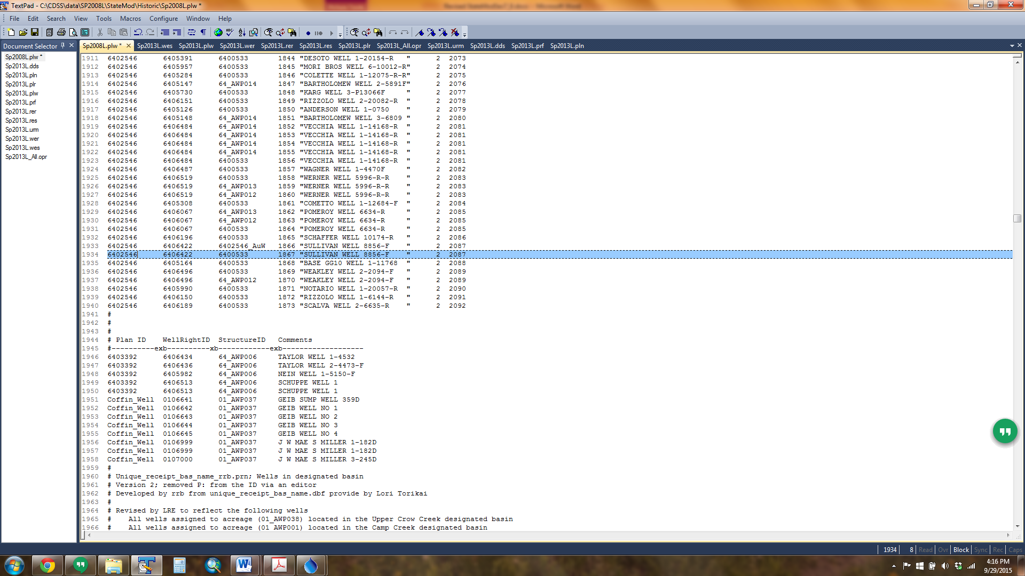

1. In the operating rule (*.opr) file, include an In-Priority Supply Operating Rule (Type 43) to define the priority date of the augmentation plan indicating when depletions to the river would not need to be augmented. StateMod uses the priorities of the individual wells from the well rights (*wer) file to determine if any depletions that occur in the same time step are in or out of priority. If in-priority, the augmentation requirement is reduced to reflect the in-priority depletion. Due to the number of wells typically included in a model, it is impractical to analyze each individual well priority to determine if future depletions are in or out of priority, therefore a common priority associated with the Type 43 operating rule is used.
   1. In some instances, the augmentation plan decrees include a specific priority at which the depletions do not have to be augmented. If so, use this date as the priority of the Type 43 rule.
   2. If no date is provided in the decree, calculate a decree-weighted average priority for the wells associated with the well augmentation plan.
2. Review the plan summary (*.xpl) file for information on the total augmentation requirement (plan demand) based on the lagged depletions and accretions, and the portion of the augmentation requirement that impacted the river when the well rights or augmentation plan was in-priority. The remainder of the augmentation plan should be offset using one or more of the supplies discussed below, however it is up to the user to ensure the full augmentation requirement is offset.

### 7.10.2 Canal Loss (Seepage) as an Augmentation Supply

StateMod allows canal loss (seepage) to be used as an augmentation plan supply and estimates the amount of this supply based on the amount of water carried to a demand, the efficiency of the canal, and the location and timing the canal loss (seepage) accrues to the river. The lagged canal loss is stored in a specific recharge plan and can then be “released from” (accounted at) the plan as a supply to offset an augmentation requirement. Canal loss used as an augmentation supply must be designated by an operating rule and therefore requires a carrier structure that diverts to meet a separate demand. Canal loss experienced by a diversion structure diverted based only on a diversion right cannot be stored in a recharge plan. As canal loss is reaching the river regardless if there is an augmentation requirement, the recharge plan only accounts for the loss as a supply in the given time-step the lagged canal loss accrues to the river and the plan does not need to be “spilled”.

1. Open the network (*.net) in StateDMI, navigate to the appropriate location, and right-click to *Add an Upstream Location*. Enter the appropriate location and structure information and designate the structure type as a plan.
   1. It is recommended the plan ID reflect the augmentation plan ID it will supply along with a suffix indicating it will store canal loss (e.g. _PlC for the *Pl*an *C*anal).
2. Recreate the river network file (*.rin) to reflect the additional structure.
3. In the plan file (*.pln), include the canal loss recharge plan as a Type 8 Plan and include the appropriate parameter information. See Section 4 for more discussion on the information in and format of this file.
4. Using a text editor, create the plan return (*.prf) file which includes return flow data used to route the canal loss back to the river. See Section 4 for more discussion on the information in and format of this file.
   1. The return flow location and patterns in the plan return (*prf) file should be similar to the return flow information for the carrier structure in the diversion station (*.dds) file.
   2. Canal loss from the recharge plan may be routed to any number of stream locations using any number of unit response functions, however the unit response functions must be included in the delay table (*.dly or *.urm) file.
5. In the operating rule (*.opr) file, include a Carrier with Transit Loss (Type 45) operating rule from the carrier to the demand including the canal loss recharge plan in the rule (creuse field). The second line of the Type 45 operating rule indicates the percent of canal loss.
   1. Note that in many cases, only the canal loss associated with specific water rights can be used as an augmentation supply. Include the canal loss recharge plan only with operating rules carrying water rights with their canal loss decreed as an augmentation supply.
   2. Consider including a Release Limit Plan in the operating rule to limit the overall total of all recharge supplies, including canal loss recharge.
6. In the operating rule (*.opr) file, include a Plan/Reservoir Reuse to Plan by Direct or Exchange (Type 48 and 49) operating rule in order to apply the water stored in the canal loss recharge plan to offset augmentation requirement.
   1. Note that the water stored in the plan is the lagged accretions to the river and will offset the lagged depletions in the augmentation plan in the same time step, if any.
   2. The source in this rule is the canal loss recharge plan and the destination is the augmentation plan.
   3. If no Type 48 or 49 rule is included, the canal loss will return to the system but is not considered as an augmentation supply, therefore a Plan Spill (Type 29) operating rule is not needed.
7. Review the plan summary (*.xpl) file for information on the total canal loss recharge plan supply and the portion of the augmentation requirement that was offset by the supply.

*Example Plan Return (*.prf) File*

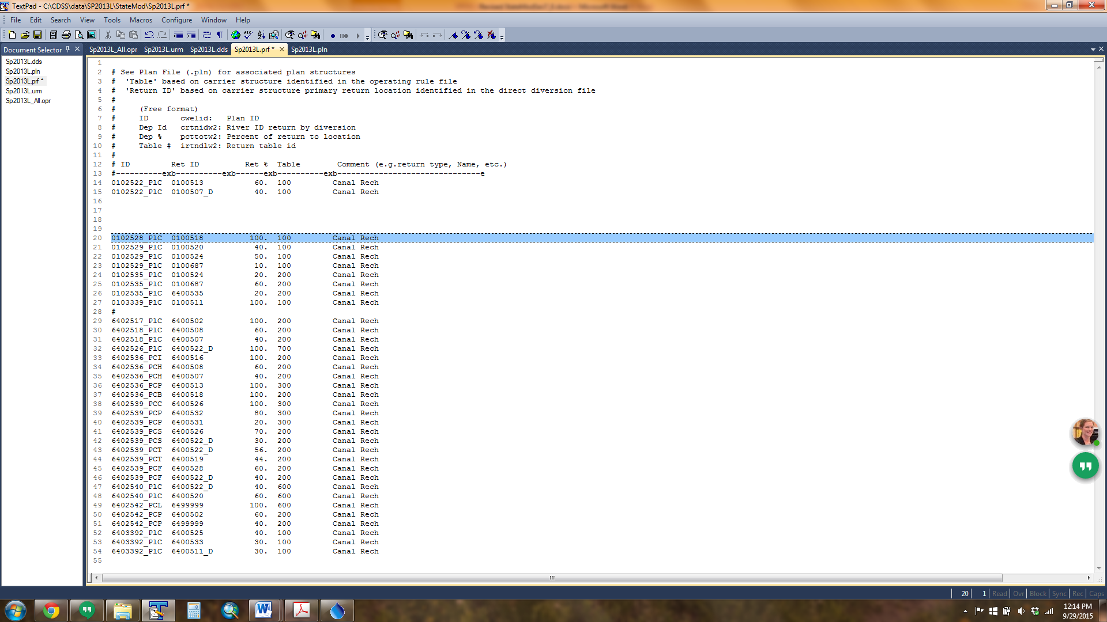

*Example Operating Rule (*.opr) File*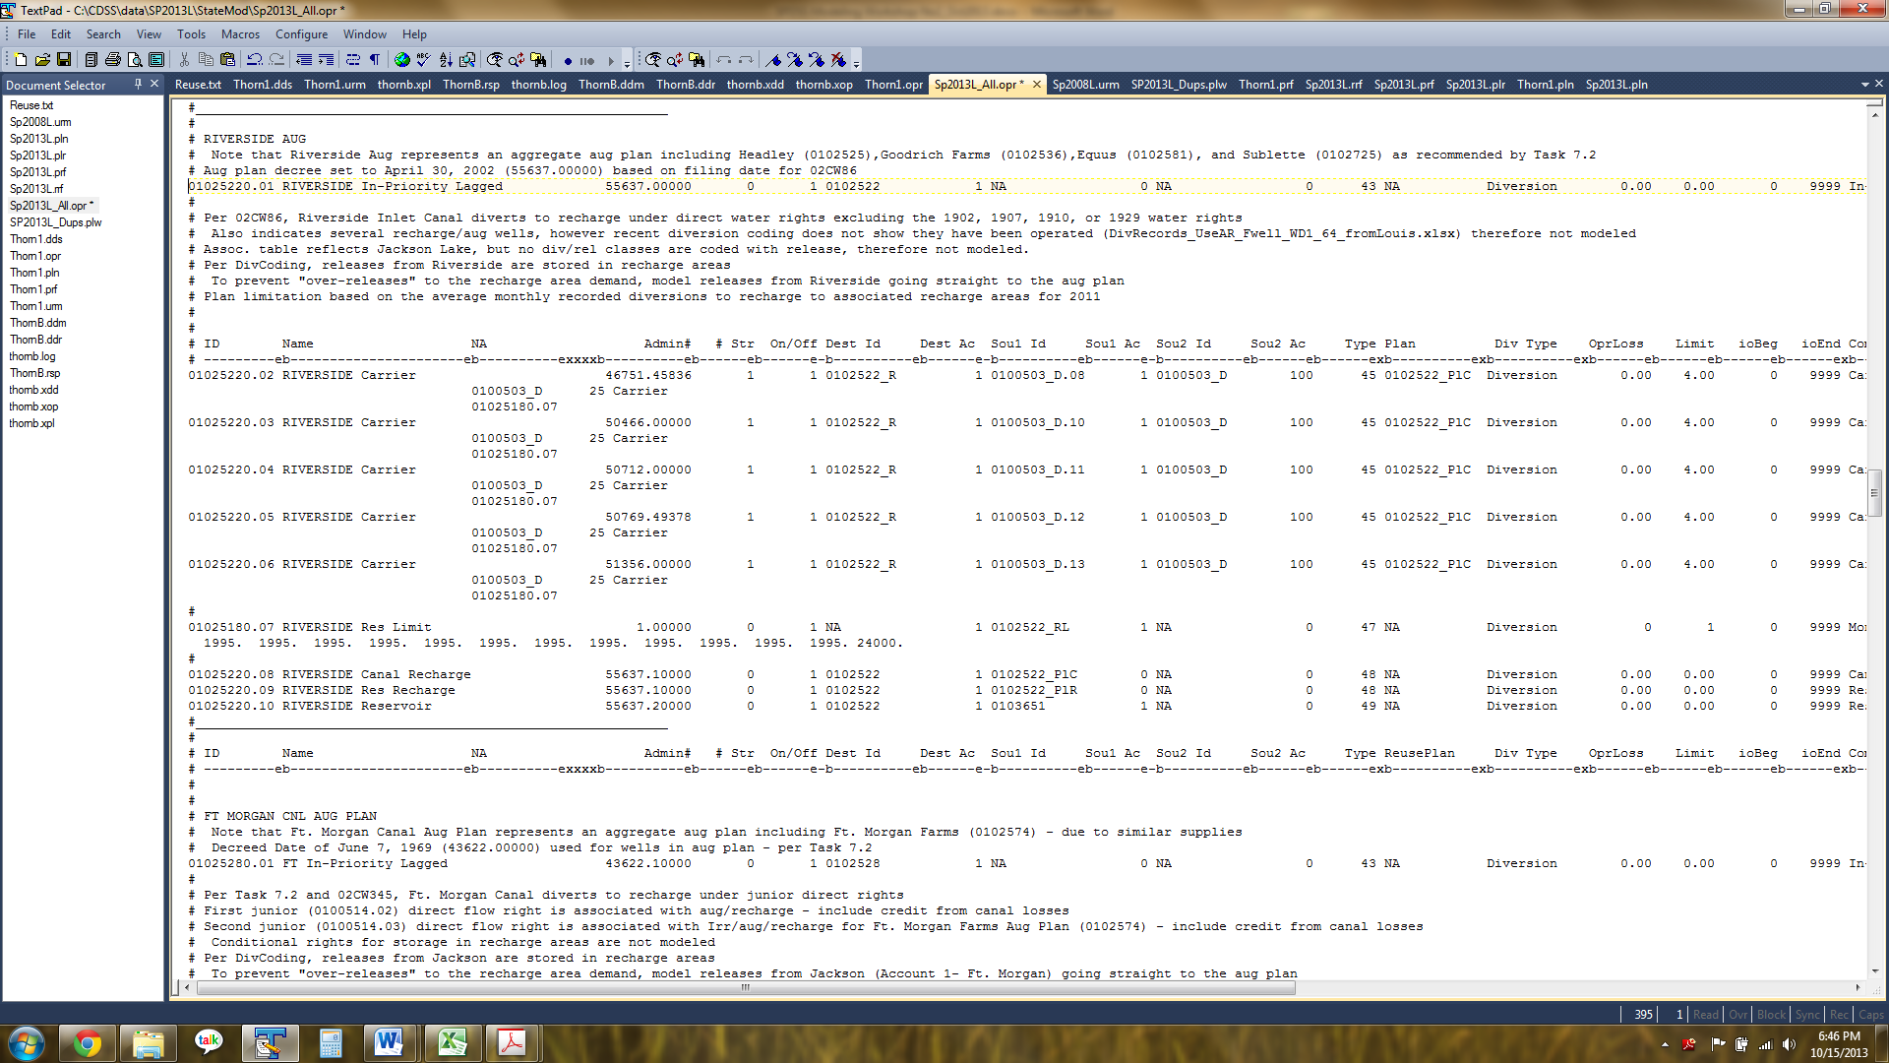

### 7.10.3 Reservoir Recharge (Seepage) as an Augmentation Supply

StateMod allows reservoir recharge (seepage) to be used as an augmentation plan supply and estimates the amount of this supply based on the amount of water carried to the reservoir/recharge area, the efficiency of the carrier, the seepage rate assigned to the reservoir/recharge area, and the location and timing the reservoir recharge (seepage) accrues to the river. The reservoir recharge is stored in a specific recharge plan and can then be “released from” (accounted at) the plan as a supply to offset an augmentation requirement. As reservoir recharge is reaching the river regardless if there is an augmentation requirement, the recharge plan only accounts for the loss as a supply in the given time-step the lagged reservoir recharge accrues to the river and the plan does not need to be “spilled”.

Representing reservoir recharge as an augmentation supply requires the inclusion of both a recharge plan and the reservoir recharge area. Recharge areas are included in the model as reservoirs, and as such, require content information to be included in the reservoir target (*.tam) file. As most recharge areas are designed to seep their entire contents, the end-of-month contents of the recharge area is often zero and the target does not serve as a limitation to the amount of water carried to the reservoir. The user may consider implementing a release limit plan on diversions to the recharge area to prevent the recharge area from “over-recharging” therefore simulate operations closer to the historical conditions.

Augmentation plans that have reservoir recharge as a supply generally have several recharge areas associated with the plan. The user may consider aggregating the recharge areas into a single modeled recharge area for the plan, or aggregate the recharge areas by return flow timing (e.g. aggregate those with a longer accretion pattern separate from those with a shorter accretion pattern).

1. Open the network (*.net) in StateDMI, navigate to the appropriate location, and right-click to Add an Upstream Location. Enter the appropriate location and structure information and designate the structure type as a reservoir.
   1. Recharge areas are assigned WDID’s in HydroBase; use this as the model ID if representing the recharge area explicitly. If aggregating recharge areas, it is recommended the reservoir ID reflect the augmentation plan ID it will supply along with a suffix indicating it is a recharge area (e.g. _R).
2. While in the network (*.net) in StateDMI, navigate to the appropriate location, and right-click to Add an Upstream Location. Enter the appropriate location and structure information and designate the structure type as a plan.
   1. It is recommended the recharge plan ID reflect the augmentation plan ID it will supply along with a suffix indicating it will store reservoir recharge (e.g. _PlR).
3. Recreate the river network file (*.rin) to reflect the additional structure.
4. Add the recharge area to the reservoir station file (*.res) using the StateDMI commands:
   1. Set the total capacity of the reservoir in AF.
   2. Set individual accounts (e.g. users in the reservoirs if recharge aggregate serves more than one augmentation plan), their respective capacities, and their starting volumes.
   3. Set the net evaporation station; must reference the evaporation station provided in the evaporation file (*.eva).
   4. Set the area/capacity/seepage table; the seepage information is included as acre-feet of seepage in each time step per volume of the reservoir. For example, if a 500 acre-foot recharge area can seep half of its contents in one month, the seepage for the 500 acre-foot volume would be 250 acre-feet.
5. Add water rights to the reservoir right file (*.rer) using the StateDMI commands:
   1. Recharge operations are generally operated based on a direct recharge right, however a reservoir right is still needed for use in the plan recharge (*plr) file.
   2. Set the water right ID as the structure ID with a numeric suffix for each right.
   3. Set the water right priority (administration number) and amount in AF.
   4. Set the accounts that can be filled with the water rights and whether it is a first-fill or refill right.
6. Add the structure’s demand to the reservoir target file (*.tam) using the TSTool commands.
   1. Set the monthly reservoir minimum and maximum targets (generally zero and the reservoir capacity) or read in an external StateMod formatted file (*.stm) with the capacity target in AF. See comments at the beginning of this section regarding issues with recharge areas reaching their target demands.
7. In the plan file (*.pln), include the recharge plan as a Type 8 Plan and include the appropriate parameter information. See Section 4 for more discussion on the information in and format of this file.
8. Using a text editor, create the plan recharge (*.plr) file which ties the recharge areas and their rights to a recharge plan ID. Note that recharge areas can be associated with more than one recharge plan. See Section 4 for more discussion on the information in and format of this file.
9. Using a text editor, create the reservoir return (*.rrf) file which includes return flow data used to route the reservoir recharge back to the river. See Section 4 for more discussion on the information in and format of this file.
   1. Reservoir recharge may be routed to any number of stream locations using any number of unit response functions, however the unit response functions must be included in the delay table (*.dly or *.urm) file.
10. In the operating rule (*.opr) file, include a Carrier with Transit Loss (Type 45) operating rule from the carrier to the recharge area, and if appropriate, include the canal loss recharge plan in the rule (creuse field). The second line of the Type 45 operating rule indicates the percent of canal loss.
    1. Note that recharge areas are generally located off-channel and therefore need operating rules that carry recharge water to them.
    2. In many cases, the recharge areas are filled under a direct diversion right decreed for recharge, which allow for credit to be taken on the canal loss associated with the diversions to the recharge area. Therefore the source of the Type 45 operating rule is the direct recharge right and the destination is the recharge area.
    3. Consider including a Release Limit Plan in the operating rule to limit the total overall supplies, including the amount carried to the recharge area each time step.
11. In the operating rule (*.opr) file, include a Plan/Reservoir Reuse to Plan by Direct or Exchange (Type 48 and 49) operating rule in order to apply the water stored in the recharge plan to offset augmentation requirement.
    1. Note that the water stored in the plan is the lagged accretions to the river and will offset the lagged depletions in the augmentation plan in the same time step, if any.
    2. The source in this rule is the recharge plan and the destination is the augmentation plan.
    3. If no Type 48 or 49 rule is included, the reservoir recharge will return to the system but is not considered as an augmentation supply, therefore a Plan Spill (Type 29) operating rule is not needed.
12. Review the plan summary (*.xpl) file for information on the total recharge plan supply and the portion of the augmentation requirement that was offset by the supply.
13. Review the reservoir summary output (*.xre) file for output information on the recharge area, including the total supply, evaporation, and the seepage rate.

*Example Plan Recharge (*.plr) File*

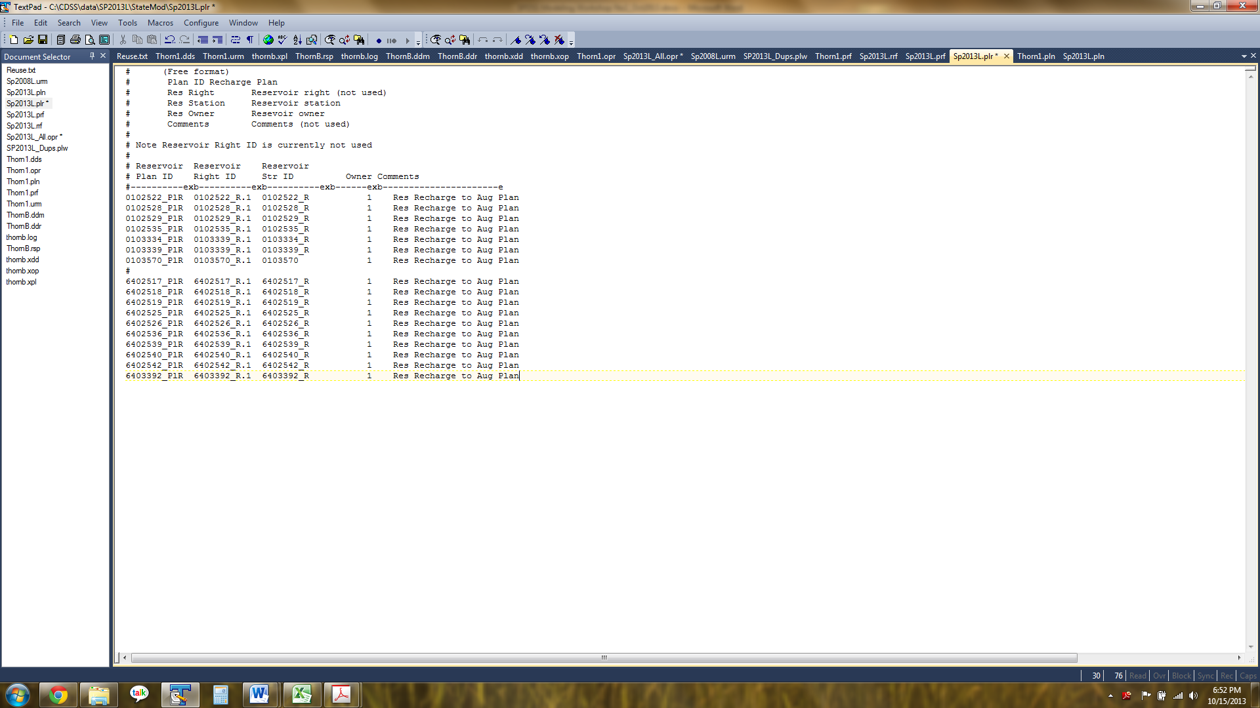

*Example Reservoir Recharge (*.rrf) File*

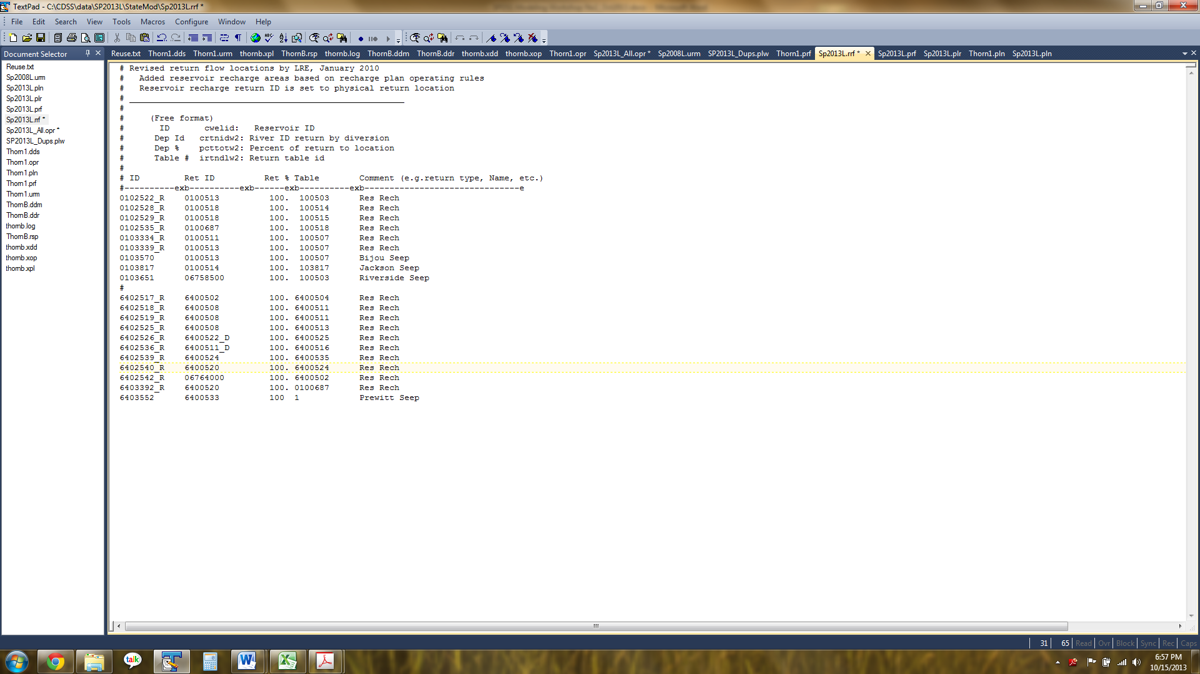

*Example Operating Rule (*.opr) File*

### 7.10.4 Augmentation or Recharge Well Pumping as an Augmentation Supply

StateMod has the ability to pump either a recharge or augmentation well to meet an outstanding augmentation requirement. Due to the pumping costs associate with this supply and the fact that the pumping itself can result in an increased augmentation demand, these supplies are generally used only when other supplies are not available. These wells are generally not exclusively used for augmentation and/or recharge, but also pump to meet irrigation demands.

An augmentation well is generally located farther away from the river (i.e. its depletions generally have a longer depletion pattern) but its pumped water is conveyed directly to the river to offset an augmentation requirement. The augmentation well depletions are generally covered by the same augmentation plan (as tied in the well augmentation plan data (*.plw) file) that the pumping is used to offset, however the future depletions are traded for immediate augmentation supply.

A recharge well is generally located closer to the river (i.e. a short depletion pattern) and pumps water to a recharge area with a longer depletion pattern where it seeps back to the river to offset a future augmentation requirement. StateMod only allows the recharge well to pump when it’s in priority, therefore it does not create an augmentation requirement.

Both types of wells can be modeled in StateMod either as explicit well structures or as a group of wells aggregated under a single well structure. As augmentation plans can add or remove augmentation and recharge wells from their plans, the aggregate well structure approach is discussed herein. This approach allows a single file and operating rule to be changed as wells are added or removed, and limits the need to update the network and all well input files.

1. Open the network (*.net) in StateDMI, navigate to the appropriate location, and right-click to *Add an Upstream Location*. Enter the appropriate location and structure information and designate the structure type as a well structure.
   1. It is recommended the well structure ID reflect the augmentation plan ID the wells will supply and a suffix indicating the type of wells they are (e.g. _ReW or _AuW).
2. Recreate the river network file (*.rin) to reflect the additional structure.
3. Add the well structure to the well station (*.wes) file using the StateDMI commands:
   1. Set the total well capacity in CFS.
   2. Set the well system efficiency as 0 percent (100 percent returns to either the recharge area or to a river location).
   3. Set the demand and use types (see Section 4 for more discussion).
   4. Set the depletion and return flow locations and patterns; must reference the delay patterns provided in the delay file (*.dly or *.urm).
      1. Recharge wells generally deplete the river in the same time step and pump to the recharge area in the same time step.
      2. Augmentation wells generally deplete the river with a lagged pattern and pump to the river in the same time step.
4. Add the well structure to well right (*.wer) file using the StateDMI commands:
   1. Use HydroBase to pull well rights for each well or set each well water right; in both situations, tie each water right to the ground water only structure ID.
   2. Set the water right priority (administration number) and amount in CFS.
   3. Review options to determine if a “turn-on” date is appropriate; note that a “turn-off” date has not been implemented and once a well is turned on, it is available to pump for the remainder of the model period.
5. Add the well structure with a zero demand to the well demand file (*.wem) using the TSTool commands. Well pumping will occur based on the augmentation requirement of the augmentation plan.
6. In the operating rule (*.opr) file, include an Augmentation Well (Type 44) operating rule associating the augmentation well structure to the augmentation plan.
   1. The source is the well right ID and the destination is the augmentation plan.
   2. The operating rule generally reflects a junior priority relative to other augmentation supplies.
   3. If appropriate, include the augmentation plan in the operating rule in which the augmentation well depletions will be stored.
7. In the operating rule (*.opr) file, include a Recharge Well (Type 37) operating rule associating the recharge well structure to the recharge area.
   1. The source is the well right ID and the destination is the recharge area.
   2. The operating rule must reflect the priority of the well right used for the recharge operations.
8. Review the plan summary (*.xpl) file for information on the portion of the augmentation requirement that was offset by the recharge or augmentation well supply and the well summary (*.xwe) file for output information on the well structures.

### 7.10.5 Direct Reservoir Release as an Augmentation Supply

StateMod allows augmentation requirements to be met by reservoir releases either directly or via exchange. This operation generally occurs when a portion of the reservoir water right is decreed for augmentation, among other uses, and the reservoir can release to meet remaining augmentation requirements. The approach below assumes the reservoir is already included in the model; see the “Add a Reservoir” section for more information on adding a reservoir to the model.

1. In the operating rule (*.opr) file, include a Plan/Reservoir Reuse to Plan by Direct or Exchange (Type 48 and 49) operating rule in order to release water from a reservoir to offset an augmentation requirement.
   1. The source in this rule is the reservoir and the destination is the augmentation plan; use more than one operating rule to release from more than one account.
2. Review the plan summary (*.xpl) file, operating rule summary (*.xop), and reservoir summary (*.xre) file for the release amount used to offset the augmentation requirement.

### 7.10.6 Special Well Augmentation Plans

A Plan Type 10 - Special Well Augmentation Plan is used to track the depletions associated with a well that is not required to be augmented. Examples include pumping in a designated basin or pumping by a well which has been decreed to be non-tributary (i.e. “coffin wells”). A special augmentation plan is typically used to demonstrate that every well in the model is assigned to an augmentation plan even if some wells are not required to augment their depletions. The plan demand, or the difference between the depletions to the river and the accretions from any return flows, is generated during model simulation. Unlike the Augmentation Plan, the Special Well Augmentation Plan is used for accounting only, and no supplies are modeled to “meet” the plan demand.

1. Open the network (*.net) in StateDMI, navigate to the appropriate location, and right-click to *Add an Upstream Location*. Enter the appropriate location and structure information and designate the structure type as a plan.
   1. Note that the special augmentation plan generally accounts for depletions from multiple wells, therefore the plan should be included at a location on the river where a majority of the depletions impact the river.
2. Recreate the river network file (*.rin) to reflect the additional structure.
3. In the plan file (*.pln), include the well augmentation plan as a Type 10 Plan and include the appropriate parameter information. See Section 4 for more discussion on the information in and format of this file.
4. Using a text editor, create the well augmentation plan data (*.plw) file to associate individual wells to a special well augmentation plan. See Section 4 for more discussion on the information in and format of this file.
   1. HydroBase contains the source (e.g. designated basin, non-tributary aquifers) for wells which provide information on which wells would not need to be augmented, however there is not a command driven approach available in current versions of the data management interfaces to query for the information and tie that information to the special well augmentation plan.

*Example Well Augmentation Plan Data (*.plw) File*



1. In the operating rule (*.opr) file, include a Plan/Reservoir Reuse to Plan by Direct (Type 48) operating rule to indicate to the model that a physical water supply is not required for these wells because well location (e.g. designated basin) or an administrative decision.
   1. The Special Well Augmentation Plan is used as the source and the destination in the operating rule.
   2. The priority is generally set to the most junior in the model but it does not impact other operations.
   3. The user may or may not include an In-Priority Supply Operating Rule (Type 43) with a specific priority to determine what portion of the depletions would not need to be augmented if the depletions were brought into the priority system.
2. Review the plan summary (*.xpl) file for information on the total lagged depletions (plan demand) associated with the special well augmentation plan.

## 7.11 How to Model Changed Water Rights and Return Flow Obligations

Changed water rights, or water transfers, are represented in StateMod by “temporarily” diverting and storing the water right into a Changed Water Right Plan when in priority, then releasing the water from the plan to meet a demand at a priority determined by the user, often junior to the original right. Water diverted into the Changed Water Right Plan to temporarily store a diversion may or may not be used depending on other water supplies and/or operations. The correct implementation of a Changed Water Right plan and associated operating rules will account for:

* Administration of the changed water right at the correct location and at the correct priority
* Sharing shortages between all users, including any un-changed portion of the water right
* Use of the changed water right at priority different to the water right and relative to other operations in the model
* Capacity limitations of the existing headgate
* Decreed monthly and annual volumetrics and/or associated terms and conditions
* Availability of any unused changed water rights to other users in the system

The following schematic provides an example of Changed Water Rights operations; the plan structures and operating rules used to represent these operations are discussed in more detail below.

Figure 9: Changed Water Rights Example Operations

Release to Reservoir

Release to Muni Demand

Release to meet T&C

Release to Muni Demand

Release Excess to Irrigators

Spill Back to River

% to Changed User

No. 1 Changed WR Plan

% to Changed User

No. 2 Changed WR Plan

% Changed to Full Changed WR Plan

% Un-Changed to Headgate Demand

DDR Water Right(s)

### 7.11.1 Changed Water Right Plan Structure

A Plan Type 13 – Changed Water Right Plan structure is used to temporarily divert and store a water right that has been changed for uses other than its historical use. This commonly occurs when water users purchase a portion of a senior water right historically used for irrigation, change the use in Water Court, and then use the changed water rights for other uses such as municipal, industrial, or augmentation. If the changed water right is to be divided among more than one user, as shown in the example schematic above, then an overall plan is needed to store the total changed portion, and individual plans are needed for each user for a total of three plans. If more than one water right is changed at the same source location, they can be put into the same overall plan *only if* all the water rights can be split to individual user plans using the same percentages and if the terms and conditions applied when the plans release the water to the end uses are the same.

As the changed water right plan operations are all accounted for at the source water right headgate (administrative) location, all the plans must be modeled off-channel on a “mock” tributary so they do not affect exchange potential or other operations on the mainstem. Note that the changed water rights are only available for use in the same time step they are diverted and must be “spilled” back to the river if they are not used.

The user should keep in mind that the changed water rights plan “demand” is the portion of the water that is changed; regardless if there is a final demand for the changed water when the water is released. For example, if 100 cfs is available under the full water right, and 50 percent of the ditch has been changed, then 50 cfs will be stored in the plan structure and the remaining 50 cfs will go towards meeting the headgate demand. Even if the 50 cfs that was stored in the plan is not used and is ultimately spilled back to the river, and the headgate demand is unmet, the spilled water will *not* go to meet the headgate demand. If the changed water can be used to meet the headgate demand, it is recommended the user set up a separate operating rule to release from the changed water rights plan to the headgate demand. Additionally, if there is no headgate demand, then all of the water right must be put into the plan.

The operating rule used to temporarily store water in the changed water rights plan (Type 26) does not limit the changed water by the capacity of the source water right location; this limitation is performed when the water is released from the plan. This ensures that capacity is not “used” with water that was only temporarily stored, and may not be ultimately used to meet demand. Similar logic can be applied to implementing Terms and Conditions associated with the historical use of the water, generally outlined in the change of use decree. The Terms and Conditions operations, which ultimately generate a plan demand, should be based only on the water that is actually released and used to meet a demand, not based on the water stored in the plan. Therefore it is recommended the user include Terms and Conditions in the plan release operations. See the following Releases from a Changed Water Right Plan section for more information on limiting the changed water right by the source diversion structure’s capacity and implementing Terms and Conditions.

1. Open the network (*.net) in StateDMI, navigate to the source water right headgate, and right-click to *Add an Upstream Location*. Create a new tributary, enter the appropriate structure information, and designate the structure type as a plan.
   1. If more than one changed water rights plan will be required to model the operations, as shown in the example schematic above, add the additional plan structures on the mock tributary in this step.
2. Recreate the river network file (*.rin) to reflect the additional structure.
3. In the plan file (*.pln), include the changed water right plan as a Type 13 Plan and include the appropriate parameter information. See Section 4 for more discussion on the information in and format of this file.
4. In the operating rule (*.opr) file, include a Changed Water Right Operating Rule (Type 26) to divert each water right into a changed water right plan.
   1. The source is the changed water right ID and the destination is the changed water right plan.
   2. Set the priority to be the same as the priority of the source water right in the diversion rights (*.ddr) file.
   3. Set the monthly and annual limitations; generally based on limits on the changed right by the decree.
   4. Set the percent of the water right that is changed and therefore stored in the plan. If the portion of the water right to be stored in the plan is not 100 percent, the remaining amount is used to meet any demand at the source water right headgate. The Type 26 turns off the water right so it cannot be used in other operating rules.
   5. The Type 26 operating rule operates only once per time step (i.e. does not re-operate).
5. If more than one changed water right plan is necessary, in the operating rule (*.opr) file, include a Multiple Plan Ownership Operating Rule (Type 46) to split the overall changed water right plan (as referenced as the destination in the Type 26 rule) into multiple owner’s plans.
   1. The split percentages to the individual users’ changed water rights plan must add up to 100 percent.
   2. Set the priority to be just junior to the Type 26 operating rule.

*See the following section for the recommended approach to release water from a changed water rights plan.*

1. In the operating rule (*.opr) file, include a Spill Plan Operating Rule (Type 29) for all changed water rights plans.
   1. The source is the changed water rights plan and the destination is the location associated with the source water right (e.g. spill back to the headgate).
   2. Set the priority to spill the plan junior to all release operating rules.
2. Review the plan summary (*.xpl) file, the operating rule summary (*.xop) file, and the diversion structure summary (*.xdd) file for information on the amount of changed water stored in the plan and the amount of water diverted to meet the headgate demand.
   1. When a changed water right (type 26) temporarily stores water in an administrative plan, the available flow in the system (Avail) and the water physically located at the source structure (River) is reduced. This makes the water temporarily stored by this operating rule unavailable for any junior water rights to divert. Because the amount diverted is considered temporary, no diversions are reported in the diversion structure summary (*.xdd) file at the source structure or destination plan unless water is released from the administrative plan as described below. Note, the total amount diverted, including any that may have been released for use or spilled, is reported in the operating rule summary (*.xop) file and the plan summary (*.xpl) file.

### 7.11.2 Releases from a Changed Water Right Plan

Once the changed water right is temporarily stored in a changed water rights plan, operating rules are used to release the water from the plan to meet a direct diversion demand, to store in a reservoir, to meet return flow obligations (e.g. Terms and Condition Plan requirement), or to offset an Augmentation Plan requirement. The user can release directly from the plan to a downstream user or via exchange using Direct Plan/Reservoir Release Operating Rule (Type 27) and the Exchange Plan/Release Operating Rule (Type 28). The functionality of these operating rules has been modified specifically for the use with changed water rights plans and should be used to simulate releases from the plan.

These operating rules allow for the following options when releasing from the plan:

* Limit the release from the plan by the source water right diversion capacity
* Limit the release based on a release limit plan (Plan Type 12)
* Limit the release based on the amount diverted via another operating rule
* Impose Terms and Conditions based on the released water
* Include a Reuse Plan to track reusable supplies associated with the changed water

1. In the operating rule (*.opr) file, include a Direct Plan/Reservoir Release Operating Rule (Type 27) or the Exchange Plan/Release Operating Rule (Type 28), depending on the location of the destination, to release water from the changed water right plan to a demand.
   1. The source is the changed water right plan and the destination is the demand.
   2. Set the priority relative to the priorities of other water sources available to the demand (e.g. release from the plan to a demand after more junior supplies are used).
   3. Include carriers or monthly switches if necessary.
   4. Include a reuse plan if applicable; see the How to Model Reusable Supplies section for more information.
   5. Use the operating limit flags (OprLimit), as described in Section 4.13.27 and 4.13.28, to limit the release amount to either a release limit plan or to the amount diverted via another operating rule.
      1. OprLimit = 5 ties the release from the plan (or sub-plan if it has been split using a Type 46 operating rule) to the source water right diversion structure and allows the model to limit the release based on available capacity at the source structure. Include the Type 26 operating rule ID that diverted the water into the changed water right plan.
      2. OprLimit = 2 or 7 limits the release from the changed water rights plan to the release limit plan. Include the Type 47 operating rule ID that defined the monthly and annual release limitations. If more than one release operating rule refers to the release limit plan, the total released from those rules will be limited to the release limit plan.
      3. OprLimit = 3 or 8 limits the release from the changed water rights plan to the amount diverted and/or carried via another operating rule. Include the operating rule ID of the diversion or carrier operating rule; generally a Type 11 carrier rule. If more than one release operating rule refers to the carrier rule, each individual release rule will be limited by the amount carried (i.e. cumulative releases will *not* be limited).
      4. OprLimit = 4 or 9 incorporates the limitations from all the limits above. Include the Type 26 operating rule ID, the Type 47 operating rule ID, and the carrier rule ID to apply all three limits.
   6. Include a Terms and Conditions plan ID and indicate whether a standard, fixed, or mixed return flow pattern is used. If a standard pattern is used, include the return flow factors in the operating rule as well. See the following Terms and Conditions Operations section for more information on implementing these plans.
2. Review the plan summary (*.xpl) file, the operating rule summary (*.xop) file, and the diversion structure summary (*.xdd) file for information on the releases from the changed water right plan.
   1. When water diverted from a Changed Water Right Plan for direct use by a Type 27/28 rule the diversion structure summary (*.xdd) files reports this release as:
      1. at the source, the water release to the destination is reported as Carried, Exchanged or Bypassed and,
      2. at the destination, the water diverted is reported as From River by Other.

### 7.11.3 Terms and Conditions Operations

“Terms and Conditions” is language used to collectively represent the return flow obligations associated with the transfer or change of water right. They generally represent the amount, timing, and location of non-consumed water returned to the river from the historical use of the changed water right. StateMod generates these return flow obligations during simulation based on the amount of changed water used to meet a demand, the consumptive use (CU) factors, and the unit response function. The Terms and Condition (T&C) plan stores the return flow obligations (plan demand) for current and future time steps. The obligations can be “offset” by a number of supplies, including changed water rights, reusable supplies, and/or reservoir releases. Note that StateMod only accounts for the return flow obligation and supplies used to offset this plan demand; it does not limit the use of changed water rights if the supplies are insufficient to meet the full plan demand. The plan demand and supplies are reported in the plan summary (*xpl) file and it is up to the user to confirm, if appropriate, that the full return flow obligation is being offset.

There are three types of return flow patterns:

* **Standard Return Pattern** = (Data in the return flow (*.urm/*.dly) file) * (Released Water) * (1.0-CU Factor), where the CU Factor is provided in the operating rule that releases water from the Changed Water Rights Plan. This return flow pattern either reflects the “immediate summer” return flow obligations owed to the river in the same time step as the release of water occurs, or reflects reretun flow boligations strictly based on the original irrigation pattern.
* **Fixed Return Pattern** = (Data in the return flow (*.urm/*.dly) file) * (Released Water), whereby a “fixed” percentage of each month’s releases becomes the return flow obligation. Generally used to represent “winter return flows” obligated based on the total amount released or “used” during the summer.
* **Mixed Return Pattern** = Standard Return Pattern + Fixed Return Pattern

Additionally, StateMod allows the user to split the return flow obligation to different locations on the river. The following schematic provides an example of return flow obligations operations; the plan structures and operating rules used to represent these operations are discussed in more detail below.

Figure 10: Terms and Conditions Plan Example Operations

% Changed

Water Rights Plan

Type 27/28 Releases Generate Return Flow Obligations –

Standard and Fixed

Full T&C Plan

% to T&C Sub-Plan @ Location 1

% to T&C Sub-Plan @ Location 2

Release to Demands (Muni, T&C, Reservoir)

*Example T&C Return Pattern Information*

|  |  |  |  |  |  |
| --- | --- | --- | --- | --- | --- |
| Standard Return Pattern Data | | |  | **Fixed Return Pattern Data** | |
| *Month* | *CU Factor* | *Factor in OPR*  *(1-CU Factor)* |  | *Month* | *URM/DLY Factor* |
| April | 65% | 35% |  | November | 7.2% |
| May | 52% | 48% |  | December | 5.9% |
| June | 42% | 58% |  | January | 4.8% |
| July | 40% | 60% |  | February | 3.9% |
| August | 51% | 49% |  | March | 2.7% |
| September | 73% | 27% |  |  |  |
| October | 100% | 0% |  |  |  |

1. Open the network (*.net) in StateDMI, navigate to the appropriate location, and right-click to *Add an Upstream Location*. Enter the appropriate location and structure information and designate the structure type as a plan.
   1. The T&C plan should be located where the historical return flows generally accrued, or the location set in the decree. The return flow obligation will be administered at the location of the plan, therefore the location can impact how much of the plan demand is in-priority or what supplies are available to offset the demand.
2. Recreate the river network file (*.rin) to reflect the additional structure.
3. In the plan file (*.pln), include the well augmentation plan as a Type 1 Plan and include the appropriate parameter information. See Section 4 for more discussion on the information in and format of this file.

*Example Plan (.pln) File*

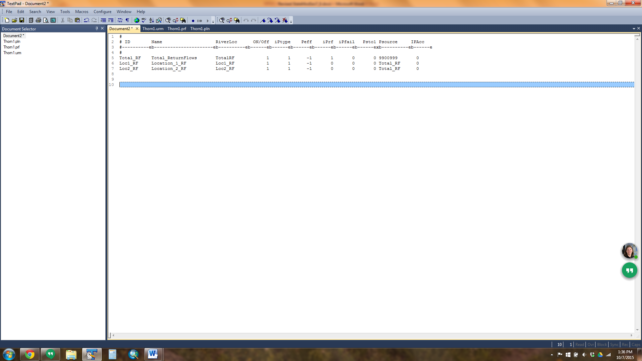

1. Using a text editor, create the plan return flow (*.prf) file to split the return flow obligations between plans and associate return flow patterns to each T&C plan. See Section 4 for more discussion on the information in and format of this file.
   1. The Plan ID reflects the full T&C Plan, the Return ID reflects the sub-plans, and the Ret % reflects the portion of obligations assigned to each sub-plan (T&C Location).
   2. Negative Ret % values indicate a fixed return flow pattern, and the Table field generally corresponds to a lagged pattern.
   3. Positive Ret % values indicate a standard return flow pattern, and the Table field generally corresponds to an “immediate” pattern (i.e. 100 percent returns in the first month).
   4. If a mixed pattern is used, an entry must be included for the standard and the fixed return flow patterns.
   5. In the example below, the full T&C plan is split 46/54 percent to two sub-plans (Loc1_RF and Loc2_RF). Each sub-plan has a standard and fixed return flow pattern; see below for discussion on the Table values for each.

*Example Plan Return (*.prf) File*

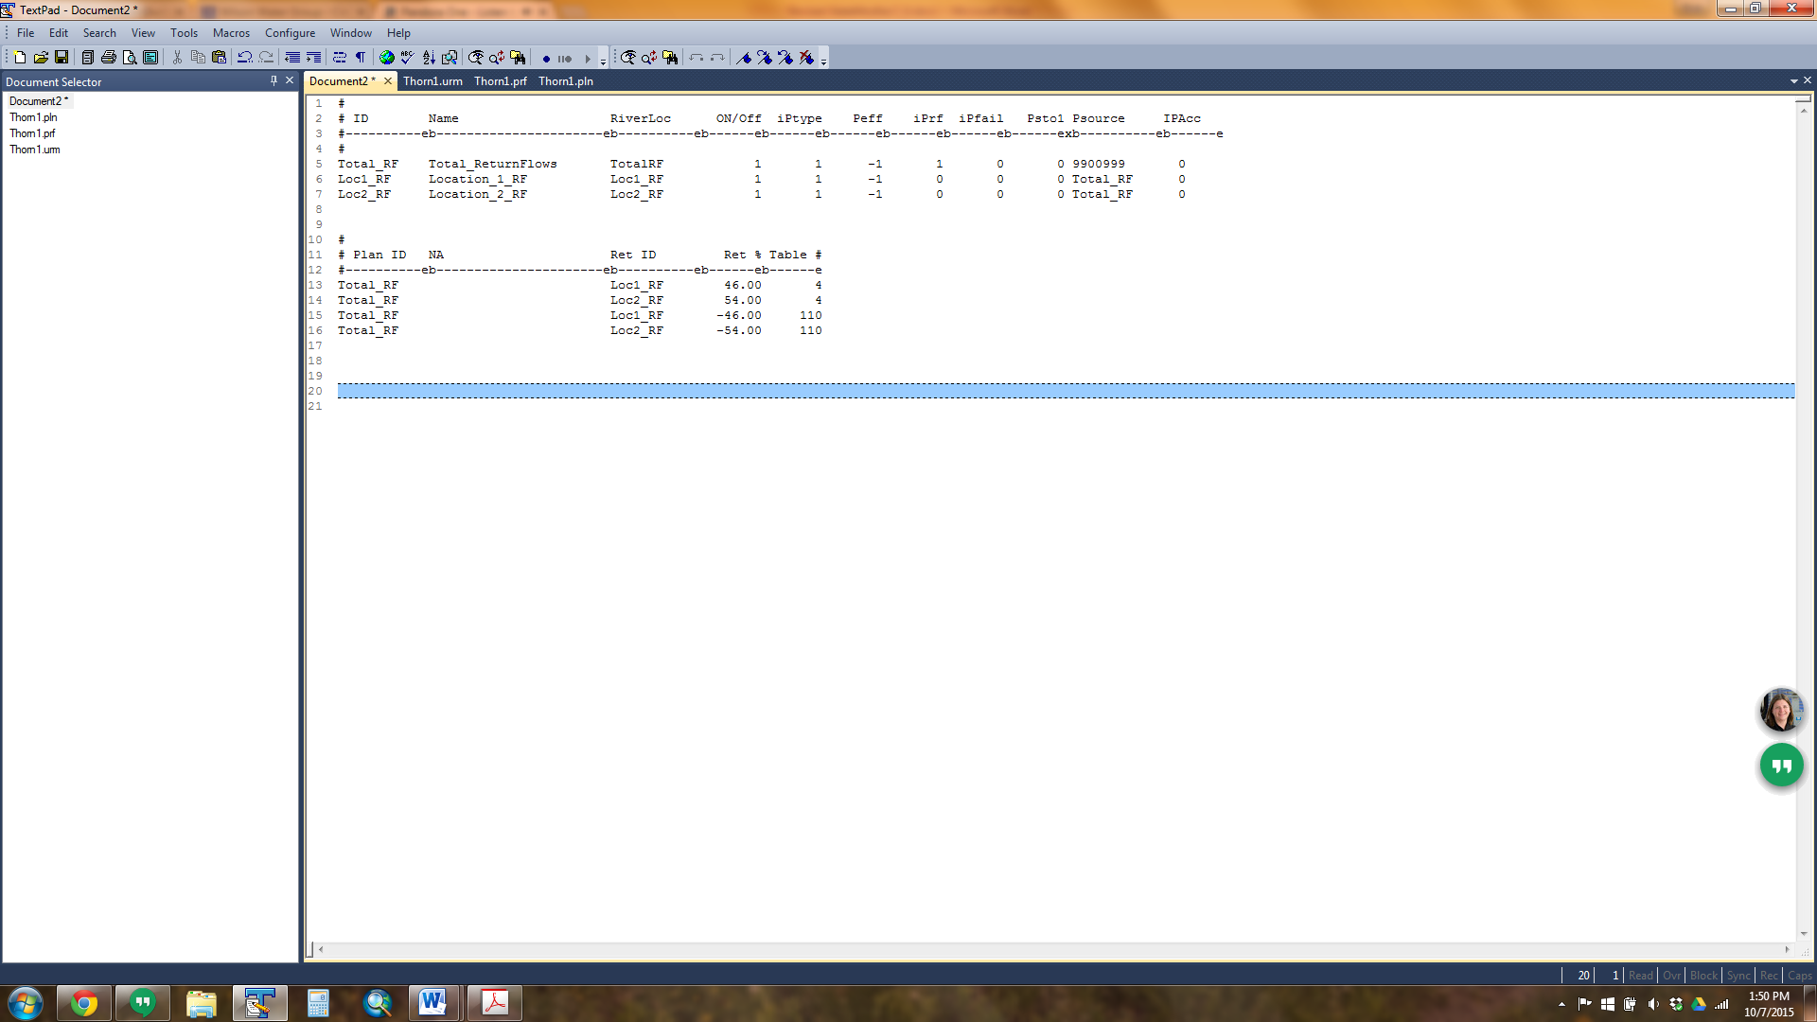

1. Using a text editor, update the return flow (*.urm/*.dly) file to include the immediate and lagged pattern associated with the standard and fixed return flow obligations, respectively. See Section 4 for more discussion on the information in and format of this file.
   1. The lagged return flows are generally decreed in the change of use decree.

*Return Flow File (*.urm/*.dly)*

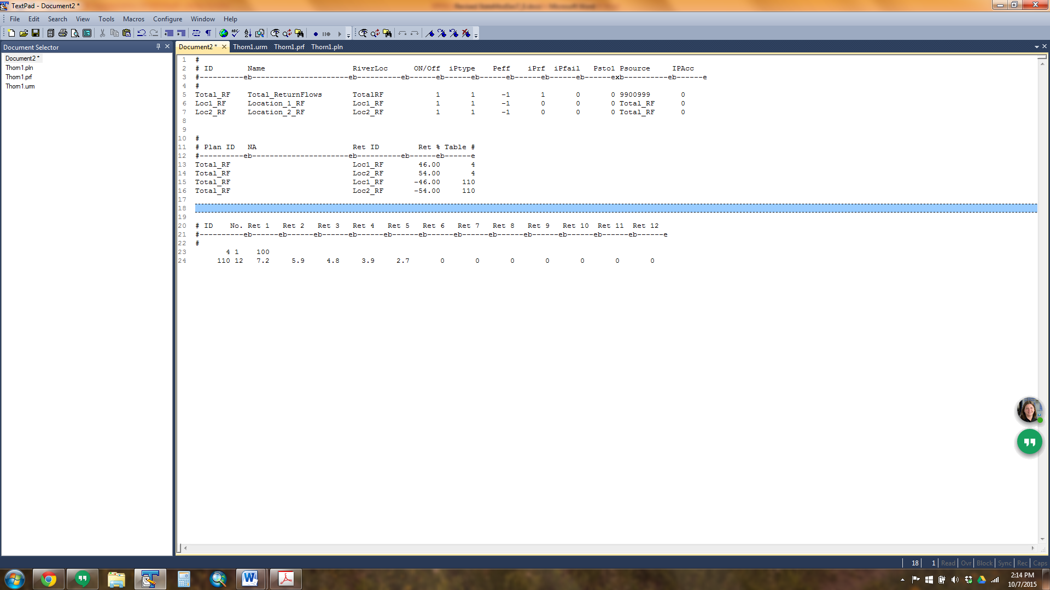

1. In the operating rule (*.opr) file, include a Direct Plan/Reservoir Release Operating Rule (Type 27) and the Exchange Plan/Release Operating Rule (Type 28), depending on the location of the destination, to release water from the changed water right plan to a demand.
   1. See the section *Releases from Changed Water Right Plan* for more information on the data included in these operating rules.
   2. Specific to the T&C plan, include the plan ID in the *ciopso(2)* field and include the CU Factors if a standard return flow pattern is being simulated.

*Operating Rule File (*.opr)*

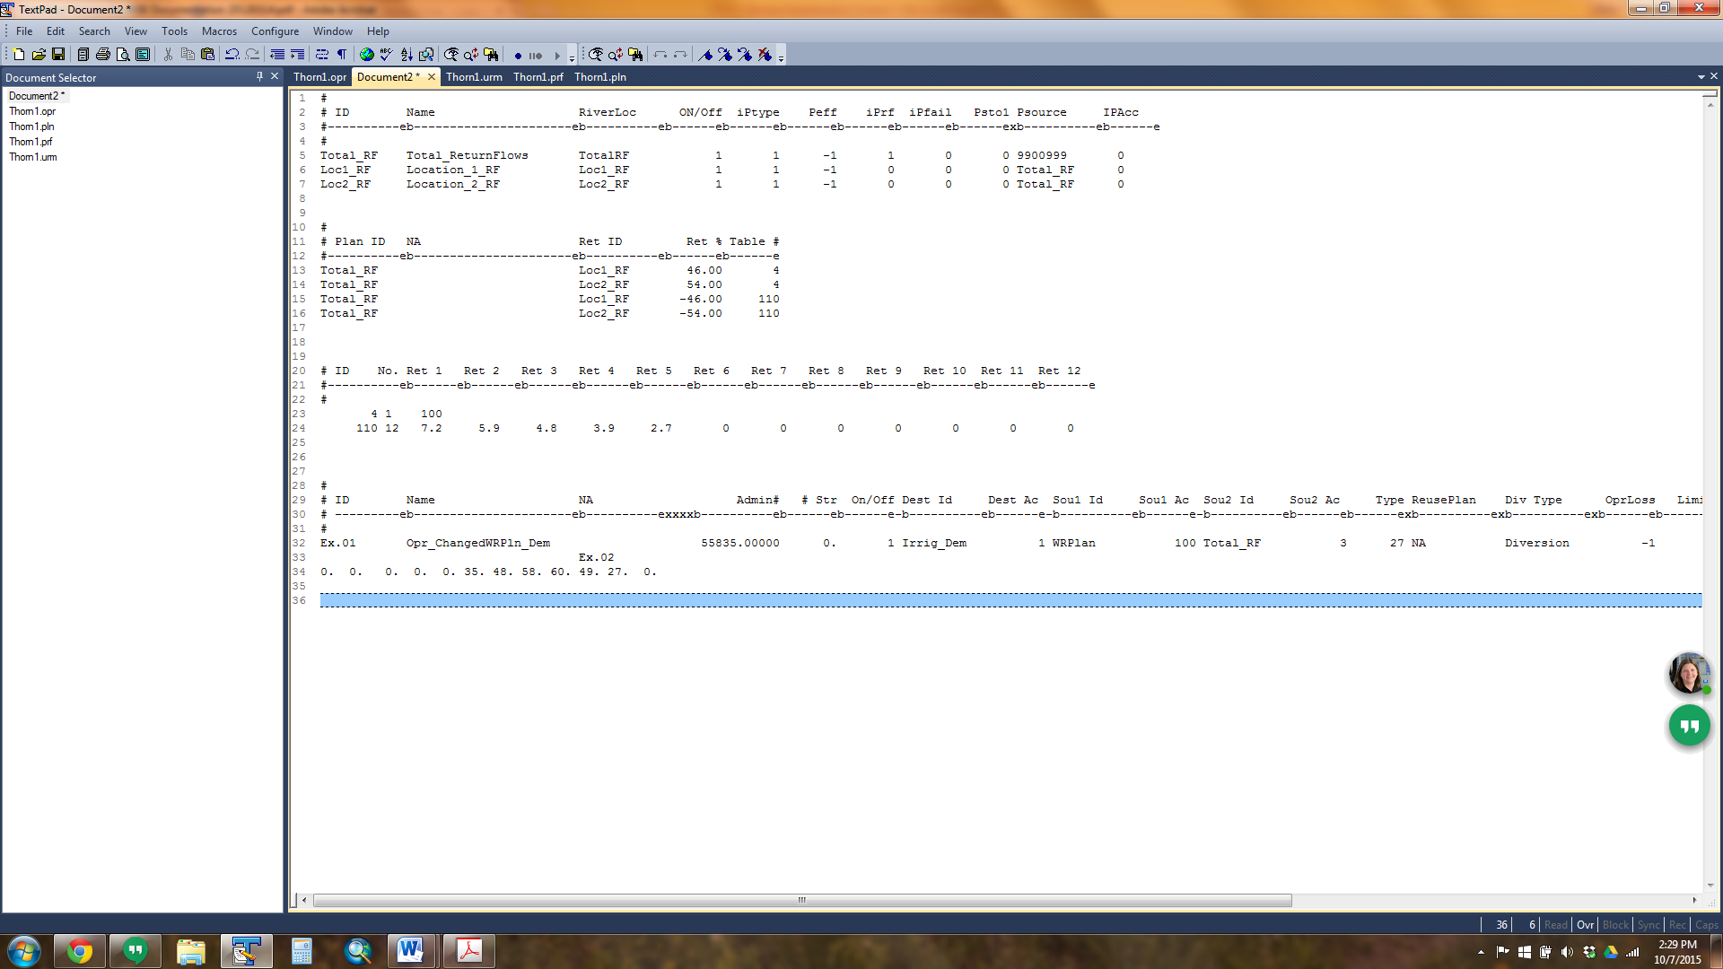

In this example, if the Type 27 operating rule carried 10 acre-feet (af) in May:

* The total standard return flow obligation would be 4.8 af (10 af * (1-52%)) in May
* The total fixed return flow obligation would be 0.72 af in November, 0.59 af in December, 0.48 af in January, 0.39 af in February, and 0.27 af in March.
* 46 percent of the total obligation would be owed to the river at Location 1 (Loc1_RF)
* 54 percent of the total obligation would be owed to the river at Location 2 (Loc2_RF)

Once a T&C Plan Return Flow Obligation is generated by the model, it is up to the user to offset these obligations in the time step and location they accrue to. If return flow obligations are not required to be offset after a specific priority, the user can use include a Type 43 operating rule to reduce the obligation based on that priority. There are many possible supplies to offset return flow obligations; in general, Type 27/28 and Type 48/49 operating rules are used to release supplies to meet a return flow obligation. The plan demand and supplies are reported in the plan summary (*xpl) file and it is up to the user to confirm, if appropriate, that the full return flow obligation is being offset.

### 7.11.4 Augmentation Station Modeling

StateMod has the ability to simulate an Augmentation Station, which is a structure that generally accounts for and returns a portion or all of a changed water right on a ditch directly to the river for subsequent re-diversion. These operations are recommended when the augmentation station is down ditch from the headgate (i.e. changed water isn’t available directly at the headgate location) and the changed water right may experience additional canal losses, or additional accounting (e.g. multiple users) at the specific augmentation station location is desired. Augmentation stations can be simulated in StateMod using a Direct Plan/Reservoir Release Operating Rule (Type 27) or Exchange Plan/Release Operating Rule (Type 28), depending on the location of the destination, to release water from a changed water right plan associated with the ditch where the augmentation station is located to a demand.

The following should be noted when including the Type 27/28 operating rules:

* It is recommended that an “Other” node be included in the network diagram to represent the physical location where the augmentation station returns to the river. Note that if the augmentation station has been assigned a WDID, it is recommended this be the “Other” node model ID.
* If the water measured at the augmentation station will meet an on-channel demand, such as a return flow obligation, augmentation requirement, or a municipal/industrial demand, then a minimum of two intervening structures need to be included in the operating rule.
  + The first intervening structure, designated as a *Carrier* structure type in the operating rule, is the structure ID associated with the changed water right so the release can be accounted for by the capacity. The *Carrier* structure can include a loss factor if appropriate.
  + The second intervening structure, designated as a *Return* structure in the operating rule, is the augmentation station ID to indicate where the water returns to the river. Note that losses cannot be designated with *Return* structure types.
  + The destination of the operating rule is the on-channel demand structure ID.
* If the water measured at the augmentation station will meet an off-channel demand, such as a reservoir or municipal/industrial demand, then a minimum of three intervening structures needs to be included in the operating rule.
  + The first intervening structure, designated as a *Carrier* structure type in the operating rule, is the structure ID associated with the changed water right so the release can be accounted for by the capacity. The *Carrier* structure can include a loss factor if appropriate.
  + The second intervening structure, designated as a *Return* structure in the operating rule, is the augmentation station ID to indicate where the water returns to the river. Note that losses cannot be designated with *Return* structure types.
  + The third intervening structure, designated as a *Carrier* structure type in the operating rule, is the structure used to carry the off-channel demand and can include a loss factor if appropriate.
  + The destination of the operating rule is the off-channel demand structure ID.
* When StateMod detects the *Return* structure, it shepherds any water delivered to the river to the destination or another carrier.

## 7.12 How to Model Alternate Points/Exchanges

In general, StateMod uses operating rules to simulate the operation of alternate points and exchanges of water rights to meet demands. The Type 39 operating rule, discussed in Section 4.13.39, was designed to operate alternate points of diversions for diversion and well structures. This operating rule includes the source alternate point water right and options as to where the water right will be administered and whether the supply is limited to water availability at the source water right location. Note that an alternative to using the Type 39 operating rule, which has not been thoroughly tested, is to assign the alternate point water right to the destination in the diversion right (*.ddr) and/or well right (*.wer) file. This work-around does not check for whether water is physically and legally available at the source water right location, but does allow the destination to divert in-priority under the alternate point water right.

The exchange of a water right can be accomplished in StateMod using two approaches: through a direct exchange of the water right (Type 24 operating rule) or the “temporary” diversion of a water right into a changed water rights plan and subsequent exchange of the released water (Type 26, 27/28). See Section 4.13.24 for more information on the Type 24 operating rule, and see Sections 4 and 7.11 for information on changed water rights operations.

Some exchanges have a decreed exchange priority. If there is limited exchange potential on the specific reach where the decreed exchanges are modeled, it is recommended that the priorities of the modeled exchanges be reflective of the decreed order. Use the changed water rights approach (Type 26, 27/28) to manage the priority and order of the exchanges.

## 7.13 How to Model Imported Water

This section provides a recommended approach on how to model imported water into a river system using the standard modeling approaches taken during developing CDSS models. Special consideration of imported water in StateMod is recommended to make sure it is not reflected as natural flow or distributed as natural flow gains; it can be distributed to various users in the basin based on a specified order; and it can be tracked as a reusable supply as appropriate. In general, the imported water is brought into the system, stored in a plan structure, and then released from the plan structure to specific users. The steps below discuss how the import can be added or included in an existing model, and do not explicitly discuss the steps required to complete the full model for natural flow or simulation scenarios.

#### River Network Setup

1. 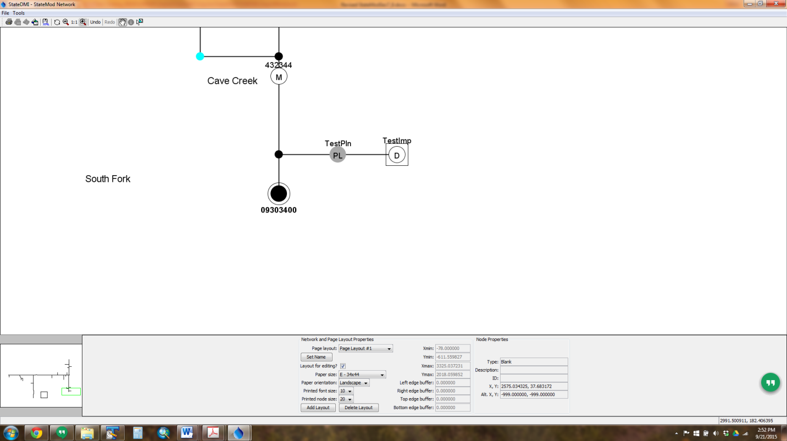Open the network (*.net) in StateDMI, navigate to the appropriate tributary (or create a new tributary for the imports), right-click to *Add an Upstream Location*, and add a diversion structure that will serve as import location.
   1. Enter the appropriate structure ID and naming information, and if desired, check the “Is Import?” box. This will include a box around the diversion structure in the network diagram, but it is used for visual representation only, and is not used by StateDMI when creating files or by StateMod.
2. In the network (*.net) in StateDMI, right-click to *Add an Upstream Location*, and add a plan structure *directly downstream* of the import diversion structure that will serve as the import plan.
3. Recreate the river network file (*.rin) to reflect the additional structures.
4. In the plan file (*.pln), include the import diversion structure as a Type 7 Import Plan (must be same model identifier) and the import plan structure as a Type 11 Accounting Plan.

*Example Operating Rule (*.opr) File*

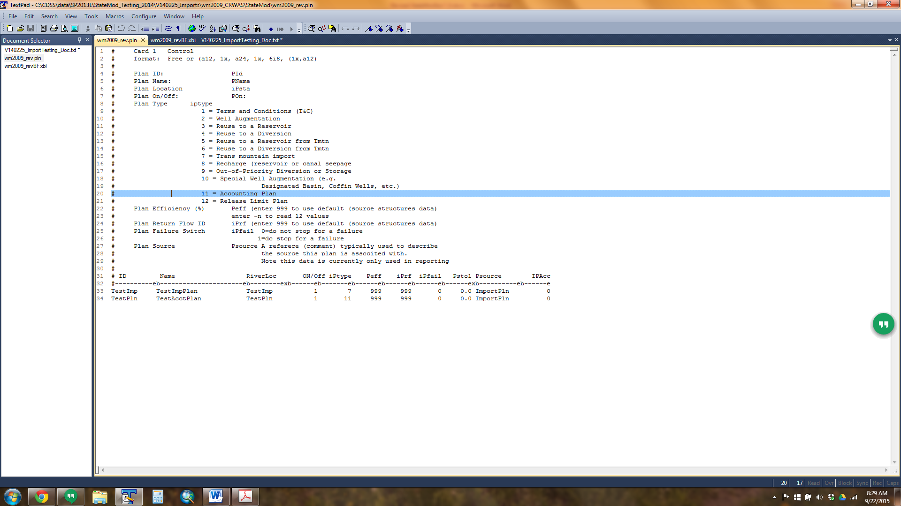

1. In the diversion station (*.dds) file, include the import diversion structure with the following parameters:
   1. Set the capacity of the structure to be greater than the maximum import amount
   2. Set the efficiency to be zero (i.e. 100 percent returns)
   3. Set the return flow pattern and location to return the full amount in the same time step to the import plan structure.

#### Natural Flow Scenario

1. In the historical diversion (*.ddh) file, include the time series of the imported amount as a negative value under the import diversion structure ID.
   1. Note that imported data is generally available in HydroBase under USGS streamflow gage identifiers, and can be converted to negative values using scale function in TSTool.
2. With the import included, run the natural flow simulation using StateMod Option 1 – Baseflow if the input data (e.g. diversions, streamflow) is not complete, or StateMod Option – BaseflowX if the input data is complete.
3. Review the baseflow result information summary (*.xbi) file to ensure that the imported amount is reflected in the Import (Col 2) and accounted for in the natural flow calculations.

#### Simulation Scenario

1. In the diversion demand (*.ddm) file, include the time series of the imported amount as a negative value under the import diversion structure ID.
2. In the operating rule (*.opr) file, include the following rules at a minimum to operate the import plan:
   1. Type 35 rule with the source as the import diversion structure and the destination as the import plan structure. This rule is generally set as the most senior priority in the model.
   2. Type 27 and/or 28 rules with the source as the import plan structure and the destination as any structures that are to receive imported supplies. Note that if the import water that is carried to a specific diversion structure using these rules is a reusable supply, then include a reusable supply plan in the Type 27 or 28 rule. See the “How to Model Reusable Supplies” section for more information.
   3. Type 29 with the source as the import plan structure and the destination as the next downstream node. Note that a destination node is required for any Type 29 plan spill rules with an accounting plan source.
3. With the import and operating rules included, run the simulation using StateMod Option 2 – Simulation.
4. Review the plan summary (*.xpl) file and operating rule summary (*.xop) file for the portion of the imported water that was carried to meet each diversion demand and the portion, if any, that was unused and spilled back to the stream.

## 7.14 How to Model Reusable Supplies

StateMod uses plan structures to track (color) reusable water in the river, in storage, and from water imported into the river system. This provides the opportunity for users to differentiate between one-time use water and reusable water when making releases from storage or from plans to meet various demands. There are two plan types, a Plan Type 3 – Reservoir Reuse Plan and a Plan Type 4 – Non-reservoir (Diversion) Reuse Plan, which can be used to track reusable water.

Reservoir reuse plans are modeled in conjunction with reservoir accounts and track the portion of the storage that can be reused. Water in reservoir reuse plans can be carried over between time steps and does not need to be spilled at the end of a time step. Reusable water is stored in a reservoir reuse plan by including the reuse plan ID (*creuse* field) in the operating rule used to stored water in the reservoir, “coloring” that water as reusable. Another operating rule can then release the reusable supplies from the reservoir to meet a specific demand.

Non-reservoir reuse plans are used to track reusable supplies associated with imports, direct diversions, and changed water rights. Examples include wastewater treatment plant effluent, imported water that can be used to extinction, or the consumptive use portion of a changed water right. Water in non-reservoir reuse plans cannot be carried over between time steps and must be spilled at the end of the time step. Reusable water is generally stored in a non-reservoir reuse plan by including the reuse plan ID in operating rules:

* used to carry a water right to meet a demand (e.g. Type 24 or 25 operating rules)
* used to release water from a Changed Water Right plan or Import plan to meet a demand (e.g. Type 27 or 28 rules)

The non-consumed portion is then stored in the non-reservoir reuse plan, which can then be released to meet another demand using another operating rule (e.g. Type 32 or 33 rules).

Due to the numerous options available to put water into and release water from reservoir and non-reservoir plans, a step-by-step approach is not provided. The following bulleted list provides a general approach to implementing these operations. Note that this approach does not include the steps to implement a Changed Water Right plan or an Import plan. The user can refer to other information in the documentation for more information on those plan structures.

* Include the reservoir and non-reservoir reuse plans in the network (*.net) and the river network (*.rin) files using StateDMI.
* Include the reservoir and non-reservoir reuse plans in the plan (*.pln) file, designating them as either Plan Type 3 or 4.
* The most common operating rules used to store and release water in a reservoir or non-reservoir reuse plan are Types 24, 25, 27, 28, 32, and 33 operating rules. The reuse plans are generally designated in these operating rules types as an associated reuse plan in either the *ciopso(2)* or the *creuse* fields. These operating rules also allow monthly and annual volumetrics and/or terms and conditions to be specified with the use of the reusable supplies.
* Include a Plan Spill Type 29 operating rule for all non-reservoir reuse plans.
* Review the plan summary (*.xpl) file to review the amount of reusable supplies stored and released from each plan.

|  |
| --- |
| **Modeling Tips:**   * The functionality associated with evaporation and releases from reservoir reuse plans has not been thoroughly tested or vetted; it is up to the user to verify these operations are simulating as desired. |

## 7.15 How to Implement a Futile Call

A futile call, as implemented in StateMod, allows a tributary stream to operate independently of the mainstem. Therefore, the impact of upstream diversions and return flows are not passed downstream of the futile call locations. This operating rule was originally developed for use in the Rio Grande, where dry stretches of the river can occur and create an opportunity for a futile call to extend upstream in these reaches.

1. In the river network (*.rin) file, add a river node downstream of where a futile call occurs and keep the downstream location (*cstadn*) blank.

*Example River Network (*.rin) File with Futile Call*

#> ID Name DownStream Comment GWMax

#>---------eb----------------------eb----------exb----------exb------e

Riv_10 RiverDiversion_10 Riv_20 Riv_10 0

Riv_20 RiverDiversion_20 Riv_50 Riv_20 0

Riv_50 RiverDiversion_50 Futile Riv_50 0

Futile FutileCallPoint Futile 0

Riv_60 RiverDiversion_60 Riv_70 Riv_60 0

|  |
| --- |
| **Modeling Tips:**   * The river network (*.rin) file is generally created using StateDMI commands; this operation requires editing this file in text editor. If so, these revisions will not be captured in a commands file and may be overwritten if the river network (*.rin) file is recreated using StateDMI commands. * This functionality has not been thoroughly tested or vetted; it is up to the user to verify these operations are simulating as desired. |

## 7.16 Basin-Specific Operations and Compacts

There have been several operations implemented in StateMod to represent basin-specific operations and/or administration, most typically Interstate Compacts. The discussion below provides insight as to how StateMod is set up to represent these operations; the user is encouraged to review the basin-specific documentation and the individual basin models for more information.

Although designed for a specific operation, in many cases these operations can be adapted to represent operations in other models or areas of the State. This section discusses how the basin-specific operations have been implemented, however the user should consider other opportunities on how to adapt the functionality to use these operations in other modeling efforts.

### 7.16.1 Blue River Decree (Upstream Storage and OOP Plans)

In brief, the Blue River Decree allows Dillon Reservoir, Roberts Tunnel, Upper Blue Lakes, and Continental-Hoosier Tunnel to store or divert out of priority with respect to Green Mountain Reservoir’s first fill decree. The water diverted or stored out of priority at each structure is tracked in an Out-of-Priority (OOP) plan. If Green Mountain Reservoir does not fill under its storage rights at a user-specified priority, Denver and Colorado Springs are required to “repay” Green Mountain from various reservoirs to meet the OOP obligation.

Blue River Decree operations are very complex and involve several operations and structures; the user should refer to the Colorado River Basin Water Resources User’s Manual for information on the specific operations. The summary provided herein is used to illustrate the general functionality of the operations and provide sufficient information for the user to potentially implement these operations in other models.

This summary will focus on a simplified representation of the Blue River Decree operations as they pertain to out-of-priority storage in Dillon Reservoir. When Denver incurs an obligation to repay Green Mountain Reservoir for water stored out-of-priority at Dillon Reservoir, provisions of the Blue River Decree, as more specifically described in a 1964 Stipulation and Agreement, allow Denver to replace the water owed by substituting releases from its Williams Fork Reservoir. In 1991, the agreements were again modified and allowed use of Wolford Mountain Reservoir as an additional source of substitution supply for water owed to Green Mountain Reservoir by Denver. The following structures and operations are used to model these Dillon Reservoir operations.

* **Out-Of-Priority Plans (Plan Type 9).** The OOP plan tracks and stores the OOP storage or diversion amount; the user is then responsible for providing supplies that offset the OOP obligation. An OOP plan should be included for each OOP storage or diversion; the Dillon Storage OOP Plan is modeled as 364512OOPPLN. The OOP plan is included in the network (*net) diagram, river network file (*.rin), and the plan file (*.pln).

*Colorado River Basin Model - Plan (*.pln) File Excerpt*

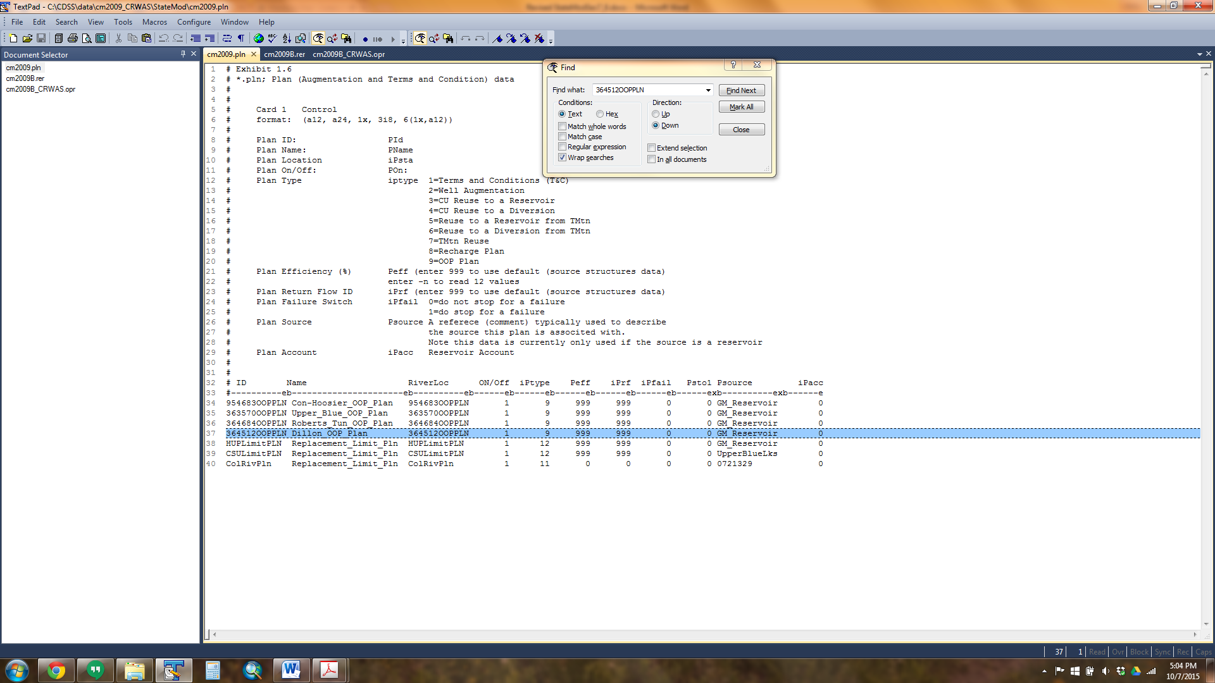

* **Reservoir Structures.** Much of the Blue River Decree operations center on selective use of specific reservoir accounts and bookovers. Dillon Reservoir, shown below, has specific accounts used to manage the OOP bookover operations, these accounts are not tied to any other users of the reservoir.

*Colorado River Basin Model – Reservoir Station (*.res) File Excerpt*

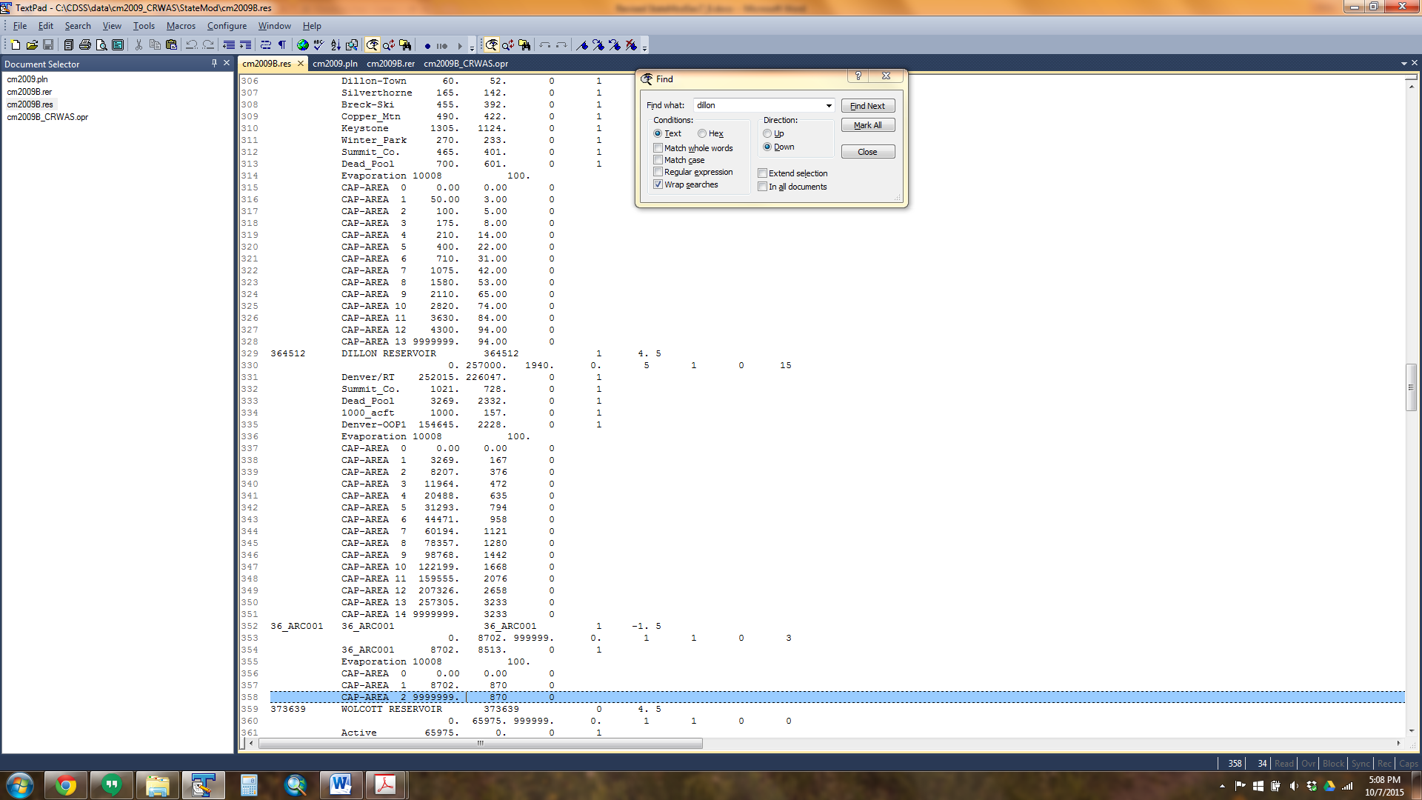

* **Operating Rules**. The Blue River Decree operations associated with OOP plans use several operating rules.
  + **OOP Diversions (Type 38)** allows a reservoir to store (or a carrier to divert) OOP with respect to a more senior reservoir storage. This rule was developed based on the Upstream Storage Statute; upstream reservoirs can store before a more senior downstream reservoir, however the upstream storage stored OOP must be repaid to the senior reservoir right if it is not satisfied. Therefore, as shown below, the more junior Dillon Reservoir right can store before the more Green Mountain Reservoir and the OOP obligation is stored in the OOP plan.
    - The destination of the rule is Dillon Reservoir (364512), the primary source is the senior subordinated Green Mountain storage right (363543.01), and the secondary source is the junior Dillon Reservoir storage right (364512.01).
    - The priority of the operating rule is set senior to the Green Mountain storage right, allowing it to simulate prior to storage in Green Mountain Reservoir.

*Colorado River Basin Model – Type 38 Rule Example*

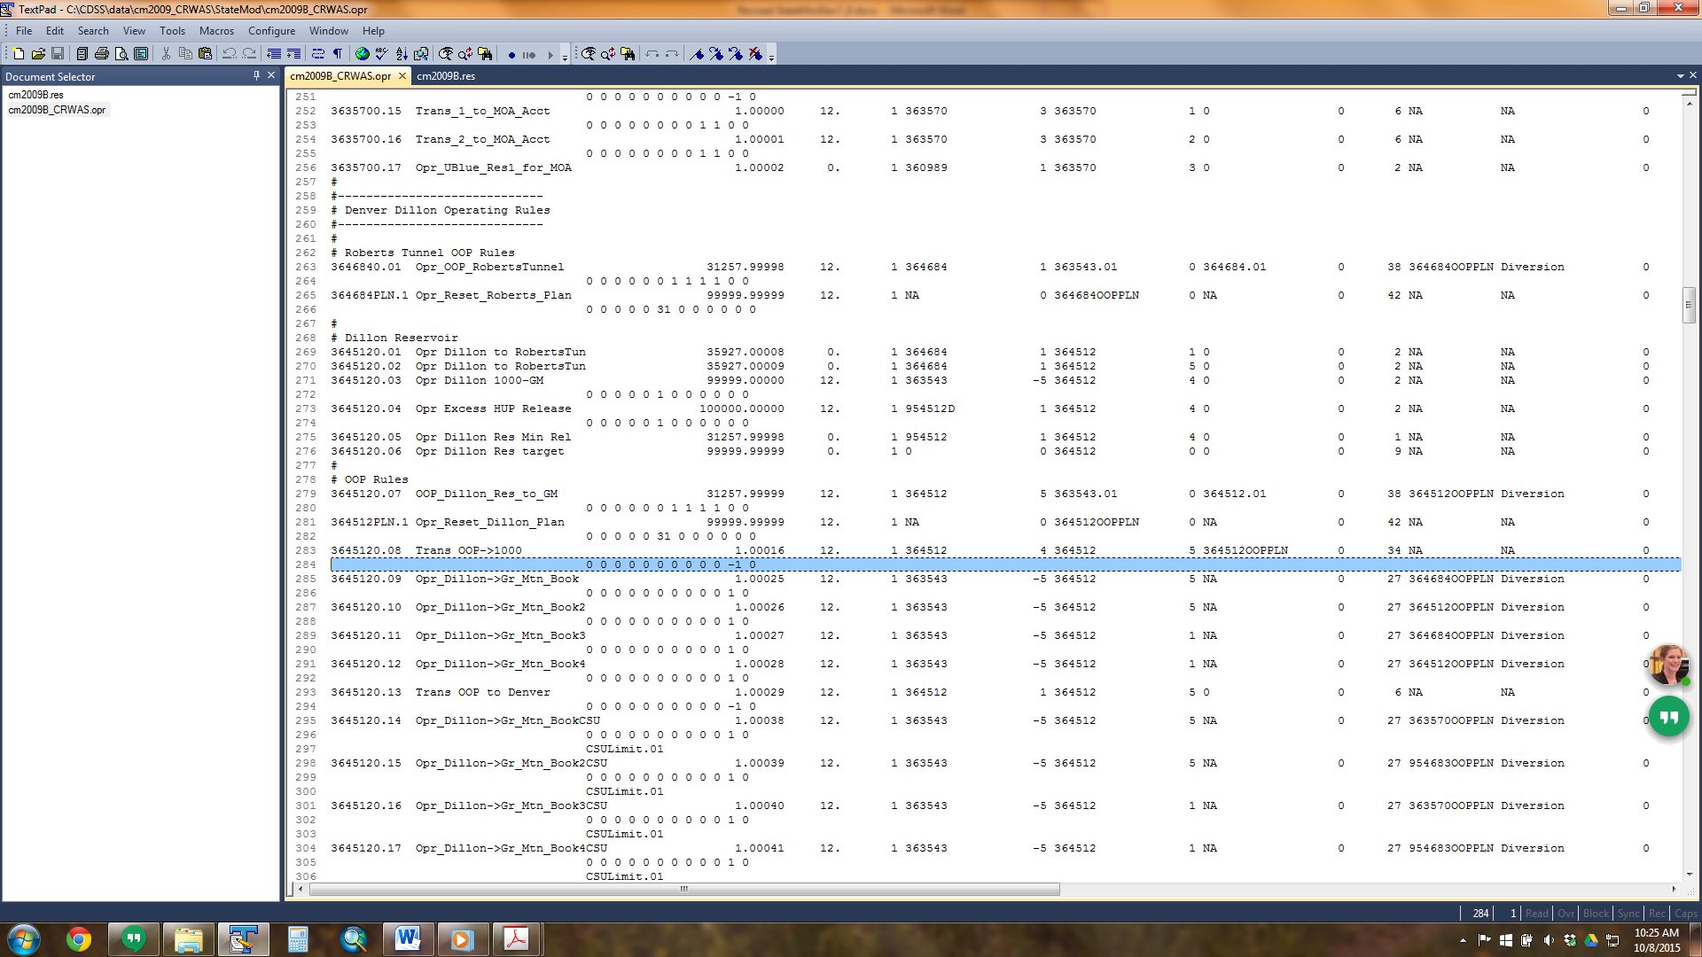

* + **Reservoir Storage with Special Limits (Type 41)** allows a reservoir to store under a reservoir right up to the volume of water in an OOP plan. This rule was developed specifically for the Blue River Decree operations, and allows Green Mountain to store, under a 1955 right, the amount of water that was diverted and stored OOP to Green Mountain’s senior first fill right. When water is stored under this right, it reduces the OOP obligation owed by Denver and Colorado Springs proportional to their OOP operations. This rule operates after the out-of-priority operations are complete which allows for a pro rata amount to be credited to each of the four out-of-priority plans. When the amount stored under this right equals out-of-priority operations by both cities, the right is satisfied.

*Colorado River Basin Model – Type 41 Rule Example*

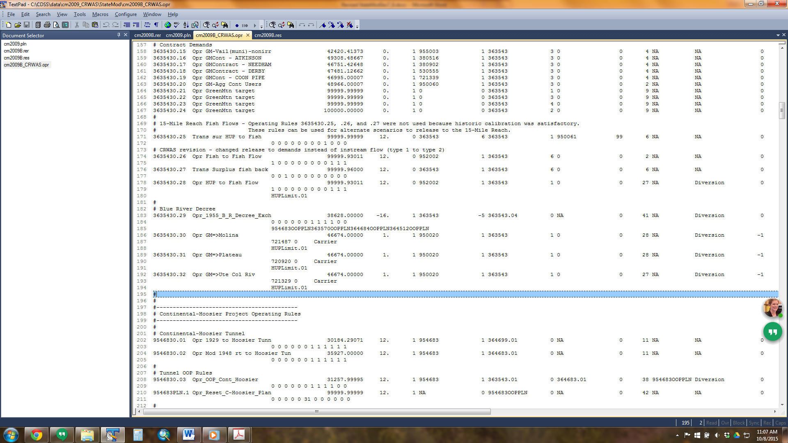

* + **Plan Demand Reset (Type 42)** is used to reset the OOP plans to zero at a specific priority and specific time step. The Dillon Reservoir OOP plan is reset at the most junior priority in the model (99999.99999) on March 31st of each year.
    - Note that this operating rule can also reset T&C Plans (Plan Type 1) or a Well Augmentation Plan (Plan Type 2), if applicable.
  + There are 14 operating rules, including **Bookover with Plan (Type 34)**, **Bookover (Type 6)** and **Direct Plan/Reservoir Release Operating Rule (Type 27),** used to simulate Denver’s OOP obligation replacement operations. Denver has the ability to repay OOP obligations from three reservoirs –Dillon Reservoir, Wolford Mountain, and Williams Fork. Wolford Mountain Reservoir and Williams Fork Reservoir each have two accounts to which Denver can transfer water for replacement. Denver prefers to meet the OOP obligation during substitution years using the bookover operations (Type 34 and 6), however if these supplies are not sufficient, Dillon Reservoir can release directly to Green Mountain Reservoir via the Type 27 operating rule.

*Colorado River Basin Model – Documentation Excerpt*

|  |  |  |  |  |  |
| --- | --- | --- | --- | --- | --- |
| Right # | Description | Account or Carrier | Admin # | Right Type | Plan Structure |
| 17 | Dillon transfer from OOP account to 1000 af account | 5 to 4 | 1.00016 | 34 | 364512OOPPLN |
| 18 | Wolford transfer from Denver account to Denver R1 account | 2 to 5 | 1.00017 | 34 | 364684OOPPLN |
| 19 | Wolford transfer from Denver account to Denver R1 account | 2 to 5 | 1.00018 | 34 | 364512OOPPLN |
| 20 | William Fork transfer from Denver account to WF GMR1 account | 2 to 5 | 1.00019 | 34 | 364684OOPPLN |
| 21 | William Fork transfer from Denver account to WF GMR1 account | 2 to 5 | 1.00020 | 34 | 364512OOPPLN |
| 22 | Wolford transfer from Denver account to Denver R2 account | 2 to 6 | 1.00021 | 34 | 364684OOPPLN |
| 23 | Wolford transfer from Denver account to Denver R2 account | 2 to 6 | 1.00022 | 34 | 364512OOPPLN |
| 24 | William Fork transfer from Denver account to WF GMR2 account | 2 to 6 | 1.00023 | 34 | 364684OOPPLN |
| 25 | William Fork transfer from Denver account to WF GMR2 account | 2 to 6 | 1.00024 | 34 | 364512OOPPLN |
| 26 | Dillon release from OOP account to Green Mountain | 5 | 1.00025 | 27 | 364684OOPPLN |
| 27 | Dillon release from OOP account to Green Mountain | 5 | 1.00026 | 27 | 364512OOPPLN |
| 28 | Dillon release from Denver account to Green Mountain | 1 | 1.00027 | 27 | 364684OOPPLN |
| 29 | Dillon release from Denver account to Green Mountain | 1 | 1.00028 | 27 | 364512OOPPLN |
| 30 | Dillon transfer remaining OOP water to Denver account | 5 to 1 | 1.00029 | 6 |  |

*Colorado River Basin Model – Type 34 Rule Example*

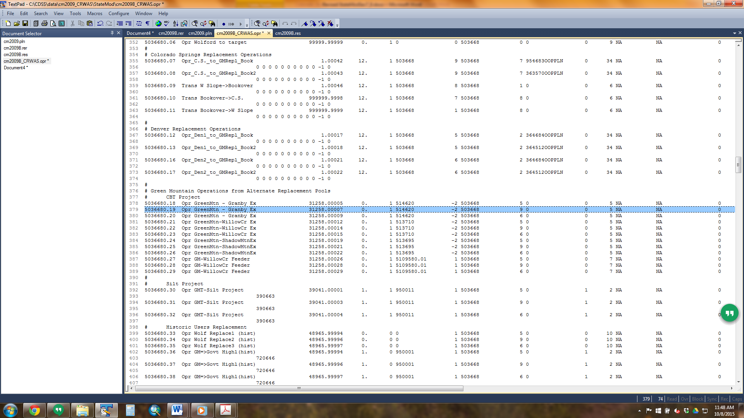

|  |
| --- |
| **Modeling Tips:**   * If the user is interested in setting up an OOP operation, download the full Upper Colorado River StateMod Model from the CDSS website and use it as an example. * Section 5.9.18 in the Upper Colorado River Basin Water Resources Planning Model User’s Manual provides more information on the Blue River Decree operations. |

### 7.16.2 Rio Grande Compact

The Rio Grande Compact of 1938 apportioned water based on the variable river conditions during the Compact Study period (1928 – 1937). Therefore, the amount of water that Colorado has to deliver downstream varies based on the actual or forecasted river conditions as measured at index gages (Rio Grande near Del Norte, Conejos River near Magote, Los Pinos river near Ortiz and the San Antonio river near Ortiz). The more water produced in the Rio Grande River basin, the more water Colorado owes to downstream states. The State Model allows the Rio Grande Compact to be simulated as an operating rule with the following features:

* Compact demands are reflected as forecasted (negative) data in the monthly instream flow demand file.
* Compact “trigger” parameters are reflected in specific operating rules (Type 17 for the Rio Grande River, Type 18 for the Conejos River).

The following approach summarizes the approach to implement the Rio Grande Compact at both the Rio Grande River and Conejos River locations.

1. In the network (*.net) via StateDMI, add two instream flow structures to the model; one downstream of the Rio Grande River at Labatos streamflow gage and the other downstream of the Conejos River near La Sauses streamflow gage. Navigate to the appropriate locations, right-click to *Add an Upstream Location,* enter the appropriate information, and designate the structure type instream flow.
2. Recreate the river network file (*.rin) to reflect the additional structures.
3. Add the structures to the instream flow station file (*.ifs) using the StateDMI commands:
   1. Set the same ID for the upstream and downstream nodes to reflect a point.
   2. Set the demand type variable (*iifcom)* to a 1 to indicate monthly demand (*.ifm) will be provided.
4. Add the structure’s forecasted (negative) demand to the instream flow demand file (*.ifm) using the TSTool commands.
   1. For the Rio Grande demand, enter in the monthly forecast for each year as a negative number based on the April to September forecast for the Rio Grande River Index Station (Rio Grande near Del Norte).
   2. For the Conejos demand, enter in the monthly forecast for each year as a negative number based the April to September forecast for the sum of the Conejos River Index stations (Conejos River near Magote, Los Pinos river near Ortiz and the San Antonio river near Ortiz).
   3. A zero should be entered for months without a forecast.
   4. Set the monthly instream flow demands or read in an external StateMod formatted file (*.stm) with the demand in CFS . Note that if demand is entered in units of acre-feet, adjust the conversion factor (*ffacto*) for instream flow demands in the control (*.ctl) file and confirm all instream flow demands are provided in units consistent with this conversion.
5. In the operating rule (*.opr) file, include a Rio Grande Compact - Rio Grande (Type 17) operating rule to estimate the demand for the Rio Grande instream flow demand.
   1. Set the destination to the Rio Grande instream flow structure
   2. Set source 1 to the stream gage that represents the index flow (e.g. Rio Grande at Del Norte) with a coefficient (account) of 1.
   3. Set source 2 to the stream gage used to adjust to the discharge at the instream flow location (e.g. the combined discharge of the Conejos River near La Sauses) with a coefficient (account) of -1.
   4. Set the appropriate information in the second line of the rule, including:
      1. Year when annual obligation calculation includes an adjustment for cumulative surplus storage
      2. Initial surplus/shortage for the Rio Grande in the year the operating rule triggers
      3. Closed Basin annual yield to the Rio Grande River in acre-feet per year.
      4. Norton Drain South annual yield to the Rio Grande River in acre-feet per year.
6. In the operating rule (*.opr) file, include a Rio Grande Compact - Conejos River (Type 18) operating rule to estimate the demand for the Conejos River instream flow demand.
   1. Set the destination to the Conejos instream flow structure
   2. Set source 1 to the first index stream gage (e.g. Conejos River near Magote) with a coefficient (account) of 1.
   3. Set source 2 to the second index stream gage (e.g. Los Pinos River near Ortiz) with a coefficient of 1.
   4. Set source 3 to the third index stream gage (e.g. San Antonio River at Ortiz) with a coefficient of 1.
   5. Set the appropriate information in the second line of the rule, including:
      1. Year when annual obligation calculation includes an adjustment for cumulative surplus storage
      2. Initial surplus/shortage for the Conejos River in the year the operating rule triggers
      3. Closed Basin annual yield to the Conejos River in acre-feet per year.
      4. Norton Drain South annual yield to the Conejos River in acre-feet per year.
7. Review the instream flow summary (*.xir) file for information on instream flow demands and the portion of the demand met based on the Type 17 and 18 operations.

|  |
| --- |
| **Modeling Tips:**   * It is recommended the user research the full Rio Grande Compact requirements prior to implementing the operations in StateMod. This particularly applies to understanding and implementing the correct forecasted demand. |

### 7.16.3 South Platte Compact

The South Platte Compact requires that Colorado deliver 120 cfs to the Stateline from April 1 to October 15 at an administration date of June 14, 1897, without calling out any diversions located upstream of the Washington County line (i.e. upstream of Water District 64). As StateMod operates water rights from senior to junior over the entire river system, the Washington County limitation was implemented by developing two operating rules specific to the Compact. A Type 50 operating rule is used to temporarily store water available to the South Platte Compact in a plan when in priority and a Type 40 operating rule is used to release water from the plan first to any structure that is water short and outside/upstream of Water District 64 and then to the Compact demand. The Type 40 operating rule is used to determine if exchange potential exist which will allow a junior water right to exchange water from the Compact plan to meet their unmet demand. This check occurs immediately following the priority of a water right that is short.

* If exchange potential exists, water will be exchanged to the diversion limited by the structure’s demand, water right and capacity. In addition return flows will be calculated, a re-operation will occur and potentially allow water rights throughout the system to divert more water to meet their demands.
* If exchange potential does not exist, the water stays in the Compact plan.

The Type 40 operating rule determines if the structure is outside/upstream of Water District 64 based on the first two digits of the model ID and does *not* exchange to any diversion structure with a 64* model ID. Additionally, the Type 40 operating rule only exchanges to diversion structures located on-channel; exchanges to any off-channel demands (i.e. off-channel irrigation demands) in upstream reaches of the river will require a separate operating rule (Type 28).

1. In the network (*.net) via StateDMI, add one instream flow structure to the model located directly downstream of the South Platte River at Julesburg streamflow gage. Navigate to the appropriate location, right-click to *Add an Upstream Location,* enter the appropriate information, and designate the structure type instream flow.
2. Recreate the river network file (*.rin) to reflect the additional structures.
3. Add the structure to the instream flow station file (*.ifs) using the StateDMI commands:
   1. Set the same ID for the upstream and downstream nodes to reflect a point.
   2. Set the demand type variable to a 2 to indicate constant demand (*.ifa) will be provided.
4. Add water rights to the instream right file (*.ifr) using the StateDMI commands:
   1. Set a 120 CFS water right with a June 14, 1897 (17332.00000 administration number)
5. Add the structure’s demand to the instream flow demand file (*.ifa) using the StateDMI commands.
   1. Set the monthly instream flow demand to 120 CFS for April through September, 60 CFS for October to represent that the Compact is only in effect through October 15th, and zero for the remaining months.
6. In the plan file (*.pln), include an accounting plan as a Type 11 Plan and include the appropriate parameter information. See Section 4 for more discussion on the information in and format of this file.
   1. Set the River ID as the Compact Plan ID (e.g. Compact_Pln) and set the River Location as the Compact instream flow structure ID indicating the Compact Plan will be administered at the instream flow structure location.
7. In the operating rule (*.opr) file, include a South Platte Compact Storage (Type 50) operating rule to temporarily store water available to the Compact in the Compact administrative plan.
   1. Set the administration date to a 17332.00000 administration number (June 14, 1897).
   2. The source is the Compact instream flow right and the destination is Compact plan.
   3. This rule turns off the source instream flow right so that it is completely controlled by the operating rule.
8. In the operating rule (*.opr) file, include a South Platte Compact Release (Type 40) operating rule to exchange Compact plan water to diversion structures located outside/upstream of Water District 64.
   1. Set the administration date to a 17332.00000 administration number; however note that the administration number is not read since this operating rule is called immediately following the priority of any water right that is water short and not located in Water District 64.
   2. The source is the Compact plan and the destination is “64x” indicating all diversion structures with a model ID that does not start with a 64*.
9. In the operating rule (*.opr) file, include a second South Platte Compact Release (Type 40) operating rule to release the water remaining in the Compact plan to the Compact instream flow demand.
   1. Set the administration date to the most junior in the model (99999.99999). The Compact instream flow demand is first satisfied by the physical water in the river, and if short, this rule releases from the Compact plan to meet the remaining demand up to the amount available in the plan. Since the full plan amount is released to the instream flow, a spill plan operating rule is not needed.
   2. The source is the Compact plan and the destination is the Compact instream flow.
10. In the operating rule (*.opr) file, include Exchange Plan/Release (Type 28) operating rules for any off-channel demands located outside/upstream of Water District that are entitled to releases from the Compact plan if exchange potential is available.
    1. Set the administration date to be junior to the diversion structure’s most junior supply.
    2. The source is the Compact plan and the destination is the diversion structure ID.
    3. Include carriers with losses, if applicable.

*South Platte River Basin Model – Compact Operations Example*

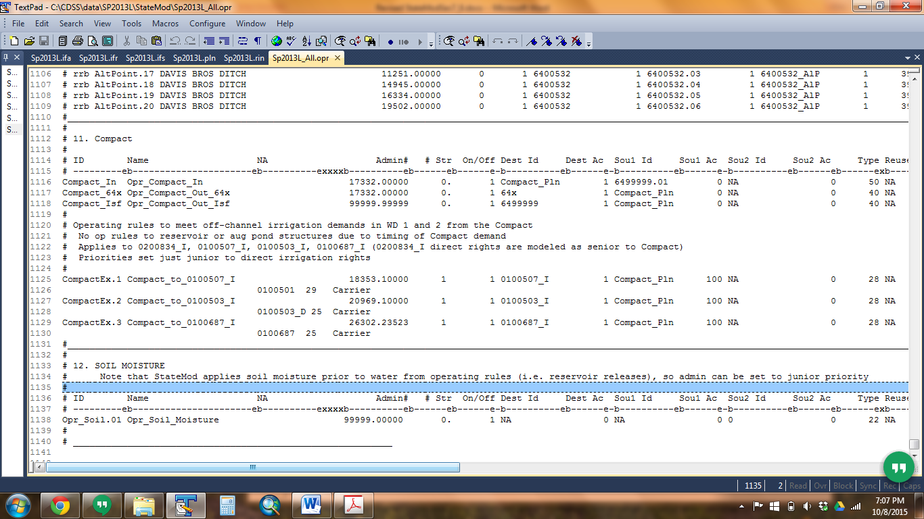

1. Review the operating rule summary (*.xop) file, the diversion structure summary (*.xdd) file, the plan summary (*.xpl) file, and the instream flow summary (*.xir) file for information on the South Platte Compact operations and the amount of water released from the Compact plan for exchange.

### 7.16.4 La Plata Compact

The La Plata Compact governs the distribution of water on the La Plata River between the states of Colorado and New Mexico. The administration is dependent upon the streamflow at two gaging stations: Hesperus Station (USGS No. 09365500) and Interstate Station (USGS No. 9366500). During the year from December 1 to February 14, each state has the right to use all water within its boundaries. For the remainder of the year, February 15 to November 30, allocation for La Plata River water is performed according to the following guidelines:

* If the flow at Interstate Station is greater than or equal to 100 cubic feet per second (cfs), each state has unrestricted rights to all water within its boundaries.
* If the flow at Interstate Station is less than 100 cfs, the State of Colorado shall deliver at the Interstate Station a quantity of water equal to one-half of the mean flow at the Hesperus Station for the preceding day, not to exceed 100 cfs.

During periods of extreme low flow, the guidelines above may be superseded by a method of administration that allows the delivery of all available water successively to each state in alternating periods. When flow at the Hesperus Station is less than 30 cfs, the lower reaches of the La Plata will run dry, and Colorado cannot deliver any water in accordance with No. 2 above.

The Type 13 operating rule was developed in order to implement the La Plata Compact in the San Juan River Basin model. This rule allows an instream flow to operate based on its location on the river and the flow at an upstream index streamflow gage. Although developed specifically for the La Plata Compact, this rule could be used for more generic applications in other models.

1. In the network (*.net) via StateDMI, add one instream flow structure to the model at the Colorado – New Mexico state line and one “other” structure immediately downstream to reflect the instream flow reach. Navigate to the appropriate location, right-click to *Add an Upstream Location,* enter the appropriate information, and designate the structure type instream flow for the upstream instream flow structure and “other” type for the downstream structure.
   1. 332999 and 332999_Dwn are used as model IDs in the San Juan/Dolores River Basin models for the upstream and downstream structures, respectively.
2. Recreate the river network file (*.rin) to reflect the additional structures.
3. Add the structure to the instream flow station file (*.ifs) using the StateDMI commands:
   1. Set the upstream and downstream model IDs to reflect the reach.
   2. Set the demand type variable to a 2 to indicate constant demand (*.ifa) will be provided.
4. Add water rights to the instream right file (*.ifr) using the StateDMI commands:
   1. Set a 100 CFS water right with the most senior water right in the model (00001.00000 administration number).
5. Add the structure’s demand to the instream flow demand file (*.ifa) using the StateDMI commands.
   1. Set the monthly instream flow demand to 100 CFS for April through November and zero for the remaining months.
   2. Note that this demand provides the upper bound of demand; the Type 13 operating rule will calculate the instream flow demand as the minimum of the Compact instream flow water right; the specified percent (e.g. 50%) of the flow at the Compact gage (e.g. 09365500); the instream flow demand (*.ifa); and the available flow at the instream flow.
6. In the operating rule (*.opr) file, include a La Plata Compact (Type 13) operating rule to define the index gages and percentages used to calculate the Compact instream flow demand.
   1. Set the administration number to be senior (00001.0000 administration number).
   2. The primary source is the index streamflow gage ID (09365500) and the percent of flow (50%); the secondary source is the Compact instream flow water right.
   3. This rule turns off the source instream flow right so that it is completely controlled by the operating rule.
   4. Monthly on/off switches can be used to further refine the months when the Compact should be administered.
   5. Using a very senior administration number in this operating rule, the Compact demand is typically equal to the natural flow plus any lagged returns to the gage from upstream diversions in a prior time step multiplied by the specified percent (e.g. 50%).

*San Juan River Basin Model – Compact Operations Example*

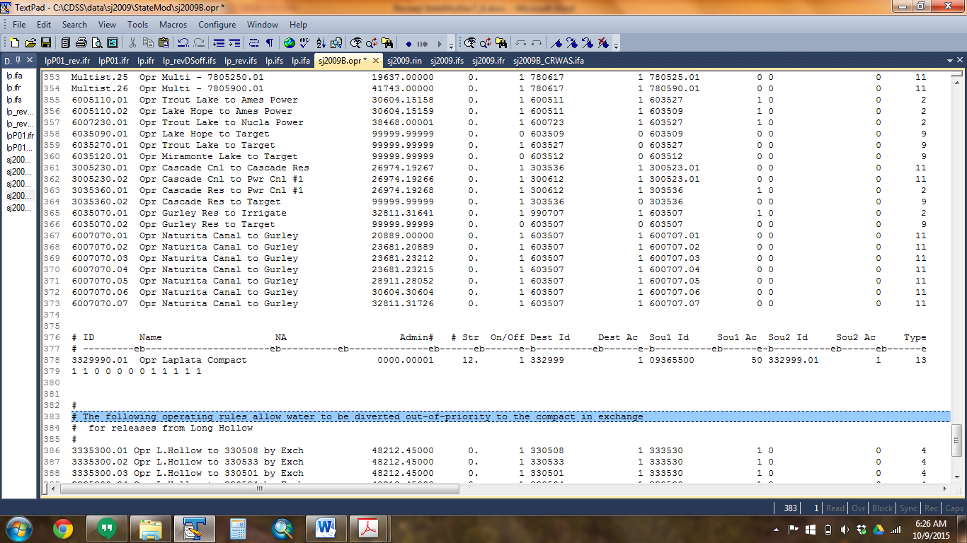

1. Review the operating rule summary (*.xop) file, the diversion structure summary (*.xdd) file, and the instream flow summary (*.xir) file for information on the La Plata Compact demand and operations.
   1. As the Compact demands are calculated within the model, the information printed under the column titled “demand” in the diversion station summary (*.xdd) file is the minimum of the specified percent (e.g. 50%) of the flow at the compact gage (e.g. 09365500) and the instream flow demand provided in the instream flow demand files.
   2. To obtain additional details (printed in the log file (*.log) on the calculations associated with this operating rule the control file variables ***ichk*** and ***ccall*** should be set to 113 (operating rule 13) and 3329990.01 (the operating right ID for the La Plata Compact).

## 7.17 How to Add Daily Capability to a Monthly Model

StateMod allows a daily analysis to be performed with or without monthly data being provided. In general providing and preparing a monthly model first is recommended for the following reasons:

* The most difficult part of developing a basin wide model is understanding the system. By first developing a monthly model, the system operation can be investigated without burdening the user with the volume of information required for a daily model.
* Relying on monthly data means that daily natural flow generation is not required. If daily baseflows are developed, then the sum of daily baseflows will equal monthly baseflow estimates.
* A daily model is typically developed to be able to simulate large and small flow events that occur within a monthly time step or to investigate flow requests that vary within a monthly time step. Therefore, although daily streamflow data will be required, the user may want to estimate the other terms required for daily analysis, such as diversion demands or reservoir targets, using a simplified approach. As presented in the table below, StateMod provides six options to provide or estimate daily data.
* Note that the daily ID code/Station ID are generally set in the station files, including the well station (*.wes), diversion station (*.dds), reservoir station (*.res), instream flow (*.ifs), and the river station (*.ris) files.

Table 3: Daily Modeling Options

|  |  |  |  |
| --- | --- | --- | --- |
| Distribution Code | Daily ID Code for Station ID | Description | Controlling Data |
| 0 | 0 | Daily data are estimated to be the average of monthly data | Monthly |
| 1 | Station ID | Daily data are estimated using the daily pattern provided under the station ID | Monthly |
| 2 | Another Station’s ID | Daily data are estimated using the daily pattern provided under another station’s ID | Monthly |
| 3 | 3 | Daily data are provided in a daily file | Daily |
| 4 | 4 | Daily data are estimated by connecting the midpoints of monthly data. | Monthly |
| 5 | 5 | Daily data are estimated by connecting the endpoints of monthly data | Monthly |

* As described above, if both daily and monthly data are provided for the same structure and the daily data does not sum to the monthly total, the type of daily distribution specified determines which data (monthly or daily) takes precedence. For example, when option 2 is selected, daily data are used to distribute the monthly value to daily values regardless of what the sum of the daily values equal. Similarly, when option 3 is selected and the sum of daily data does equal the monthly value, the daily values are used.
* For the case where a user supplies monthly data and a representative gage to use for daily data, the sum of daily data typically equals the monthly total. Daily data may not equal the monthly total if the representative gage with daily data contains all zeros.
* The routing of daily streamflows is accounted for by the gain and loss term that results from the natural flows estimated by or provided to the model.
* Routing of reservoir releases are not included for the following reasons:
  1. StateMod is a primarily a planning model.
  2. The additional detail required to properly implement reservoir releases with a travel time component is not justified since the system would have to include some kind of forecasting to know when a reservoir release is required before a reservoir demand actually occurs.
  3. The volume of water potentially delivered early by ignoring a reservoir's travel time is offset by the potential over release that occurs after the demand is satisfied.
* StateMod allows a user to estimate daily demands by providing a monthly total that is decreased each day in the month that a diversion occurs (see the control file (*.ctl) variable *iday*). This "daily decrementing" capability can be important when simulating a ditch with a significant flood right that typically only diverts a few days a month. When this option is used for ditches without a significant flood right, water rights or canal capacity typically limit the amount diverted in a day.

StateMod’s ability to use or estimate daily data requires the user be extremely careful when assigning a daily streamflow gage for a given structure. Following are four examples successfully used in prior StateMod applications. The first two examples (Tables 4 and 5) perform a daily analysis using monthly natural flow results. The last two examples (Table 6 and 7) perform a daily analysis by first calculating daily natural flows.

Table 4 is an example used for a typical Historical Calibration run with natural flows. It does not perform a daily natural flow analysis to estimate daily natural flows. Instead it uses monthly natural flow results and disaggregates them to daily values using historical daily data at a streamflow gage. Daily diversion data are used to estimate daily historical diversion demands and instream flow demands. Interpolation routines are used to estimate daily reservoir targets and well demands. Note that daily diversion demands are typically equal to daily historical diversions for a Historical Calibration run. Also daily instream flow demands often change from one value to another on a specified day of the month that requires daily data.

Table 4: Example 1, Daily ID Assignment for Historical Calibration Scenario with Monthly Natural Flow

|  |  |  |
| --- | --- | --- |
| **File** | **Daily ID** | **Comment** |
| River Station (*.ris) | USGS Gage ID | Estimate daily streamflows by distributing monthly natural flows to daily values using daily data at a streamflow gage. Note the monthly totals in the monthly natural flow file (*.rim or *.xbm) control. |
| Diversion Station (*.dds) | 3 | Daily diversion data (*.ddd) is used to estimate daily demands. Note the daily data controls. |
| Reservoir Station | 5 | Estimate daily reservoir targets by connecting the endpoints of data in the Monthly Target file (*.tar/*.eom). |
| Instream Flow Station | 3 | Daily instream flow demand data (*.ifd) is used to estimate daily demands. Note the daily data controls. |
| Well Station | 4 | Estimated daily well demands by connecting the midpoints of data in the monthly well demand (*.wem) file. |

Table 5 is an example used for a typical Daily Baseline run. Similar to the Historical Calibration run, it does not perform a daily natural flow analysis to estimate daily streamflows. Instead it uses monthly natural flow results and disaggregates them to daily values using historical daily data at a stream gage. Daily data are used to estimate daily instream flow demands. Interpolation routines are used to estimate daily diversion demands, daily reservoir targets and well demands. Note that daily diversion demands are estimated using an interpolation approach because it is the most appropriate technique to estimated future daily diversion demands. The approach used to estimate daily reservoir targets, instream flow demands and well demands are the same as those used in Table 4 above.

Table 5: Example 2, Daily ID Assignment for Daily Calculated/Baseline Scenario with Monthly Natural Flow

|  |  |  |
| --- | --- | --- |
| **File** | **Daily ID** | **Comment** |
| River Station (*.ris) | USGS Gage ID | Estimate daily streamflows by distributing monthly natural flows to daily values using daily data at a streamflow gage. Note the monthly totals in the monthly natural flow file (*.rim or *.xbm) control. |
| Diversion Station (*.dds) | 4 | Estimated daily diversion demands by connecting the midpoints of data in the calculated monthly demand (*C.ddm) file. |
| Reservoir Station | 5 | Estimate daily reservoir targets by connecting the endpoints of data in the calculated monthly reservoir target file (*C.tam) |
| Instream Flow Station | 3 | Daily instream flow demand data (*.ifd) is used to estimate daily demands. Note the daily data controls. |
| Well Station | 4 | Estimated daily well demands by connecting the midpoints of data in the monthly well demand (*.wem) file. |

Table 6 is an example used for a Daily Historical Calibration Run with daily natural flows. Unlike the examples described above, this example does perform a daily natural flow analysis to estimate daily streamflows. Note that daily data are used for streamflow, diversions and instream flows. Interpolation routines are used to estimate daily reservoir contents and daily reservoir targets. An interpolation approach is used for reservoirs and wells because daily reservoir and well data are typically unavailable.

Table 6: Example 3, Daily ID Assignment for a Daily Historical Calibration Scenario with Daily Natural Flows

|  |  |  |
| --- | --- | --- |
| **File** | **Daily ID** | **Comment** |
| River Station (*.ris) | 3 | For the natural flow run, use the daily streamflow data located in the Daily Historical Streamflow file (*.riy). For a simulation run, use the daily natural flow streamflow data located in the Daily Streamflow file (*.rid or *.xby) created by the daily natural flow run. |
| Diversion Station (*.dds) | 3 | For the natural flow run, use the Daily Historical Diversion data (*.ddy) to estimate daily historical diversions. For the simulation run, use the Daily Diversion Demand data (*.ddd) to estimate daily historical demands. |
| Reservoir Station | 5 | For the natural flow run, estimate daily reservoir end-of-day contents by connecting the endpoints of data in the monthly reservoir target file (*.eom). For the simulation run, estimate daily reservoir targets by connecting the endpoints of data in the Monthly Reservoir Target file (*.tam). |
| Instream Flow Station | 3 | For the natural flow run, instream flows are not required because they are non-consumptive. For the simulation run, use daily instream flow demand data (*.ifd). |
| Well Station | 4 | Estimated daily well demands by connecting the midpoints of data in the monthly well demand (*.wem) file. |

Table 7 is an example used for a Daily Calculated or Baseline Run with daily natural flows. The simulation run uses an interpolation routine for diversion demands and well demands because it is the most appropriate technique to estimate future daily diversion demands. Using a different approach for diversions during a natural flow run and a simulation run requires a different diversion station file be used for each. Interpolation routines are again used to estimate daily historical reservoir contents and daily reservoir targets for both the natural flow and simulation runs because daily reservoir data are typically unavailable.

Table 7: Example 4, Daily ID Assignment for a Daily Calculated/Baseline Scenario with Daily Natural Flows

|  |  |  |
| --- | --- | --- |
| **File** | **Daily ID** | **Comment** |
| River Station (*.ris) | 3 | For the natural flow run, use the daily streamflow data located in the Daily Historical Streamflow file (*.riy). For a simulation run, use the daily natural flow streamflow data located in the Daily Streamflow file (*.rid or *.xby) created by the daily natural flow run. |
| Diversion Station (*.dds) | 3 = natural flow  4 = simulation | For the natural flow run, use the Daily Historical Diversion data (*.ddy) to estimate daily historical diversions. For the simulation run, use the Daily Diversion Demand data (*.ddd) to estimate daily historical demands. |
| Reservoir Station | 5 | For the natural flow run, estimate daily reservoir end-of-day contents by connecting the endpoints of data in the monthly reservoir target file (*.eom). For the simulation run, estimate daily reservoir targets by connecting the endpoints of data in the Monthly Reservoir Target file (*.tam). |
| Instream Flow Station | 3 | For the natural flow run, instream flows are not required because they are non-consumptive. For the simulation run, use daily instream flow demand data (*.ifd). |
| Well Station | 4 | Estimated daily well demands by connecting the midpoints of data in the monthly well demand (*.wem) file. |

### 7.17.1 Implementing Daily Model Capabilities in a Monthly Model

This section provides information as to the specific flags and files required to add daily capability to a monthly model. As daily natural flow generation is not required nor recommended, the approach to implement daily model capabilities in a monthly model *without* generating daily natural flows is provided below. This section does not provide information on the development of the daily files due to the wide variety of information and/or scenarios that could be modeled. It is recommended users refer to a previously developed daily model for specific information and format of the input files.

1. In the response (*rsp) file using a text editor, add the file names for the appropriate daily files that are required for the specific scenario (i.e. exclude well and/or reservoirs if the scenario does not include them).

Stream_Base_Daily = Stream Base Daily *.rid

Diversion_Demand_Daily = Direct Flow Demand Daily *.ddd

Instreamflow_Demand_Daily = Instream Flow Demand Daily *.ifd

Well_Demand_Daily = Well Demand Daily *.wed

Reservoir_Target_Daily = Reservoir Target Daily *.tad

DelayTable_Daily = Delay Table Daily *.dld

ConsumptiveWaterRequirement_Daily = ConsumptiveWaterReq. Daily *.iwd

StreamGage_Historic_Daily = StreamGage Historic Daily *.riy

Diversion_Historic_Daily = Diversion Historic Daily *.ddy

Well_Historic_Daily = Well Historic Daily *.wey

Reservoir_Historic_Daily = Reservoir Historic Daily *.eoy

1. In the control (*.ctl) file using a text editor, set the daily flag (*iday)* to either 1 for a daily analysis or 2 for a daily analysis where the daily demand is a monthly total that is decreased by the amount diverted each day (i.e. “daily decrement approach”).
2. Using the StateDMI commands, set the Daily Station IDs in each of the files listed below to indicate the desired method to use or estimate daily data.
   1. River station (*.ris) file = Daily Stream Station ID (*crunidy*) flag; note daily data for the station ID must be provided in the daily streamflow file (*.rid).
   2. Diversion station (*.dds) file = Daily Diversion ID (*cdividy)* flag
   3. Instream station (*.ifs) file = Daily Instream Station ID (*cifridy)* flag
   4. Well station (*.wes) file = Daily Well Station ID (*cdividyw)* flag
   5. Reservoir station (*.res) file = Daily Reservoir Station ID (*cresidy)* flag
3. Using TSTool commands, create the daily input files as appropriate for the scenario:
   1. Daily streamflow (*.rid) file
   2. Direct diversion demand (*.ddd) file.
   3. Daily instream demand (*.ifd) file.
   4. Daily well demand (*.wed) file if wells are simulated.
   5. Daily reservoir target (*.tad) file.
   6. Daily return file (*.dld) file.
   7. Daily Consumptive Requirement (*.ddx) file if variable efficiency is simulated.

|  |
| --- |
| **Modeling Tip:**   * Daily modeling options are complex and all functionality has not been thoroughly tested or vetted; it is up to the user to verify these operations are simulating as desired. |

[*cdss.state.co.us*](cdss.state.co.us)

Last updated: October, 2015